TAJUK KAJIAN….

NAMA ANDA 1
NAMA ANDA 2
NAMA ANDA 3

TAHUN…

DIPLOMA TEKNOLOGI ELEKTRONIK
KOLEJ VOKASIONAL SEGAMAT

Tajuk projek

Oleh:
Nama
Nama
Nama

A thesis submitted in
fulfilment of the requirement for the award of the
Doctor of Philosophy In Electrical Engineering

Faculty Of Electrical And Electronics Engineering
Universiti Tun Hussein Onn Malaysia

diploma teknologi elektronik
December 2024

STUDENT DECLARATION
Pengakuan penulis

Student | : | ...........................................................................
 |  | MAHDZIR BIN JAMIAAN
Date | : | 25 August 2025

Supervisor | : | ...........................................................................
 |  | PROF. IR. DR. SOON CHIN FHONG

Co-Supervisor |  | : | ...........................................................................
 |  |  | ASSOCIATE PROF. IR. DR. CHIA KIM SENG

DEDICATION
My beloved families… wife and kids…

ACKNOWLEDGEMENT
The author would like to express his sincere appreciation to his supervisor, Prof. Dr. Soon Chin Fhong, for the full support, advice and motivation given throughout the duration of this research.
Associate Prof. Ir. Dr. Chia Kim Seng as co-supervisor for the advice and ideas. Thank you

ABSTRACT
Microalgae cultivation has emerged as a promising solution to support the global bioeconomy through the production of biofuels, nutritional supplements, and sustainable aquaculture feed. Chlorella sp., a species known for its high growth rate and nutrient content, is widely cultivated for these purposes. However, maintaining optimal environmental conditions throughout the growth cycle remains a major challenge. Manual monitoring is time-consuming, reactive, and lacks the precision needed to detect critical changes in real time. To address this limitation, this study proposes the development of a novel IoT-based parameter monitoring system integrated with edge Artificial Intelligence (AI) and Machine Learning (ML) models to enhance the precision and responsiveness of indoor Chlorella sp. cultivation. The research introduces a multi-parameter sensor system designed to monitor key water quality indicators, including Oxidation Reduction Potential (ORP), Electrical Conductivity (EC), pH, and water temperature. Sensor data were transmitted via LoRaWAN to a cloud-linked Node-RED dashboard and stored in InfluxDB for data collection and visualisation. The system was deployed in a closed photobioreactor environment, and cultivation experiments were conducted over three nine-day cycles. Biomass growth was measured using OD at 680 nm and cross-validated with an SX731 portable multiparameter probe. To detect anomalies and forecast microalgae growth performance, two edge-compatible ML models were implemented: Long Short-Term Memory Autoencoder (LSTM-AE) and Isolation Forest (IForest). Experimental results revealed a strong inverse correlation between EC and Optical Density (OD) values with a score of r = 0.780, while ORP patterns showed significant alignment with photosynthetic activity with a score of r 0.978, confirming their utility as predictive indicators. This study contributes to the advancement of precision aquaculture and smart microalgae cultivation systems by offering a scalable and low-cost IoT-Edge AI framework. This system supports Malaysia’s bioeconomy and Sustainable Development Goal (SDG) by promoting digital innovation, clean energy, and environmentally friendly agricultural practices. The proposed monitoring system and machine learning model provide an efficient, real time, and intelligent platform for the cultivation and harvesting of Chlorella sp. It sets a foundation for future developments in smart agriculture applications for microalgae systems, ultimately supporting higher productivity, sustainability, and resilience in the sector.

ABSTRAK
Penanaman mikroalga kini diiktiraf sebagai antara penyelesaian berpotensi tinggi dalam menyokong bioekonomi global melalui penghasilan biofuel, makanan tambahan, dan sumber makanan akuakultur yang mampan. Chlorella sp. merupakan spesies mikroalga yang mempunyai kadar pertumbuhan tinggi dan kandungan nutrien yang tinggi, menjadikannya pilihan utama dalam aplikasi tersebut. Namun begitu, cabaran utama dalam proses penanaman ialah mengekalkan keadaan persekitaran yang optimum secara konsisten sepanjang kitaran pertumbuhan. Kaedah pemantauan manual yang diamalkan kini adalah lambat, bersifat reaktif, dan tidak dapat mengesan perubahan berskala kecil secara masa nyata. Justeru itu, kajian ini mencadangkan pembangunan satu sistem pemantauan berasaskan IoT yang disepadukan dengan model Kecerdasan Buatan (AI) dan Pembelajaran Mesin (ML) di peranti hujung bagi meningkatkan ketepatan dan kecekapan pemantauan penanaman Chlorella sp. Kajian ini membangunkan sistem penderiaan pelbagai parameter untuk memantau parameter kualiti air utama, termasuk potensi Oxidation Reduction Potential (ORP), Electrical Conductivity (EC), pH, dan suhu air. Data penderiaan dihantar melalui rangkaian LoRaWAN ke papan pemuka Node-RED dan disimpan dalam pangkalan data bersiri masa, InfluxDB untuk pengumpulan dan visualisasi data. Sistem ini diuji dalam persekitaran fotobioreaktor tertutup dengan tiga kitaran eksperimen penanaman selama sembilan hari. Pertumbuhan biojisim mikroalga diukur melalui ketumpatan optik pada 680 nm dan disahkan menggunakan meter mudah alih SX731. Bagi tujuan pengesanan anomali dan peramalan prestasi pertumbuhan mikroalga, dua model ML dilaksanakan di peranti hujung iaitu Long Short-Term Memory Autoencoder (LSTM-AE) dan Isolation Forest (IForest). Analisis eksperimen menunjukkan korelasi songsang yang signifikan antara EC dan Ketumpatan Optik (OD) dengan mencatatkan skor r=0.780, manakala pola ORP berkait rapat dengan aktiviti fotosintesis dengan skor r= 0.978, sekali gus mengesahkan keberkesanan ORP sebagai penunjuk pertumbuhan. Sistem ini sejajar dengan Matlamat Pembangunan Mampan (SDG) melalui pemerkasaan inovasi digital, tenaga bersih dan pertanian lestari. Sistem pemantauan dan model pembelajaran mesin yang dicadangkan menyediakan platform pintar dan efisien untuk penanaman dan penuaian mikroalga Chlorella sp. secara masa nyata. Kajian ini menjadi asas kepada pembangunan lanjut dalam bidang pertanian pintar dalam sistem mikroalga, sekali gus meningkatkan produktiviti, kebolehskalaan dan kelestarian sektor ini

CONTENTS
TITLE Error! Bookmark not defined.
STUDENT DECLARATION ii
DEDICATION iii
ACKNOWLEDGEMENT iv
ABSTRACT v
ABSTRAK vi
CONTENTS vii
LIST OF TABLES x
LIST OF FIGURES xi
LIST OF SYMBOLS AND ABBREVIATIONS xiii
LIST OF APPENDICES xiv
CHAPTER 1 INTRODUCTION 1
1.1 Introduction 1
1.2 Background Study 3
1.3 Problem statements 7
1.4 Research questions 9
1.5 Objectives 9
1.6 Scope of the study 10
1.7 Significant contribution 11
1.8 Thesis organisation 12
CHAPTER 2 LITERATURE REVIEW 13
2.1 Introduction 13
2.2 The applications of microalgae 15
2.3 The general introduction to the production of microalgae biomass 16
2.4 Microalgae growth curve 20
2.5 Microalgae Culture Techniques and Culture Parameters Requirements 21
2.5.1 Open culture technique 21
2.5.2 Closed culture technique 24
2.6 Sensor 26
2.6.1 Oxidation-reduction potential 26
2.6.2 Electrical conductivity 27
2.6.3 The potential of hydrogen 28
2.6.4 Water temperature 29
2.7 Long-Range Wide-Area Network Communication Technology 31
2.7.1 LoRaWAN classes 31
2.7.2 LoRaWAN communication network 32
2.8 Machine learning in microlagae cultivation 35
2.8.1 Edge AI computing 35
2.8.2 Training-testing split ratio 37
2.9 Previous research in applying machine learning for predicting microalgae growth 38
2.10 Comparison analysis of LSTM-AE and IForest ML methods of microagae cultivation with the current study 42
2.11 Multivariate Time Series Anomaly Detection (MTAD) 45
2.12 Summary 48
CHAPTER 3 METHODOLOGY 50
3.1 Introduction 50
3.2 Research Framework of Microalgae Cultivation System 50
3.3 Development of microalgae water quality parameter acquisition using IoT sensor system 53
3.3.1 Development of the physical layer 54
3.3.2 Development of the Network Server Layer 57
3.3.3 Development of the Application Layer and Dashboard 61
3.4 Microalgae photobioreactor indoor cultivation experimental setup 71
3.5 Machine Learning algorithm for time series analysis 73
3.5.1 Workflow of LSTM-AE for time series analysis 74
3.5.2 Workflow of IForest for time series analysis 76
3.6 The growth pattern of Chlorella sp. by measuring the Optical Density 78
3.7 Validation of IoT sensor data 80
CHAPTER 4 RESULTS AND DISCUSSION 83
4.1 Microalgae photobioreactor indoor cultivation experimental results 83
4.2 The real time physical parameters of microalgae in a single cycle 84
4.3 Change pattern of OD and EC of Chlorella sp. in a single cycle of cultivation 87
4.4 The real time physical parameters of microalgae in the 3-cycle 89
4.5 Optical density of Chlorella sp. in indoor cultivation 95
CHAPTER 5 CONCLUSION AND FUTURE WORK 102
5.1 Conclusion 102
5.2 Future Work 103
REFERENCE 105
APPENDICES 124
PUBLICATION AND CONFERENCE 133
VITAE

LIST OF TABLES
Table 2-1: The comparison of water quality and ambient parameters for culturing Chlorella sp. and Botryococcus sp. 17
Table 2-2: The ability of Chlorella sp. in a comparative context with other unicell microalgae 18
Table 2-3: Comparison of microalgae cultivation techniques: challenges, and technological gaps (potential) 22
Table 2-4: Processing units for edge computing devices and application suitability 36
Table 2-5: Various types of ML/DL types for microalgae application 40
Table 2-6: Comparison analysis of LSTM-AE and IForest ML methods of microalgae cultivation with the current study 44
Table 2-7: Compact Summary of Time-Series ML Models for Forecasting and Anomaly Detection (F = Forecasting, R = Reconstruction, D = Dissimilarity/Outlier Detection 46
Table 3-1: GPIO configuration and MQTT Topics (PubSub) 57
Table 3-2: Experimental setup for indoor microalgae cultivation 71
Table 3-3: Parameters of LSTM-AE ML models for microalgae cultivation 76
Table 3-4: Parameters of IForest ML models for microalgae cultivation 78
Table 3-5: SX731 portable handheld multiparameter specifications [158] 81
Table 4-1: Value of OD and EC in a single cycle cultivation (mean) 89
Table 4-2: Triplicate readings of Chlorella sp. cultivation in a single cycle using SX731 Multiparameter Meter Kit 93
Table 4-3: Pearson Correlation Results on OD and culture parameters 99
Table 4-4: Optical Density (OD) from Multiskan Go photospectrometer for a single Chlorella sp. cultivation in 3 batches of cultivation 100

LIST OF FIGURES
Figure 2.1: Cell structure of Chlorella sp. [52] 14
Figure 2.2: The process of extracting microalgae-based biomolecules 16
Figure 2.3: Photosynthesis Active Radiation (PAR) ranges from 400 to 700 nm (Visible Light Spectrum) for algae cultivation. Adaptation from [71] 19
Figure 2.4: Growth curve of microalgae with phases: (1) Lag phase, (2) Exponential phase, (3) Stationary phase, (4) Death phase [17], [79], [85] 21
Figure 2.5: Types of open pond system: (a) Unstirred pond, (b) Circular pond, (c) Raceway pond [86] 23
Figure 2.6: Diagram representation of various methods of photobioreactors [86] 24
Figure 2.7: Cell concentration vs nutrient concentration [17] 28
Figure 2.8: LoRaWan Classes [120], [121] 32
Figure 2.9: LoRaWAN connectivity from end device through gateway 33
Figure 2.10: LoRaWAN encryption standard architecture [124] 34
Figure 3.1: Flow chart of LSTM-AE and IForest ML for time-series analysis of microalgae cultivation 52
Figure 3.2: ML model framework using TensorFlow Keras 53
Figure 3.3: Architectural diagram of the IoT-LoraWAN multiparameter sensor data acquisition and monitoring system 54
Figure 3.4 Wiring connection of the microalgae physical layer 55
Figure 3.5: End node (sensors) connected to LoRaWan gateway via 915MHz shield 56
Figure 3.6: Frequency cluster for TTN [126] 57
Figure 3.7: Microalgae-uthm LoRaWan setup 58
Figure 3.8: TTN LoRaWan gateway heatmap 58
Figure 3.9: End node AppEUI, DevEUI and AppKey 59
Figure 3.10: End devices under microalgaeimap application 60
Figure 3.11: TTN dashboard Uplink data from gateway to Node-Red 60
Figure 3.12: Microalgae Cultivation Node-Red flow 62
Figure 3.13: Uplink messages from TTN to Node-Red 63
Figure 3.14: Time series data logging to InfluxDB 64
Figure 3.15: Microalgae Cultivation Node-Red dashboard 64
Figure 3.16: InfluxDB query extracting data from bucket 65
Figure 3.17: Grafana microalgae cultivation dashboard 65
Figure 3.18: Grafana database storage 66
Figure 3.19: Indoor photobioreactor medium setup; (a) Medium under light exposure (b) Medium with inoculum concentration and fertilizer. 71
Figure 3.20: Data collection on Grafana at 10-minute intervals 74
Figure 3.21: LSTM-AE ML modelling framework for microalgae cultivation 76
Figure 3.22: IForest ML modelling framework for microalgae cultivation 78
Figure 3.23: (a) Multiskan Go Photospectrometer, (b) 96 Well-microplates 79
Figure 3.24: Process of obtaining OD value for each cycle of cultivation 80
Figure 3.25: SX731 portable handheld multiparameter device 81
Figure 4.1: Photographic view of Chlorella sp. in a single cycle cultivation 83
Figure 4.2: Daily average EC (mean ± SD) of Chlorella sp. culture over a 9-day cultivation period 84
Figure 4.3: Daily average ORP (mean ± SD) of Chlorella sp. culture over a 9-day cultivation period 85
Figure 4.4: Decomposition process of Chlorella sp. (Day 3 and 4) 86
Figure 4.5: Daily average pH value (mean ± SD) of Chlorella sp. culture over a 9-day cultivation period 86
Figure 4.6: Daily average temperature (mean ± SD) of Chlorella sp. culture over a 9-day cultivation period 87
Figure 4.7: Temporal fluctuations between the OD and EC of a single cultivation period (9 days) of Chlorella sp. 89
Figure 4.8: Daily average EC for 3 batches of Chlorella sp. culture over a 9-day cultivation period 90
Figure 4.9: Daily average ORP for 3 batches of Chlorella sp. culture over a 9-day cultivation period 91
Figure 4.10: Daily average pH value for 3 batches of Chlorella sp. culture over a 9-day cultivation period 92
Figure 4.11: Daily average temperature for 3 batches of Chlorella sp. culture over a 9-day cultivation period 92
Figure 4.12: OD (680nm) of Chlorella sp. in a single cycle of cultivation 96
Figure 4.13: OD (680nm) of Chlorella sp. in 3 cycles of cultivation 97
Figure 4.14: Pearson Correlation of ORP with other parameters 98

LIST OF SYMBOLS AND ABBREVIATIONS
IoT | - | Internet Of Things
EC | - | Electrical Conductivity
ORP | - | Oxidation Reduction Potential
pH | - | Potential of Hydrogen
TTN | - | The Things Network
MQTT | - | Message Queuing Telemetry Transport
OD | - | Optical density
PBR | - | Photobioreactor
LoRaWAN | - | Long Range Wide Area Network
AI | - | Artificial Intelligence
ML | - | Machine Learning
LSTM-AE | - | Long Short-Term Memory Autoencoder
IForest | - | Isolation Forest
SDG | - | Sustainable Development Goal
UTHM | - | Universiti Tun Hussein Onn
CO₂ | - | Carbon dioxide

LIST OF APPENDICES
APPENDIX | TITLE | PAGE
A | Table 1: Optical Density (OD) for a single Chlorella sp by UV VIS | 129
B | Table 2: Optical Density (OD) for a single Chlorella sp. cultivation by Multiskan Go Photospectrometer | 130
C | Photographic view of Chlorella sp. | 131
D | Experimental setup for microalgae cultivation | 132
E | Table 3: Mean and SD for ORP for 3 batches of Chlorella sp. culture over a 9-day cultivation period | 133
F | Table 4: Mean and SD for ec for 3 batches of Chlorella sp. culture over a 9-day cultivation period | 134
G | Table 5: Mean and SD for pH for 3 batches of Chlorella sp. culture over a 9-day cultivation period | 135
H | Table 6: Mean and SD for water temperature for 3 batches of Chlorella sp. culture over a 9-day cultivation period | 136
I | Letter of Permission from PTM UTHM to access external servers via UTHM internet | 137

INTRODUCTION

Introduction
Over the past decade, great attention has been paid to the bioeconomy sector in Malaysia. According to the National Bioeconomy Policy, Malaysia is ambitious to establish a biotechnology-based sector utilizing local natural resources, including microalgae, in pursuit of sustainable economic growth [1]. In addition, microalgae as a type of renewable energy source may also contribute to the country's effort to reduce carbon emissions and protect the environment in line with the aspiration of the 13th Malaysia Plan. Microalgae can capture carbon dioxide during photosynthesis in biomass production and reduce carbon dioxide emissions. With such great potential, however, the application of smart technologies by applying ML in the microalgae sector in Malaysia is still in its infancy, hence limiting the country's competitiveness in the same in the global context.

Background Study
The integration of IoT and ML-based monitoring technologies has demonstrated significant promise in enhancing the efficacy of microalgae growth monitoring systems, as well as in the classification of microalgae and biomass production [5]. Nevertheless, the current ML models employed for the surveillance of microalgae growth encounter several obstacles, particularly regarding real time monitoring throughout the cultivation process.
In general, microalgae growth goes through four main phases, namely lag, exponential, stationary and death phases [17], [18], [19]. In the lag phase, cells undergo physiological adaptation to the new culture medium, an initial period of slow growth resulting in a slow increase in cell density [17], [19]. After the adaptation phase, the second phase is the exponential phase, where cells divide rapidly, and rapid growth of biomass, representing the most productive period of the cultivation cycle [19]. The growth of microalgae begin to slow down and the culture reaches a stationary phase, ss nutrients become depleted and metabolic by products accumulate where the rate of cell division is balanced by the rate of cell death [17]. In the death phase, cells begin to die due to lack of nutrients and resources [19]. This growth phase is very sensitive to environmental parameters making real-time monitoring and anomaly detection essential to maintain culture stability and optimize biomass yield.
In the domain of time-series data analysis, anomalies within the data set are categorised into two distinct types: global anomalies, which are data points that are detected are well beyond the established range of the data set [25]. Conversely, local anomalies reside within the data set's range but are significantly distant from the surrounding neighbouring observations; nonetheless, they present greater challenges in detection [25]. Anomalies cases which are not removed before data modelling tasks will likely adversely affect the model inference capabilities and potentially degrade the performance of the ML developed. The cause of the anomaly may be discovered at a later stage of the cultivation cycle [20].
Previous research has established that algorithms such as Convolutional Neural Networks (CNN) have been extensively utilised in the identification of microalgae species through the analysis of image data or light spectra [26]. For instance, a study conducted by [27] , indicated that the application of CNN to visual data obtained from sensors yielded a high classification accuracy (>96%) for Chlorella sp. and other microalgae species. However, this research is exclusively applicable to image-based detection methodologies and is perceived as less efficacious in monitoring actual physiological parameters such as biomass growth or the stability of culture conditions. The utilisation of CNN algorithms also comes with an obstacle of requiring large training data to achieve precise results [26].
There has been a notable increase in the utilisation of time series-based models, including Long Short-Term Memory (LSTM), Extreme Gradient Boosting (XGBoost), and Autoencoders, in the modelling of microalgae growth [22], [28][29]. For example, the Recursive Variational Functional Link (RVFL) model and LSTM have been reported to possess the capability to predict biomass yield in relation to variations in cultivation time and parameters [29]. Nonetheless, the implementation of these models within the context of direct microalgae growth monitoring remains infrequent, and they have yet to be rigorously evaluated in real time monitoring systems.
A comparative study conducted by [30] assessed the predictive accuracy of Artificial Neural Networks (ANN), K-Nearest Neighbors (KNN), and Support Vector Regression (SVR) in forecasting dry biomass weight, achieving high precision. The findings from this investigation revealed that ANN surpassed the performance of the other models, attaining an R² value of 0.9897. However, the efficacy of ANN is constrained by the necessity for a more diverse dataset to enhance its performance [26]. ANN requires varied datasets or layers to comply with complex relational analysis. When the analysis encompasses more than one layer, the application of Deep Neural Networks (DNN) is required [5]. This requirement increases analytical complexity and necessitates a larger volume of data, which may lead to issues of data overfitting [5].
The application of Isolation Forest (IForest) models has been validated as effective for anomaly detection within water treatment systems, achieving an accuracy exceeding 97% [22]. The study of [22] suggested that anomaly detection models based on edge computing present significant advantages concerning low latency and operational capabilities independent of cloud connectivity. However, the deployment of these models in authentic microalgae systems remains exceedingly limited [22]. The majority of studies that engage with edge AI are predominantly confined to simulations or applications within water treatment frameworks, rather than in actual photobioreactor systems that necessitate monitoring of parameters such as ORP, EC, pH and temperature.
More importantly, most existing systems only incorporate one or two parameters as inputs to the ML model. In comparison, a study conducted by [31] aims to enhance prediction accuracy in biogas systems with input variables of biomass type, pH, and temperature. In the reality of microalgae growth, the interaction of various parameters such as ORP [mahdzir],[soon], EC, temperature and pH is very critical and dynamic. A system that does not take into account all four parameters simultaneously will fail to detect fine-scale micro-changes that directly affect microalgae growth [21].
The development of a complete monitoring system that integrates ORP, EC, pH and temperature sensors with ML models such as LSTM or IForest running directly on edge devices has the potential to be advanced in research related to smart monitoring and offers an efficient solution for early detection of any abnormality. This potential is expected to help for the purpose of cultivating and harvesting microalgae accurately, responsively, and suitable for use by small-scale operators.
Edge device AI empowered by ML provides the ability to continuously analyse incoming data in real time and make predictions based on identified patterns, which is useful in a microalgae production environment. ML techniques can improve efficiency in manufacturing, development, and predictive insights for intelligent and continuous inspection, predictive maintenance, and improvement in production analysis [32].
Using smart ML technology in microalgae seeding offers significant potential for optimising reproduction and boosting microalgae production yield. Through smart and precision agriculture, ML technology enables remote management using real time digital information, promoting increased productivity and sustainability [33]. Although this technology is not yet widely adopted in Malaysia, there is growing interest among researchers and industries in exploring its potential to enhance productivity and sustainability in the microalgae sector. ML facilitate the monitoring of parameters like ORP, CE, pH, and water temperature, and has proven effective in applications such as species classification, bioenergy generation during cultivation, and algae growth monitoring [5]. However, this application faces several challenges in Malaysia. ML requires extensive, high-quality data to ensure accurate analysis in microalgae monitoring.
Another important aspect is the consistent and periodic collection of data, to ensure the accuracy of analysis and predictions produced by ML. Additionally, developing and maintaining a system based on ML demands substantial financial investment and robust technical support, which may be limiting for some institutions or small-scale industries. The ML also encounters challenges such as effective communication, data collection, processing power limitations, interdisciplinary collaboration, and the absence of a standardised development methodology [34]. This highlights the need for more in-depth research to overcome these challenges and enable the full utilisation of this technology in Malaysia's microalgae sector.
The primary challenge in this research is to develop an ML model-based system that can monitor the microalgae growth efficiently and accurately. Given that microalgae like Chlorella sp. have significant potential for biofuel and product production, this smart technology can enhance productivity and effectiveness in microalgae production. The limited application of smart technologies in Malaysia’s microalgae industry means that local entrepreneurs face challenges in achieving optimal productivity and reducing operational costs.
This study aims to establish a real time system for monitoring, collecting and analysing ORP and other parameters by using an ML model. This enables operators to swiftly monitor the microalgae growth and detect any changes or anomalies in the seeding environment and make necessary adjustments, thereby improving the quality and quantity of microalgae yields. Success in this study could substantially impact Malaysia’s biotechnology sector and microalgae industry, contributing to the national economy by introducing an innovative and sustainable high-technology approach.

Problem statements
Manual microalgae monitoring without the support of ML technology faces several major challenges, especially in data collection and analysis of ORP, EC, pH, and water temperature. Optimal temperature range and pH control are essential to maximise biomass growth and productivity [35], [36]. Chlorella sp. shows better growth at around 29-32°C [35], [36] and pH values between 7-8 [37]. Without real time analysis, corrective action can only be taken after significant changes have occurred, which may be too late to reverse the negative impact on the culture. This increases the risk of imbalances in the microalgae culture environment, making it difficult to maintain stable conditions and consistent culture productivity [38], [39], with further reliance on manual monitoring.
The continuous inability to monitor the parameters, including ORP, EC, pH, and water temperature, provides unstable conditions for the microalgae, thus decreasing their productivity in culture and the quality of the results. For the growth of microalgae, it is necessary to achieve a stable environment by continuously monitoring temperature, light intensity, and the colour of the water. Poor monitoring generates a state of instability, reducing the cultural productivity and affecting the quality of the results obtained [38]. Moreover, pH and carbonate chemistry instability due to fluctuating environmental parameters of ORP, EC, and temperature will certainly affect microalgae physiological processes to a great extent [39]. In the long run, this may result in issues such as the failure of microalgae operators to remain competitive within the market, particularly in the highly competitive segment represented by the bioeconomy.
Another limitation in the models presently available for study and management in the context of microalgal cultures is that they are not comprehensive enough to identify patterns of changes in environmental parameters. Classic models used in general contemplate only one or two parameters; thus, the general assessment of environmental conditions tends to be so limited. This deficiency represents a big challenge because the microalgae culture environment is dynamic: the various factors influencing one another include ORP, EC, pH, and temperature [38], [39]. If the pattern of change in these parameters could not be accurately identified, this would impede the researchers from ensuring that the culture environment was maintained within a stable and suitable state for maximum microalgae growth.
The unstable growth of microalgae can have causes and changes in biomass composition, which lead to low rates of productivity [31]. Further, [38] stated the effects on the products of microalgae-based production, biofuels, and food additives, considering an instability in supplies and cost enhancement toward production. Existing monitoring models often lack a comprehensive approach to combine and integrate various important input parameters, such as ORP, pH, water temperature, and chlorophyll a, to measure outputs, which are important for monitoring as well as predictive modelling of microalgae growth [40], [41], [42]. A model that does not focus on these important inputs and outputs will tend to provide less accurate analysis results and may not be able to identify appropriate and effective control actions, resulting in the control actions taken being ineffective and often slow.
The consequences of this issue may include low productivity of microalgae, failure in culture management, uncertain product quality, and rising operating costs. This further inhibits advancement in more responsive and proactive microalgae monitoring.

Research questions
The research questions are as follows:
- Can an IoT LoRaWAN monitoring system using EC, ORP, pH, water temperature sensors to acquire the growth data of the microalgae for training the ML models.be designed and developed?

- Can a LSTM-AE and IForest ML model based on time series micoralgae growth data for anomalies detection and growth phase forecasting be developed?

- Can the LSTM-AE and IForest ML model trained in Edge AI system to perform the function of time series data anomalies detection be implemented?

Objectives
The main objective of this study is to develop a novel anomaly detection and growth phase forecasting in microalgae cultivation using IoT sensor and edge-deployed LSTM Autoencoder and Isolation Forest models.
The specific objectives of the study are:
- To design an IoT LoRaWAN monitoring system using EC, ORP, pH, water temperature sensors to acquire the growth data of the microalgae for training the ML models.

- To develop a LSTM-AE and IForest ML model based on time series microalgae growth data for anomalies detection and growth phase forecasting.

- To implement the LSTM-AE and IForest ML model trained in Edge AI system to perform the function of time series data anomalies detection.

Scope of the study
The scope of this study includes developing and testing ML models for microalgae seeding by focusing on Chlorella sp. as the main sample. This study will be carried out experimentally, where the ML functions as a real-time monitoring platform for growth parameters. A network server connection, such as LoRaWAN, will send ORP sensor data directly to the application server developed using Node-RED, which uses a visual kind of programming, enabling the flow of the coding to help monitor and visualise seeding parameters [43]. Using an application server enables efficient data integration from various sensors, thus facilitating real-time data handling in this digital platform. The integration frameworks utilise resource-rich cloud infrastructures for remote sensing and monitoring in various mission-critical services[44] . This increases the capability of handling data in real time and thus enhances the efficiency of integrating data from different sensors [45].
The obtained data will undergo monitoring of the growth and anomaly detection by using LSTM Autoencoder (LSTM-AE) ML models in order to outline the major growth patterns of Chlorella sp. The integration of real-time sensor data and an ML model approach is an alternative solution for monitoring the growth of Chlorella sp., plus early notification for any abnormal condition or contamination during cultivation. As a comparison, LSTM-AE is the best tool for anomaly detection with high accuracy (Fi > 97%) compared with other ML models [22]. To validate the effectiveness of the model, Isolation Forest (IForest) model will be used to compare using the same dataset. This ML algorithm would systematically contribute to the precise determination of the degree of microalgae grown [46] and create a possibility for predicting reproduction according to variations of parameters. While these algorithms have shown good performance in microalgal biohydrogen production, there is a risk of overfitting, which could reduce the predictive performance of the models [46].
This experimental study was conducted to ensure the accuracy and effectiveness of the ML model in monitoring the growth of microalgae and detecting anomalies during the cultivation of Chlorella sp., which are known for their ability to produce biofuels and health supplements [15], and is easy to culture and shows a high level of carbon sequestration [47], making it ideal for studies focused on developing green technologies. This study evaluates the response of Chlorella sp. to changes in selected parameters and also enable the evaluation of the quantity of microalgae production in a controlled environment base on the Optical Density (OD) and biomas concentration.
This work realizes the direct and real time transmission of data from the ORP sensor to the application server using the LoRaWAN server network and further employs wide-area communication technologies with greater signal propagation range and better obstacle penetration [43], hence making continuous monitoring with less inefficiency of earlier manual monitoring. While Node-RED acts as an application server here because it will easily integrate the data from various sensors and will provide a flexible, user-friendly platform to visualise that data, integrating hardware devices, APIs, and online services [43].

Significant contribution
Conventional microalgae monitoring systems continue to employ a static thresholding methodology that lacks dynamism and fails to exhibit sensitivity to real time physiological alterations in microalgae. This approach is inadequate in identifying complex unexpected patterns, as it relies solely on simplistic comparative logic, such as exceeding or falling below a predetermined value.
To address these shortcomings, unsupervised ML, LSTM-AE and IForest are implemented to identify anomaly patterns within time-series data without the presence of output labels. Both of these models are integrated into the proposed system to execute inference directly on edge devices, thereby facilitating continuous local monitoring with minimal latency and eliminating reliance on cloud infrastructures. This capability endorses the notion of “physical AI,” which functions as an intelligent on-site monitoring apparatus, wherein anomaly detection is conducted based on the dynamic patterns of various parameters, including Oxidation-Reduction Potential (ORP), Electrical Conductivity (EC), pH, and temperature. This system serves as a watchdog model that is highly responsive and accurate compared to systems grounded in fixed rules.
In addition to depending on laboratory or manual measurements, the proposed system also enhances labour efficiency and the adaptability of the monitoring framework for small and medium-scale applications. The capacity to identify disturbances at an early stage can facilitate prompt adjustments to the environmental conditions of microalgae cultures, thereby ensuring more stable growth.

Thesis organisation
Chapter 1 presents the studies on elaborating an ML model for monitoring the growth and anomaly detection for improving productivity and quality in microalgae Chlorella sp. reproduction. In this scope, microalgae seeding is integrated with smart technology and ML, where the model represents a real time platform for monitoring the parameters, predicting the growth and detecting any abnormality during the cultivation. The data will be continuously transmitted and monitored for accuracy regarding ORP and any other changes in microalgae growth while applying the LoRaWAN network server and Node-RED application server in IoT technology. Moreover, incorporating ML technology is expected to raise the quality of analysis by identifying patterns to make predictions of microalgae growth based on the data obtained.
This study will also contribute to attaining several SDGs: clean energy, industrial innovation, and environmental sustainability. Though there are certain limitations, such as dependence on quality data and high research costs, this study has the potential for a high impact on the Malaysian microalgae and biotechnology industry and, at the same time, contributes towards the national economy and global sustainability.

LITERATURE REVIEW

Introduction
This chapter provides a comprehensive overview of key concepts and literature relevant to this study, including microalgae, smart technologies, and analytical methods used. Microalgae Chlorella sp. is a group of microorganisms playing an important role in the bioeconomy sector due to its ability to produce biofuels and health supplements, and absorb carbon dioxide during its reproduction process [47], [48]. The study results from [47] stated that Chlorella sp. can absorb up to 39% of CO₂ during photosynthesis.
All types of microalgae play an important role in the agricultural and bioeconomy sectors. Microalgae are frequently employed across many industries and are regarded as a highly valuable by-product owing to their substantial nutritional composition, which includes proteins, omega-3 fatty acids, vitamins, and minerals [9]. Furthermore, they play a significant role as a source of dietary supplements abundant in essential nutrients and fundamental components within the pharmaceutical and cosmetic sectors [35].
Microalgae in the field of bioeconomy has potential in modern agriculture because of its properties that can be produced in a closed system with optimal control of parameters such as temperature [35], pH, CO₂ [47] and ORP [mahdzir],[soon]. With this, microalgae can be produced faster and with higher yields, enabling sustainable agriculture with minimal impact on natural resources [9].
Figure 2.1 shows the basic structure of the microalgae Chlorella sp., which are microscopic cells. The main components of this cell include the cell wall, the chloroplast, the nucleus, the plasma membrane, the lipid body, and the pyrenoid. Each structure plays an important role in ensuring the physiological functions and photosynthetic capabilities of the microalgae operate efficiently.
Chloroplasts are organelles that are directly involved in the photosynthesis process. They contain pigments such as chlorophyll-a and carotenoids that absorb light in specific wavelengths (470 nm and 680 nm) to convert light energy into chemical energy [49], [50]. Also found within the chloroplasts are pyrenoids, which are responsible for the accumulation and conversion of carbon into starch. Pyrenoides function as microenvironmental centres for the formation and storage of photosynthetic products [51].
The nucleus contains the genetic material of the cell and controls the expression of genes related to growth, division, and protein synthesis [52]. The cell wall functions to provide protection and stability to the cell structure, while the plasma membrane acts as a regulator of the exchange of substances between the surrounding medium and the cytoplasm [52].
Figure 2.1: Cell structure of Chlorella sp. [52]

The applications of microalgae
Microalgae cultivation is gaining the attention of various industries, including biofuel production, wastewater treatment, and nutraceuticals [53], [54]. Microalgae have been a promising alternative source of high-value compounds to replace the non-sustainable fossil fuel resource [55]. The recent research development of algae-based bioproducts has had a remarkable impact on various industries because of their renewability, efficiency, and environmentally friendly crops over synthetic products [55].
Culturing microalgae in various methods can help to remediate the problem of fish feed shortage in the following ways. Firstly, microalgae can be used as a sustainable and nutritious feed ingredient for aquaculture [56], [57], [58], [59], [60]. Microalgae are rich in omega-3 fatty acids, antioxidants, and other essential nutrients that are beneficial for fish growth and health. In addition, microalgae can be used to enhance the self-purification capacity of aquaculture systems by digesting some of the organic matter and nutrients in the water [56], [59], [60], [61], [62]. This can help to maintain water quality and reduce the need for water exchanges, which can save water and reduce the environmental impact of aquaculture. Moreover, microalgae can be used to replace some of the fish meal and fish oil that is currently used in aquaculture feeds [56], [57], [58], [59], [60]. This can help to reduce the pressure on consuming sea-fish stocks and make aquaculture more sustainable.
One of the headlines of microalgae is a promising biomass feedstock that can restore the global carbon balance and produce sustainable bioenergy. The demand for microalgae for biofuel is increasing due to their potential as a promising future biofuel feedstock [63], [64]. Microalgae are considered competent and preferable to produce biofuels because they do not require cultivable land and fresh water for cultivation, cannot grow during winter, but can be grown in a photobioreactor irrespective of seasonal conditions [65].
However, the production of biofuel from microalgae faces significant economic challenges, and commercialisation has not yet been realised in large-scale production [61]. To make microalgae biofuel production economically feasible, cost-minimisation strategies, particularly for microalgae cultivation, need to be developed [63]. Some of the challenges that need to be overcome include managing a high-energy and capital-intensive harvesting/dewatering process, coping with the high number of residues left after lipid extraction, and the need for fertilisers [64]. Therefore, research is ongoing to optimise the sustainable and renewable industry for biofuels, feed, and other products [65].

The general introduction to the production of microalgae biomass
Figure 2.2 visualise the process of extracting microalgae-based biomolecules starts with the selection of an appropriate microalgae strain, combined with cultivation conditions of wastewater, CO₂, nutrients, and sunlight. A successful cultivation method refers to the method by which the microalgae are cultivated in a pilot scale to produce a large amount of biomass and, in turn, synthesise a large quantity of high-value compounds that can be used for pharmaceuticals, food industries, cosmetic products, and personal care. Microalgae can be cultivated in batch, fed-batch or continuously in open- or closed-systems with different cultivation modes. Once the microalgae reach their mature stage, harvesting, comprising chemical, biological, mechanical, or electrical methods, is an important step to separate the microalgae biomass from the culture medium. This allows an efficient extraction and purification of high-value compounds from the microalgae biomass for further processing [60].
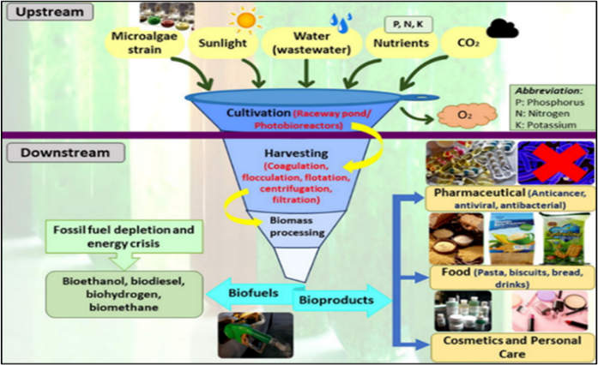
Figure 2.2: The process of extracting microalgae-based biomolecules
Chlorella sp. is known as a unicell with a fast growth rate under optimal conditions, making it a prime choice for commercial cultivation. It is able to grow at a good rate with controlled environmental conditions, allowing for efficient biomass production. As shown in Table 2-1, the optimal growth temperature for Chlorella sp. ranges from 25°C to 35°C, within a pH range of 6.0 to 8.5 [8]. In addition, Chlorella sp. shows a peak light absorption at 680 nm [50], which supports effective photosynthesis and is directly correlated with chlorophyll-a content in microalgae cells and is widely used as an indicator of biomass growth [50].
Table 2-2 describes the ability of Chlorella sp. in a comparative context with other unicell microalgae. The table provides an in-depth comparison of the robustness, applications, and lipid/protein content of various unicellular microalgae. Chlorella sp., known for producing 15–30% lipids and 50–60% proteins, is highly valued for its rapid growth, versatility, and pollution resistance. This makes it ideal for applications in nutraceuticals, biofuels, and wastewater treatment, effectively balancing nutrient and energy demands.
Spirulina sp., with its high protein content (60–70%) and resistance to alkaline conditions, holds significant potential for food supplements and aquaculture feed production. Haematococcus sp., although requiring stress conditions to form cysts, produces astaxanthin, a valuable component in cosmetics and nutraceuticals. Compared to Nannochloropsis sp., it stands out for its high lipid production (30–50%), making it suitable for biofuel and omega-3 fatty acid production, particularly in saline environments. Similarly, Scenedesmus sp. produces 20–40% lipids and 40–50% proteins, offering high biomass productivity and diversity, making it suitable for biofuels and environmental remediation. Lastly, Dunaliella sp. and Euglena gracilis sp. specialise in producing beta-carotene and beta-glucan, respectively, which are valuable for nutraceuticals, food colouring, and energy sources. However, Dunaliella sp. produces relatively lower lipid and protein levels.
Table 2-1: The comparison of water quality and ambient parameters for culturing Chlorella sp. and Botryococcus sp.
Parameter | Chlorella sp. | Botryococcus sp. | References
Water temperature (optimum) | 25 to 35°C | 20°C to 25°C | [8], [49], [66]
Electric Conductivity (EC) | 1.5–3.0 mS/cm | 0.5–1.5 mS/cm | [8], [66]
pH value (optimum) | 6.0 to 8.5 | 6.5 to 7.5 | [49]
Total sun irradiance (Lux) | 2000 | 5200 | [49], [67]
Light absorbance (Chlorophyll a) | 680 nm peak | 665 nm peak | [50], [68]

Microalgae | Robustness Factors | Applications | Lipid/Protein Content | References
Chlorella sp. | Fast growth, nutrient versatility, and contamination resistance | Nutraceuticals, biofuels, wastewater | 15–30% lipids, | [70], [176], [177]
Spirulina sp. | Alkalinity tolerance, rapid growth | Food supplements, aquaculture, and wastewater | 50–60% protein | [178]
Haematococcus sp. | Stress-resistant (cyst formation), produces astaxanthin | Cosmetics, aquaculture, nutraceuticals | 7–10% lipids, | [69]
Nannochloropsis sp. | Saline-tolerant, high lipid yield | Biofuels, omega-3 production | 60–70% protein | [178]
Scenedesmus sp. | Versatile growth, high biomass productivity | Biofuels, remediation, protein | ~35% lipids | [179]
Dunaliella salina sp. | Hypersaline conditions produce beta-carotene | Nutraceuticals, food colouring | 30–50% lipids | [179]
Euglena gracilis sp. | Dual metabolism (auto-/heterotrophic), beta-glucans | Supplements, bioenergy | 20–40% lipids, | [179]
a
Table 2-2: The ability of Chlorella sp. in a comparative context with other unicell microalgae
Malaysia's warm equatorial weather conditions support this good absorption rate throughout the year [55]. The species is capable of growing at a daily growth rate of 10%–20% of its original biomass under optimal conditions. Within 7–10 days, biomass production can reach up to 4–6 g/L in a closed photobioreactor culture system [69]. It has a high protein content of between 50–60% dry weight [70] makes it very useful for the production of food supplements and aquaculture feeds. Furthermore, its lipid content, which is around 15–30% dry weight, makes it very suitable for biofuel production.
Figure 2.3 shows Photosynthesis Active Radiation (PAR) ranges from 400 to 700 nm (Visible Light Spectrum) for algae cultivation [71]. The two wavelength ranges were specifically chosen because they represent the visible light spectrum used in the photosynthesis process of microalgae [72]. All the optical processes in microalgae are dependent on the wavelength of the incident light [72]. Microalgae absorb light primarily in the 400–500 nm (blue) and 600–700 nm (red) range, termed photosynthetically active radiation (PAR) [73].
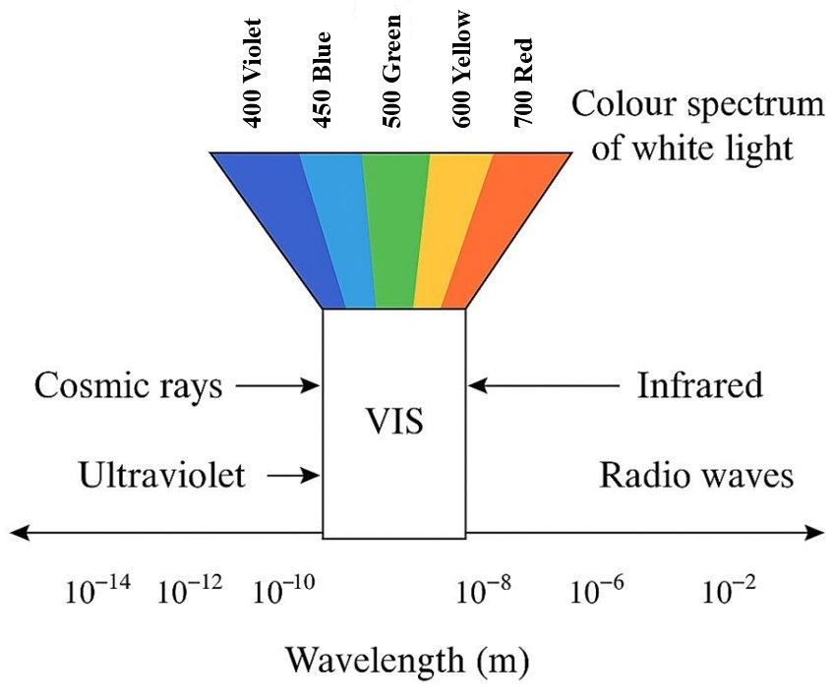
Figure 2.3: Photosynthesis Active Radiation (PAR) ranges from 400 to 700 nm (Visible Light Spectrum) for algae cultivation. Adaptation from [71]
As detailed by [71], the active area for photosynthesis or Photosynthetic Active Radiation (PAR) covers the range of 400 to 700 nm, with the absorption peak of chlorophyll-a usually around 680 nm, while carotenoid and xanthophyll pigments absorb blue light around 470 nm. Therefore, the use of these two wavelengths allows the simultaneous monitoring of the metabolic activity and growth rate of microalgae cells, especially Chlorella sp., more comprehensively and not biased to one type of pigment only.
The absorbance value obtained from each reading is interpreted as a biomass density level and has been widely used in various previous studies as a quantitative indicator of microalgal populations [74], [75], [76]. In the context of developing ML-based predictive models, these standardised OD values are used as outputs in supervised learning models, especially in the Artificial Neural Network (ANN) approach, which requires consistent and reliable input-output datasets [77], [78]. This allows the system to make inferences about future growth based on inputs such as ORP, EC, temperature and pH.

Microalgae growth curve
Microalgal growth is generally characterised by a growth kinetics curve. Based on Figure 2.4, Chlorella sp. growth is divided into four main phases: lag, exponential, stationary, and death [17], [79], [80]. Each phase reflects the changes in the microalgal population in response to different environmental conditions, depending on nutrients, lighting, temperature, pH, and culture medium conditions [81].
The initial stage of microalgae culture is the lag phase, in between day 0 to day 1, where microalgae are adapting to the new environment [82]. The metabolic activity exhibited by microalgae remains constrained, and the rate of cell division is low. The growth period of microalgae in this phase depends on the microalgae species, seed concentration, and medium conditions provided [82].
Microalgae will enter the exponential phase after successful adaptation. Growth occurs rapidly, in between day 2 to 3 [82], due optimal conditions, such as high nutrient availability, sufficient lighting, and suitable temperature, have been achieved. Population growth occurs logarithmically until environmental parameters begin to change significantly [17].
The stationary phase will occur after day 4 to 5, when microalgae reach the carrying maximum population of the culture medium [17], [82]. In this phase, the cell density become relatively constant [83], the cell division slows down due to the limitation of light and the rate of new cell growth is almost balanced and constant by the rate of cell death, resulting from nutrient depletion [17].
If culture conditions continue to deteriorate, the microalgae population will enter a death phase. This phase is characterised by a significant decrease in cell number due to nutrient depletion and an environment that is no longer conducive to growth [84].
Figure 2.4: Growth curve of microalgae with phases: (1) Lag phase, (2) Exponential phase, (3) Stationary phase, (4) Death phase [17], [79], [85]

Microalgae Culture Techniques and Culture Parameters Requirements
The main techniques in microalgae culture are divided into open culture (outdoor) and closed culture systems (indoor) [86]. Each of these techniques has its advantages and disadvantages to ensure that microalgae grow in a controlled and optimal environment.

Open culture technique
Open culture or the outdoor cultivation technology (open ponds and raceway systems) is a traditional technique widely used for large-scale microalgae production. Based on Table 2-3, these techniques are widely used due to their low cost and easy maintenance, making them the preferred choice for the biofuel and animal feed industries [4], [87]. These systems make full use of natural sunlight to promote the photosynthesis process of microalgae, thus reducing the dependence on artificial light sources [2]. Nonetheless, excessive and elevated light intensity may lead to an increase in the internal temperature of the cultivation system, consequently resulting in inhibited growth of microalgae [9]. Open culture using wastewater as a source of nutrients (organic and inorganic) is essential for microalgae growth. In addition, the utilisation of wastewater as a growth medium for microalgae development makes biofuel production more cost-effective [88].
Table 2-3: Comparison of microalgae cultivation techniques: challenges, and technological gaps (potential)
Category/Method | Challenges | Potential | References
Open technique (Outdoor cultivation) | Open-air ventilation, low maintenance and easy to maintain. However, it is at risk of exposure to pollution, impurities, contamination, risk of weather changes (rain, heat, cloudy) and limited parameter control, making it difficult to combine the latest technology | Lack of control over parameters such as pH, ORP and temperature, pollution requires additional mitigation measures. | [8], [89]
Open pond | Circuit-shaped Pond with mechanical control to ensure circulation of culture solution throughout the microalgae pond. Suitable for medium to large-scale cultivation. However, it is still at risk of exposure to pollution, weather changes and requires mechanical support to stir the microalgae during cultivation. | Less effective in monitoring real time parameters such as ORP and temperature | [7], [90]
Closed technique (Indoor cultivation) | Photobioreactor (PBR) systems either use transparent tubes or flat panels to maximise lighting. Controlled and more efficient control of environmental parameters, in addition to reducing the risk of pollution, contamination. However, installation and maintenance costs are high and require a large area for cultivation. | Real time automation control using IoT and ML needs to be improved, in addition to monitoring and improving cultivation parameter control through digital technology | [8], [91]

Figure 2.5 shows various types of open systems with various sizes and shapes [86]. Unstirred open ponds and circular ponds are included in the open pond category and are the simplest and most economical but also the least effective method [92], [93], [94]. They are only suitable for small-scale production [95]. Tanks allow for mixing of the culture by aeration or with agitators. Mixing is required to promote high algae growth rates while minimising the risk of overgrowth by other algae species [87]. While racing ponds with a height of 15-30 cm are constructed of concrete or compacted soil lined with plastic. Rotating agitators attached to circular ponds and paddle wheels for raceway ponds function to drive the water and mix the microalgae during the cultivation process [86], [87].
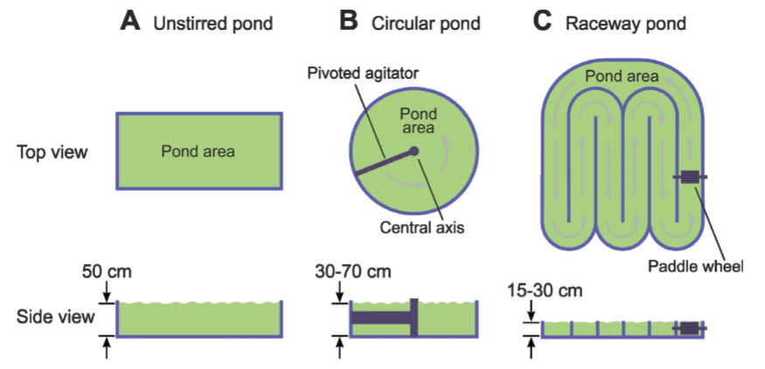
Figure 2.5: Types of open pond system: (a) Unstirred pond, (b) Circular pond, (c) Raceway pond [86]
However, open systems are prone to critical weaknesses. The most significant weakness is the potential for contamination [86] from chemicals, heavy metals, and other microorganisms [96], which can reduce the quality and productivity rates of microalgae [4], [87]. Furthermore, the growth of microalgae species must be free from any contamination, such as heavy metals and other microorganisms [87]. Open tanks exhibit a heightened vulnerability to bacterial and various environmental contaminants [87], [95], do not ensure a robust reproducibility of algal biochemical profiles and productivity metrics, and restrict extensive cultivation to a finite array of species [97]. In addition, potential environmental impacts [4] and various weather conditions, such as heavy rain, extreme temperatures, or cloudiness, have the potential to negatively impact microalgae growth rates and culture stability [98].
Control and monitoring of microalgae growth parameters, such as ORP, pH, and temperature, are also limited in this system [66], resulting in less efficient microalgae growth. This drawback makes it difficult to integrate IoT to improve the effectiveness of real time control [99]. Therefore, although this technique is cost-effective, it requires technological improvements to ensure yield stability and production sustainability [4].

Closed culture technique
Closed culture or indoor cultivation technique, also known as Photobioreactors (PBR), is widely used for multiple types of microalgae species in large-scale cultivation [87]. PBRs are specialised systems that foster the growth of microalgae (indoor cultivation) under controlled environmental conditions. They are closed systems where every parameter is closely related to the growth of microalgae, light intensity [2], [100], temperature [35]pH and nutrient availability are regulated. With a controlled indoor growth process, PBRs can reduce the risk of contamination from foreign microorganisms, dust, or weather changes, which are often challenging in open systems [17], [87].
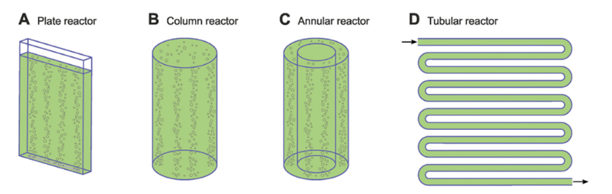
Figure 2.6: Diagram representation of various methods of photobioreactors [86]
Figure 2.6 shows various reactors for culturing microalgae using an indoor method. Plate reactor (A), known as a flat reactor [101], is commonly applied for laboratory cultivation. It is made up of a thin glass plate arranged horizontally for mass cultivation [101]. Column reactor (B) is the best cultivation for Chlorella sp. [101] stated that it is a simple system that compresses air to circulate and mix gas and nutrients. However, due to its vertical structure, it results in less light penetration, hindering the growth of microalgae [101] as light is the main parameter of obtaining the microalgae mass [2].
Tubular reactor (D) is a U-shaped design [62], an array of transparent tubes is driven by air pumps for aeration, mixing, and circulating nutrients of the microalgae [86]. The arrangement of the tubes depends on the area and mode of cultivation [101]. It is sometimes placed parallel to each other or flat above the ground, called serpentine or manifold [101]. However, due to the lowest volume-to-surface ratio (VSR), it was ranked the lowest in biomass productivity [95]. Yet still, the light penetration is primarily restricted to the surface of the reactor [2].
The significant weakness of the closed technique is the high cost [63] of energy utilisation for the controlling parameters during cultivation. To achieve a low cost of operation during concentration still remains a challenge [63], [95]. Besides the cost, the challenge of controlling the parameters of light intensity [2], [86], large-scale growth and dense population achieved [86]. A better control of other parameters such as pH, nutrients, and temperature, plus reducing the loss of CO₂ concentration [95].
Although microalgae industrial-scale production still faces challenges of scaling up and economic feasibility [40], advancements in technology, particularly the IoT [42] and ML [102], provide economically viable alternatives. The advancement of technology might be applied either to open or closed technique [103]. For instance, the incorporation of IoT facilitates the real time monitoring of parameters [104], whereas ML methodologies [46] can be employed to scrutinize datasets and generate forecasts that enhance the efficacy of parameter regulation. Moreover, PBRs have the potential to augment the efficiency of resource utilisation, including carbon dioxide, thereby rendering the technology more sustainable and conducive to extensive production. In contrast, open tanks exhibit heightened vulnerability to bacterial and other environmental contaminants [105] fail to ensure consistent reproducibility of algal biochemical profiles and productivity levels, and limit extensive cultivation to a restricted array of species.

Sensor
End node sensors or end devices for microalgae cultivation play an important role in collecting parameters and data in real time, which is then sent through the communication layer to be analysed and monitored in a digital system. Parameters such as ORP, pH, EC, and water temperature play a significant role in cultivating microalgae [35], [38], [39], [47].

Oxidation-reduction potential
Oxidation-Reduction Potential (ORP) is the oxidation-reduction potential of a solution expressed in millivolts (mV), representing how well this solution donates or accepts electrons [106]. The redox potential, one of the indicators of the culture conditions, is a parameter detected and controlled in microalgae culture, suitable for keeping an appropriate stable ORP value, as the oxygen concentration has a strong impact on maintaining the normal growth of microalgae, depending on temperature [66], [107]. This is essential for maintaining favourable conditions for microalgae growth as it closely associates with biochemical and metabolic activity within the culture. The ORP value, when excessively low or high, may signify adverse environmental conditions, such as an overabundance of oxidising or reducing agents, which can disrupt the metabolic equilibrium of microalgae and, in turn, influence their growth rates [66], [107].
The utilisation of ORP sensors in microalgae cultures enables researchers to promptly detect alterations in the cultural environment and implement corrective measures when warranted. Through the continuous assessment of ORP values, researchers can regulate the cultural conditions to optimal levels, thereby ensuring the health and productivity of microalgae. This is particularly critical in closed culture systems or reactors requiring stringent control to deliver consistent and high-quality outputs.
ORP values serve as a pivotal indicator of the health of microalgae cultures, and can provide insight into the oxygen dynamics within the system [108]. These values can be attributed to the photosynthetic process of Chlorella sp., producing oxygen as an outcome in culture production [108]. Determining the correlation of ORP with the absorbance of microalgae can be employed to analyse and forecast potential changes within the culture, thereby enhancing the efficacy and precision of microalgae production.

Electrical conductivity
Electrical Conductivity (EC) (measured in Siemens per meter (S/m) or micro-Siemens per centimeter (uS/cm)) is one of the indicator of applied in measuring C. vulgaris growth [mahdzir2026], [21], [109]. It specifically applies as an indicator of the amount of free flowing ions and/ or electrons of the culture medium [109] and act as a measure of dissolved ions such as nitrate, phosphate, potassium and other minerals required for maximum microalgae growth [81]. Depending on the type of algae that is being cultured, an ideal culture medium for microalgae must contain inorganic elements such as Phosphorus (P), Nitrogen (N), and Iron (Fe) [110]. Since microalgae are highly dependent on these ions as the main nutrients, regular EC monitoring provides a direct measurement of the fertility level of the culture medium. The fertility level of the medium is normally measured in nutrient concentration rate [17] . Figure 2.7 visualize the correlation of cell concentration and nutrient concentration to represent the EC parameter during the cultivation.
In microalgae culturing, EC values will fluctuate over the growth cycle according to the microalgae's biological activity and conditions of the culture environment. In the early culture or lag phase, EC values will typically remain stable since microalgae are fresh in the culture environment [82]. After the transition to the exponential growth stage, there was a tremendous increase in metabolic activity and nutrient uptake, resulting in an enormous decrease in the EC value due to the utilisation of ions from the medium [17]. It is clear from this observation how the EC value can be used to measure the rate of nutrient consumption by the population of microalgae.
However, an excessive value of EC can induce osmotic stress in the microalgae and hence retard growth and decrease biomass productivity. On the other hand, an excessively low value of EC implies that there is poor nutrient medium and therefore limits the rate of microalgal growth [82]. Therefore, it is crucial to keep the EC value in the range favourable for optimal growth, generally between 0.5 and 3.0 mS/cm, to ensure Chlorella sp. growth stability [90].
Apart from that, the culture method also has an impact on the tendency of the EC value. For example, cultivating microalgae in a sealed photobioreactor produces a more stable EC value compared to an open system, such as an open pond (raceway pond). Open systems are exposed to external conditions such as rainwater dilution and water evaporation, which cause greater variations in EC [84]. Therefore, the selection of a culture system must be performed with serious thought of the possibility of controlling factors such as EC to achieve consistent and productive microalgae growth.
The use of EC sensors in IoT-based monitoring systems has helped to make the monitoring process of microalgae culture more efficient with real time data analysis. Use of EC with other factors such as temperature, pH, and ORP also provides more comprehensive information on microalgae growth conditions, hence making the overall process of culture optimisation and control easier [54].
Figure 2.7: Cell concentration vs nutrient concentration [17]

The potential of hydrogen
The concentration of potential of hydrogen (pH) may also affect the growth of microalgae and the biomass content. The productivity of the biomass in microalgae has a negative correlation with the pH value, as a decrease in pH will increase the biomass productivity [111]. The level of acidity or alkalinity in the microalgae culture medium does not respond to the metabolic activity of the microalgae, nutrient uptake, or the rate of photosynthesis of the microalgae. Imbalance and incompatibility of the pH value in the culture medium can cause physiological stress on the cells, thus affecting the growth and productivity of biomass [92].
In most studies, the optimal pH value for microalgae growth is in the range of 7.0 to 8.5 [35], [65], [112]depending on the type of microalgae, medium and culture system used. Changes in pH value during the culture period usually occur naturally. For example, photosynthetic activity using carbon dioxide (CO₂) can increase the pH of the medium [111], while cellular respiration and the release of organic metabolites tend to decrease it [113]. Therefore, dynamic monitoring of pH values is essential to ensure that the physiological needs of microalgae are met at each growth phase.
There is a synergistic relationship between pH and other parameters, such as EC. Changes in pH can affect the solubility of ions such as phosphate, nitrate, and potassium in the medium, which in turn affects EC readings and nutrient availability for growth [81]. Even if the EC is within the optimal range, deviating pH values can reduce photosynthetic efficiency and cause nutrient imbalances in the system. Therefore, pH needs to be precisely controlled to maintain ionic stability and the normal metabolic function of microalgae.
In modern culture system management, integrating pH sensors into IoT-based and ML-based systems allows for real time monitoring and more efficient automatic control responses. A study by [114] showed that controlling environmental parameters such as pH contributed to the success of microalgae growth simulation models in photobioreactor systems. This data-driven approach supports the development of more responsive, sustainable and scalable microalgae cultivation systems.

Water temperature
Microalgae culture temperature is a parameter that also affects the growth rate and productivity of microalgae [81] where most microalgae have varying optimum ranges of temperature for breeding [48]. The growth rate to reach the maximum increase in biomass occurred during algae cultivation at 29–32 ⁰C [35]. Light and temperature are closely related in influencing microalgae productivity, especially for unsupervised outdoor cultivation [66], [68]. This makes effective temperature control play an essential role in ensuring the stability of the microalgae culture process at the laboratory or industrial level [81]. Higher temperatures increase cell enzymatic activity and promote growth. However, an increase in temperature that reaches a critical level results in effects on cell metabolism [66]. This is due to some proteins involved in the photosynthesis and electron transport processes beginning to denature, causing cell death.
In C. Vulgaris cultivation, significant temperature changes can cause significant changes in cell metabolic rate, photosynthetic activity, and nutrient utilisation in the culture medium [68]. In contrast to parameters such as EC and pH that can be controlled by adding or replacing medium, temperature is highly dependent on the system environment, especially in open systems such as raceway ponds exposed to external factors such as sunlight and air circulation. Studies have shown that the optimal temperature for the growth of Chlorella sp. is around 25°C to 30°C [35], [68], and any deviation from this range can cause a decrease in growth rate or even cause cell death of microalgae [115].
Temperature can also be linked to the trend of pH and EC changes in the culture medium. For example, high temperature increases the rate of photosynthesis, which can increase the pH of the medium due to the reduction of CO₂. At the same time, temperature also affects salt solubility and ion diffusion rates, which can indirectly affect EC readings [116]. To support consistent temperature control in modern culture systems, digital temperature sensors such as the DS18B20 in IoT-based monitoring systems have become the main choice. It is a digital thermometer capable to measuring temperatures within the range of -55 ºC to +125 °C with a deviation limit of 0.5°C when operating between -10 °C to +85 °C [23]. The integration of temperature data together with EC and pH allows for more intelligent and automated process simulation and control, increasing competitiveness in large-scale microalgae biomass production [114].

Long-Range Wide-Area Network Communication Technology
LoRa (Long Range) and LoRaWAN (Long Range Wide Area Network) are the latest communication technologies designed for the purpose of transmitting data over long distances while maintaining minimal energy expenditure. Minimal energy consumption makes this technology very suitable for applications related to the IoT. LoRa serves as a modulation protocol, while LoRaWAN forms a network protocol that facilitates interaction between LoRa devices in a wide and long-range network. This technology allows users to transmit data over long distances, reaching several kilometres, depending on environmental factors, while significantly resisting signal interference.

LoRaWAN classes
Under the industrial, scientific and medical band (ISM), LoRaWAN operates in unlicensed radio spectrum. Portion of the radio spectrum LoRaWAN is divided according to a specific region or area. Based on Figure 2.8, each LoRaWan operating frequency has been classified according to a particular region. For example, the ISM LoRaWan band for the region in Australia is 915MHz (AU915-928) with a frequency range of 915 to 928MHz. While in Malaysia, it is 920MHz (AS923-1/AS923-2) with a frequency range of 920 to 923MHz.
Under the permitted regional band, LoRaWAN end nodes are divided into 3 classes: Class A, Class B, and Class C. Each class of LoRaWAN end nodes uses a different MAC protocol depending on the manufacturer. However, most end devices use the Aloha MAC protocol because it is more energy efficient than the Carrier Sense Multiple Access (CSMA) MAC protocol [117]. The low energy consumption is due to the ability of the end devices to communicate and peer with many nearby gateways. However, CSMA still provides advantages in terms of network performance, energy consumption and throughput for larger and wider IoT network ranges [117].
All device classes support bi-directional communication (uplink and downlink). The Class A devices are two-way devices and can send uplink messages at any time, and consume less power [93]. However, this device has the highest downlink latency compared to the other two classes [93], [118]. To overcome the issue of latency, Class C provide the lowest downlink latency by receiving downlink messages at almost any time, but consumes excessive energy or power compared to other classes [93]. For Class B, it is similar to Class A, as they are also bi-directional devices with a scheduled time [93]. These times are synchronised with the gateway beacon [119] These devices provide extra reception windows at periodic intervals, in addition to the two default windows [118].

Figure 2.8: LoRaWan Classes [120], [121]

LoRaWAN communication network
LoRaWAN is the media access controller (MAC) layer protocol that uses LoRa as its physical (PHY) layer. By employing multiple LoRaWAN gateways, communicating through an Internet connection with a specific server, it is possible to build public and private wireless networks. The new concept of combining IoT and AR for microalgae culture is to use AR technology to display data being fed back from a network of IoT devices to create a more immersive and interactive experience for users. IoT technologies such as automation, sensors, lab-on-chip, and ML can be used to monitor and control the environmental conditions of the microalgae cultivation system, such as temperature, light, and nutrient levels, to optimise microalgae growth. By using IoT and ML, microalgae cultivation can be made more efficient and sustainable, which can help in the production of biofuels and other products from microalgae.
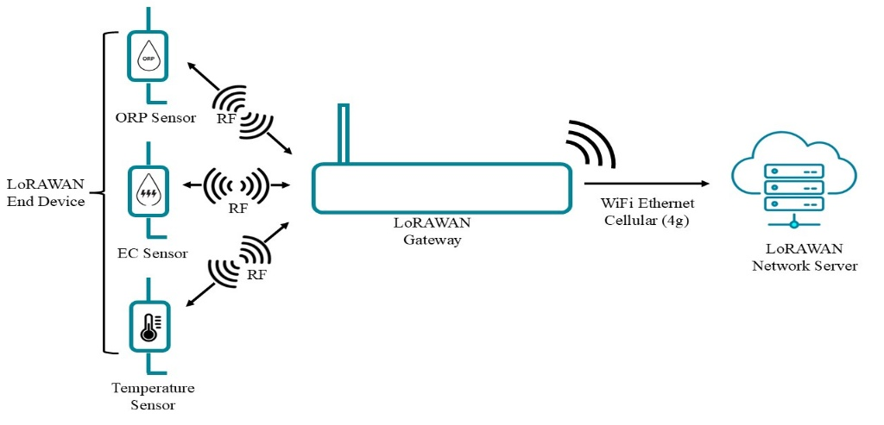
Figure 2.9: LoRaWAN connectivity from end device through gateway
In this research, the fundamentals of the LoRa physical layer model will be developed. Figure 2.9 show LoRaWAN connectivity from the end devices through the gateway. The end devices are a series of sensors related to the research, which are the ORP sensor, the EC sensor, the pH sensor and the temperature sensor. The data collected from the sensor is sent to the LoRaWan network server through the gateway. However, the transmission efficiency of LoRa wireless communication is subject to the wireless channel environment, which is classified as a large-scale fading channel. Path loss and shadowing by large objects are the main sources of signal degradation.
The Hata model is a popular model used to calculate path loss for microwave radio links up to 1500 MHz and 100 km [122] . It covers multiple environments, including Urban, Suburban, and Open areas. By employing multiple LoRaWAN gateways, communicating through an Internet connection with a specific server, it is possible to build public and private wireless networks [123]. LoRa uses forward error correction coding to improve resilience against interference. LoRa's high range is characterised by high wireless link budgets of around 155 dB to 170 dB. LoRa transmits as far as it does by sacrificing its data transmission rate. The higher the transmission rate, the closer the distance. If a project has high transmission rate requirements, the LoRa module is not a good choice.
To guarantee the end-to-end security and encryption purpose, a symmetric encryption scheme by Advanced Encryption Standard (AES) 128-bit has been implemented in LoraWAN [119], [123], [124]. AES 128-bit security provides integrity, authenticity, confidentiality, and bi-directional communication in the network, such that only authenticated end-devices can communicate [125]. AES-128 supports two activation methods: activation by personalisation (ABP) and over-the-air activation (OTAA) [126]. ABP is a straightforward method where device parameters, such as DevEUI, AppEUI, and AppKey, are pre-configured in the end node, AS, NS, and JS for joining and sending messages. This could be insecure since the session keys are always the same. On the other hand, OTAA is a more robust and secure activation method. The end devices in OTAA mode start a join procedure with DeviceEUI, Join EUI, NwkKey, and AppKey. With these parameters, dynamic session keys are generated and exchanged every session [90].
Base on Figure 2.10, the network server generates a 128-bit hexadecimal number, Application key (AppKey), which is used for LoRaWAN communication. The other two keys, the Network (NwkSKey) - shared between the application server and the network server and the Application Session Key (AppSKey) - shared between the network server and the end-device via the gateway are generated by the AppKey [124], [125]. The application key is only known by the end device and the application server, and is unique for each end device [124].
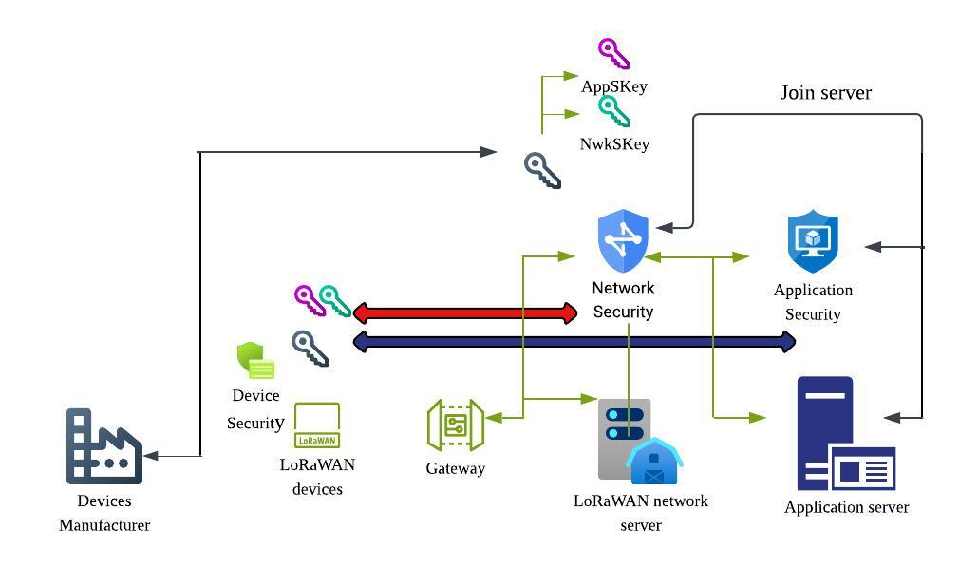
Figure 2.10: LoRaWAN encryption standard architecture [124]

Machine learning in microlagae cultivation
The implementation of ML within the domain of microalgae cultivation is progressively becoming more prevalent, in line with the advancements in IoT systems and the need for real-time data processing. Within the framework of microalgae species such as Chlorella sp., growth-related data is acquired through various parameters, including ORP, EC, pH levels, and water temperature, which collectively form a time series and require the implementation of ML modelling methodologies to classify and monitor the growth [5], forecast growth trajectories and detect anomalies within the culture system [21] . This is critically significant for the maintenance of cultural stability and the mitigation of risks associated with failure during the harvesting and propagation procedures.

Edge AI computing
Edge computing approaches are gaining attention in IoT-based systems due to their ability to process data close to its source, being energy efficient, and responding in real time [127], [128] Unlike cloud-centric models, they face issues of high latency, excessive bandwidth usage, and security risks [127].
The availability of various high-performance hardware and AI accelerators, such as GPUs, TPUs, and VPUs, supports this technological development. Table 2-4 describes the processing units for edge computing devices, highlighting their strengths, limitations, and application suitability [127]. Based on the table, GPUs offer AI inference capabilities directly at the edge, making them suitable for industrial automation and monitoring systems [128]. Training and testing data for ML can be directly fed into the GPU core. This is due to the capability of GPU can process a large amout of data [129]. However, they operate with high power consumption, making them less energy efficient [130], [131] . MPUs such as Raspberry Pi provide options for time series ML applications. However, due to speed and memory constraints, they can support light ML algorithms and are suitable as gateways [132]. Google Coral Dev Board provides fast inference via Edge TPU processor, but it is less flexible and only suitable to accelerate ML workload, especially in tensor operations for Neural Network ML [133].
Using an LSTM-AE and an IForest in edge devices allows pattern analysis and anomaly detection to be performed without having to send data to the cloud. This is very relevant to this study, which focuses on developing an ML model based on an ORP, EC, pH and water temperature sensor for a real-time microalgae cultivation system. With the integration of TinyML or light ML and model minimisation techniques, the LSTM model can be adapted to the limited resources of edge devices such as ESP32 or Raspberry Pi [132].
Table 2-4: Processing units for edge computing devices and application suitability.
Processing Unit | Devices/Cores | Application | Details | Ref.
Graphic Processing Unit (GPU) | NVIDIA Jetson Nano | Real-time Computer Vision (CV), multitask AI at the edge | Excellent throughout ML task, flexible, real-time inference. High power consumption, less energy efficient | [130], [134]
Central Processing Unit (CPU) | Arm-Cortex M55, Intel Series | Wide application for ML | The performance and efficiency may not as good as GPU | [134]]
Microprocessor Unit (MPU) | ARM Cortex-A, Raspberry Pi | Gateways, edge servers | System On Chip (SOC).Higher throughput, supports Linux, flexible I/O. However, due to limitations in memory and speed, it only supports light ML algorithms. | [132], [135]
Microcontroller Unit (MCU) | NodeMCU v3, ESP-Wroom 32 | Simple sensing, basic edge decision | Low power, low cost, integrated peripherals. But there is a limitation on processing data due to a memory < 1MB | [135]
Tensor Processing Unit (TPU) | Google Coral Dev Board | On-device ML inference | High performance per watt, efficient to accelerate ML workload, especially in tensor operations for Neural Network ML. However, it is inflexible, not suitable for general-purpose computing | [133], [136]
Vision Processing Unit (VPU) | Intel Movidius NCS2, Myriad X | Image/video processing in embedded IoT | Optimised for an AI accelerator to accelerate machine vision tasks, energy-efficient. But it is limited to CV and lack hardware product supported | [131]

Training-testing split ratio
In ML models, the data is divided into two distinct subsets, namely a dataset for training the model and a dataset for testing the model. This term is referred to as the "training-testing split ratio" [137]. This split represents an important phase in the formulation of machine learning models, as it facilitates the quantitative evaluation of model performance. Proper splitting can avoid potential issues such as under- or overfitting of ML samples, overfitting or underfitting, data leakage and ultimately lack of repeatability [137]. A typical ratio is 70:30, 80:20 or 90:10, depending on the size of the dataset, the analysis of the ML model to be performed [137], quality and the generalizability of the models [138].
The study by [139] used an 80:20 ratio in its analysis using the CNN-GRU ML model. The study of deep learning-based image classification models conducted by [140] also used the same ratio with a fraction of 840 images representing 80% of the data being used as training data while a total of 210 images representing 20% of the data being used as testing data.
The ratio of 75% testing and 35% testing was used in the study of pore water pressure and the performance of the developed ML LSTM model showing stable model performance [141]. The same ratio was also used in a study on modeling carbohydrate-enriched Cyanobacteria biomass production in wastewater treatment systems using only 108 study samples [142].
There is also a study conducted using a 70:30 dataset subset ratio. A study by [143] using an LSTM-based soft sensor for predicting the growth of microalgae, separated the data into training and testing sets before undergoing additional preprocessing steps. The training set comprises 70% of the data, while the remaining 30% is allocated for evaluation. Next, the study on short-term forecasting on climate events of non-stationary time series using K-Nearest Neighbors (KNN) and Random Forest (RF) ML model uses, 70% of the data for building and training both models. The remaining 30% of the data were reserved for assessing the performance of the model’s parameters[144].
In contrast to the study conducted by [135], where the data at the pre-processing stage was randomly divided with a distribution of 60% for training, 20% for validation and 20% for testing. There is also a distribution of data ratios made in batch or group distribution. [138] used the method of splitting the preprocessed data into training (20 days, one batch) and testing (30 days, four batches) datasets for the study. The goal of this research is to verify the possibility of prediction growth based on a small amount of data in the past [138].
The choice of the test-training split ratio is not only supported by standard practice in the field of ML, but has also been experimentally proven to be effective in balancing the prediction accuracy and generalization ability of the model. In the context of microalgae proliferation, this strategy is important to allow the model to learn complex growth patterns while maintaining performance on new data in a real-time monitoring system.

Previous research in applying machine learning for predicting microalgae growth
Current studies show a growing trend in the implementation of ML or DL algorithms for applications in monitoring and management of microalgae systems in laboratory or industrial scale environments. Based on Table 2-5 , various approaches have been applied, including productivity prediction techniques [26], classification [145],[146],[147] identification [148] , and anomaly detection based on real time sensor data[soon,][jamiaan], [22].
Among the early approaches highlighted is the use of Convolutional Neural Network (CNN) for microalgae productivity prediction using image-based modelling [26], lipid accumulation and growth modelling [28] and predicting microalgae concentration [27]. A study by [26] showed the implementation of a CNN model which can classify Ch. Vulgaris with an accuracy of up to 99% using digital images [26]Although effective in classification, this approach does not directly address the physico-chemical parameters that change dynamically in closed systems such as photobioreactors. This indicates that image-based methods are more suitable for visual monitoring, but are not efficient enough for real time sensor-based anomaly detection.
More relevant to the framework of this study is the use of an LSTM Autoencoder developed to detect anomalies in water monitoring systems. The study by [22] developed time series models were used to forecast anomaly detection in nitrate, ammonia, and pH levels. This model showed an F1-score exceeding 97% and successfully identified abnormal changes without needing labelled data. Research by [29] implemented LSTM for time series modelling, where the data was used to forecast microalgae biomass yield. In addition, the IForest model operates well in high-dimensional data. It has been used in the context of outlier detection in water treatment systems and industrial flows in real time with low latency.
Nevertheless, in contrast to the methodology presented in [29], which was exclusively formulated for predictive modelling under controlled environments utilising biomass output as the benchmark, the present study implements an LSTM-AE in an unsupervised ML model configuration aimed at real-time anomaly identification based on unprocessed sensor data within an operational microalgae cultivation environment. This research further employs the model at the edge computing level, facilitating low-latency detection independent of cloud-based infrastructure, which was not addressed in [29]. Furthermore, while [29] concentrated exclusively on the temporal forecasting of biomass yield, the current research integrates multi-parameter anomaly detection with real time inference as an integral component as part of a pragmatic IoT-driven monitoring and decision-support framework.
A Recurrent Neural Network (RNN) were applied in predicting lipid accumulation in microalgae cultures and successfully implemented the model at the edge using embedded processors [28]. This provides that LSTMs are suitable in terms of prediction accuracy, and suitable for implementing on small edge devices such as Raspberry Pi or Jetson Nano.
Based on these findings, the selection of LSTM-AE and IForest in this study is in line with the need to develop Edge AI devices that are capable of processing ORP data in real time, identifying normal growth patterns, and detecting anomalies before system failure occurs.
ML/DL Type | Application | Species | Method | Findings | Refs.
SVM,Decision Tree (DT), RF, Neural Network (NN) | Overview and summarizes the state of machine learning  algorithms used in microalgae treatment | Not specific | Discusses the use of various machine learning algorithms for classification, identification, and growth monitoring of microalgae | Successful in classification and regression tasks.  DT is simple and rule-based but highly sensitive to missing values, prone to overfitting and needs a pruning technique.  NN require a large dataset. A diverse dataset is needed to comply with complex relationship analysis | [5]
CNN | Microalgae productivity prediction in ORP | Various | Profile image-based model using sensor data (real time image) | High accuracy, no physical contact, scalable, but requires large training data, lacks biochemical context | [26]
LSTM-AE, Local Outlier Fraction (LOF), Isolation Forest, One Class SVM | Anomaly detection in nitrate, ammonia, and pH levels in wastewater plants for predictive maintenance | Not specific | Evaluation of 4 ML models for wastewater data | LSTM-AE is the best for anomaly detection with high accuracy (F1 > 97%). But the application is limited to microalgae applications in wastewater plants | [22]
SVM, Genetic Algorithm (GA), DT, RF, ANN | Application of various ML in microalgae bioprocess | Not specific | Review the use of various machine learning algorithms for classification, upstream and downstream processes. | ML offers transformative potential for the microalgae industry, enabling significant improvements in efficiency, yield, and process control across both upstream and downstream operations | [180]
RVFL, PINN, LSTM, XGBoost, ARIMA, Prophet | Time series models were used to forecast microalgae biomass yield using concentration data. | Scenedesmus sp. | Train six different model and validated it using Q-Q plots, histograms and Ljung-Box Test to confirm data distribution and model reliability | RVFL model demonstrated superior performance with minimal prediction errors and normal distribution of residuals | [29]
SVM | Polarised light scattering data analysis | Marine microalgae | Not specific | Non-linear SVM showed the best performance for classifying microalgae | [146]

Table 2-5: Various types of ML/DL types for microalgae application

ANN, k-NN, SVR | Predict dry cell weight (DCW) with high precision | Not specific | Optimal hyperparameters for ANN included activation function and hidden layer sizes | ANN outperformed other models with an R² of 0.9897, indicating strong capability to model complex relationships with minimal error | [30]
ANN, FlowCAM | Utilises FlowCAM to capture images and features of microalgae for analysis | Scenedesmus sp. Almeriensis sp., Chlorella vulgaris sp. | The models are trained with pure samples and validated with mixed combinations | Indicate the effectiveness of image analysis and deep learning for microalgae identification. The feature-based model demonstrated higher accuracy compared to the image-based model. | [147]
Decision Trees | Explores ML algorithms for optimising microalgae biomass production in wastewater | Tetradesmus arenicola sp., Chlorella Sorkiniana sp. | Parameters influencing growth include the initial inoculum level and the nitrogen /phosphorus ratio. | A decision tree model identified 18 combinations of variables leading to increased biomass production with 81.25% accuracy | [148]
ANN | Aims to enhance prediction accuracy in biogas systems with input variables of biomass type, pH, and temperature | Various | ANN were employed for biogas production prediction | ANN model achieved high R² values of 0.9929 in the biogas system. But need more varied data to enhance ANN performance. | [31]
SVM, PCA | A confocal hyperspectral microscopic imager (CHMI) is proposed. CHMI measures transmission and fluorescent spectra of microalgae | Not specific | Employs transmission and fluorescence hyperspectral imaging modes.  PCA is used for data preprocessing.  Classification is performed using SVM and deep learning methods. | CHMI achieved 96.25% accuracy using PCA-SVM for microalgae classification. Deep learning improved classification accuracy to 98.34% for microalgae species. | [145]
CNN | Using CNN combined with reconstructed fluorescence spectroscopy for predicting brown tide microalgae concentrations | Aureococcus Anophagefferens sp., Chlorella sp., Synechococcus Elongatus sp. | Enhance the reconstructed data, allowing for better utilisation of the spatial characteristics of the 3D-EEM spectra, which improves the performance of predicting microalgae concentrations using CNN. | Improvement in predicting microalgae concentrations using reconstructed 3D-EEM spectra data, with the mean squared error (MSE) for the brown tide causal algae Aureococcus anophagefferens reduced by 85.76%. 96.52% for Chlorella and 63.76% for Synechococcus elongatus. | [27]

Comparison analysis of LSTM-AE and IForest ML methods of microagae cultivation with the current study
Several previous studies have shown the efficacy of the LSTM ML model and other variations. Table 2-6, showed the efficiency of the models, for example the LSTM integrates with XGBoost [149], in forecasting of time series data patterns and the identification of anomalies, particularly within diverse specific domains or environments. A comparative analysis of effectiveness has also been conducted alongside other ML models, including AutoRegressive Integrated Moving Average (ARIMA), Fast Minimum Covariance Determinant (FMCD), Local Outlier Factor (LOF), One-Class Support Vector Machine (OCSVM), and Principal Component Analysis (PCA) [25].
The hybrid machine learning approach utilising XGBoost and LSTM has been employed to accurately forecast algal cell density and microcystin concentrations [149]; however, its applicability is confined to a singular water reservoir system, lacking cross-validation across other ecosystems. The research articulated by [29] is centred on predicting parameters such as Optical Density (OD), Dried Cell Waste (DCW), light intensity, pH, and temperature. Within the context of anomaly detection, the findings presented in [25] indicated that IForest exhibited good performance on multivariate datasets derived from wastewater treatment facilities, yet it has not been evaluated in the context of biological cultures such as microalgae, specifically devoid of biological parameters [25]. Additionally, [20] demonstrated that IForest can successfully identify early anomalies in Ch. Vulgaris cultures utilising non-invasive hyperspectral imagery, but requires labelled reference samples with high computational costs [20].
In a study conducted by [21], an integration of IoT with LSTM-AE was implemented to detect real time anomalies within microalgae cultures, revealing a robust correlation between ORP and growth; however, the application of edge devices was not incorporated into this research. Concerning biomass prediction, [29] explored a variety of models, including LSTM, but did not incorporate IoT technologies within the scope of the investigation. An approach addressing collective anomalies in IoT data utilizing IForest and K-Means yielded a detection rate of 78%, although this study was executed and validated on mechanical systems rather than biological data [150].
LSTM-AE represents a potent methodology for anomaly detection within time series data and nonlinear patterns by [151], [152], [153], [154], while hybrid models such as CNN-LSTM or AutoML frameworks possess the potential to enhance predictive performance [153]. Nevertheless, the time series data referenced in these studies pertain to generic categories such as financial metrics, meteorological data, and energy consumption statistics. An exploratory investigation involving the direct application of time series data to microalgae, which incorporated LSTM-AE with an efficiency rate reaching 97% alongside the IForest ML model, was executed by the researcher [22]. However, this particular study concentrated on parameters such as Nitrate, Ammonia, and pH levels within wastewater treatment facilities.
In contrast, the present study advances an IoT-oriented indoor monitoring system for Chlorella sp. cultures that employs LoRaWAN connectivity, integrating water quality sensors (ORP, Electrical Conductivity (EC), pH, and temperature) into the end nodes, while processing the data through a two ML models approach comprising LSTM-AE and IForest on the edge device. This methodology not only facilitates the automatic detection of anomalies in time-series data without dependence on simplistic thresholds, but also functions as an AI-based "watchdog" system capable of operating in real time at physical locations. This innovative approach addresses the deficiencies present in prior studies by incorporating critical parameters (ORP, EC, pH and water temperature), deploying a hybrid ML model which is the combination of LSTM-AE + IForest not previously tested on microalgae, and integrating this model within an IoT-edge architecture.

Table 2-6: Comparison analysis of LSTM-AE and IForest ML methods of microalgae cultivation with the current study
Previous study | ML methods | Variables and parameters | Findings /gap
[149] | Forecast algal density & microcystin in reservoirs using time-series ML (Hybrid XGBoost + LSTM) | Algal cell density, microcystin, Chl-a, and environmental data | High accuracy, good time-series capture, and effective real time and early warning
[25] | Evaluate anomaly detection methods for wastewater ML framework (IForest, Fast Minimum Covariance Determinant (FMCD), Local Outlier Factor (LOF), One Class Support Vector Machine (OCSVM), Principal Component Analysis (PCA) | pH, Chemical Oxygen Demand (COD), Biochemical Oxygen Demand (BOD), NH₃, Phosphorus (TP) | IForest has good performance in a multivariate setting; FMCD most robust overall
[20] | Detect anomalies in Chlorella vulgaris cultivation using spectral analysis (IForest (semi-supervised)) | Hyperspectral imaging, Optical Density (OD), biomass | Early anomaly detection is possible, non-invasive sensing via hyperspectral
[21] | Anomaly detection in outdoor Botryococcus microalgae culture using IoT+ML (LSTM-AE) | ORP, EC, pH, temperature, Absorbance | AUC-ROC = 1.000; ORP strongly correlates with growth; real time detection
[154] | Compare ARIMA vs LSTM for environmental forecasting (LSTM, ARIMA) | CO₂, temperature, humidity, sunlight | LSTM is better for capturing nonlinear patterns.
[29] | Forecast biomass yield in wastewater cultivation using time-series ML (Random vector functional link (RVFL), LSTM, ARIMA, XGBoost, Physics-informed neural networks (PINN), Prophet) | OD, Dried Cell Waste (DCW), light, pH, temperature | RVFL achieved best performance (MAPE=0.0006); LSTM also strong
[142] | Forecast carbohydrate-enriched cyanobacteria biomass in wastewater PBR (Artificial Neural Network (ANN), Convolutional Neural Network (CNN-1D), LSTM, k-Nearest Neighbours (k-NN), Random Forest (RF)) | Biomass population of cyanobacteria, algae, and protozoa | CNN-1D gave the best performance (MSE=0.0028)
[150] | Detect collective anomaly in IoT time series using a new approach (IForest, K-Means (variable window)) | Temperature, Absolute Difference | IForest detected 78% anomalies, more robust than K-means; supports window-based detection
[151] | Survey deep learning for anomaly detection in time series (LSTM-AE, Gated Recurrent Unit (GRU), CNN-LSTM, Transformer) | General sensor data | LSTM-AE & Transformer have the best accuracy in temporal anomaly detection

Table 2.6: Continued
[153] | Evaluate the performance of various advanced ML algorithms and AutoML in time series forecasting (LSTM, LSTM-AE, XGBoost, LightGBM, Prophet, H₂O AutoML) | General time series data (finance, weather, energy consumption) | LSTM achieved the best performance for non-linear relationships; LSTM-AE was effective in anomaly detection; AutoML simplified the selection of the best model without manual tuning
[22] | Anomaly detection (LSTM-AE, LOF, IForest, OCSVM) | Nitrate, Ammonia, and pH levels in wastewater plants | LSTM-AE is the best for anomaly detection with high accuracy (F1 > 97%).
Current study | Integration of LoRaWAN-enabled IoT water quality end-node sensors with two ML models - LSTM-AE and IForest for indoor Chlorella sp. cultivation | ORP, EC, pH, Water temperature | This study applies two independent ML approaches to detect anomalies in time-series data related to microalgae growth: LSTM-AE for pattern-based detection and IForest for distribution-based outlier detection.  Both models are deployed on an edge AI system, enabling physical AI onsite for real-time monitoring. These models act as intelligent watchdogs to identify anomaly patterns beyond simple threshold-based rule systems.

Multivariate Time Series Anomaly Detection (MTAD)
Existing MTAD techniques can be categorised into three main categories: forecasting-based, reconstruction-based, and dissimilarity-based methods. [155]
A time series is a series of data points indexed sequentially over time. The most common form of time series is a sequence of observations recorded over time [156]. Time series are often categorised as either univariate (one-dimensional) or multivariate (multi-dimensional). These two types are defined in the following subsections. Thereafter, decomposable components of the time series are outlined. Following that, we provide a taxonomy of anomaly types based on the components and characteristics of time series [157].
Research | Method/SS | LP | Analysis | Var | DS | Gap / Relevance
FORECASTING
[149] | XGBoost + LSTM | SU | Off | Multi | Reservoir algal bloom data | No anomaly detection; No real-time IoT/edge pipeline
[154] | ARIMA, LSTM | SU | Off | Uni | Climate time-series | Linear methods; not suitable for nonlinear multivariate biosensors.
[29] | RVFL, LSTM, XGBoost | SU | Off | Multi | Wastewater microalgae | No real-time IoT/edge pipeline; no anomaly detection.
[142] | CNN-1D | SU | Off | Multi | Cyanobacteria PBR | Biomass only; no anomaly detection.
[158] | LSTM + JITL | SU | RT | Multi | Fed-batch industrial data | Only soft sensor prediction; lacks anomaly detection.
[159] | LSTM + ODE (Hybrid) | SU | Off | Multi | HEK293 bioprocess | No real-time IoT/edge pipeline.
[143] | LSTM Soft Sensor, SVR | SU | Off | Multi | Indoor Nannochloropsis PBR | No anomaly detection; no ORP/EC chemical data; no IoT-edge integration.  No anomaly detection; No real-time IoT/edge pipeline;biomass prediction.
[160] | Temporal feature extraction (DWT + PE + ANOVA) + LSTM | SU | Off | Multi | Kyoto honeypot network dataset | Strong temporal feature extraction, but no anomaly detection, no IoT, no biosensor parameters; relevant to justify multivariate temporal modelling strategy.
[138] | RF, SVM, XGBoost, LSTM | SU | Off | Multi | Outdoor microalgae pond | No anomaly detection; No real-time IoT/edge pipeline; biomass prediction.
Table 2-7: Compact Summary of Time-Series ML Models for Forecasting and Anomaly Detection (F = Forecasting, R = Reconstruction, D = Dissimilarity/Outlier Detection

Table 2.7: Continued
RECONSTRUCTION
[161] | LSTM-AE | UN | Off | Uni | Artificial & DCASE audio datasets | Not multivariate; no IoT; no biological sensors
[21] | LSTM-AE | UN | Off | Multi | Botryococcus, Chlorella | Baseline algae anomaly detection, offline, no hybrid/edge AI.
[162] | CNN-LSTM Hybrid AE | UN | RT | Multi | Industrial IoT | Not microalgae context; no ORP/EC/pH; no hybrid adaptive threshold.
[163] | VAE + Association Discrepancy + POT threshold | UN | Off | Multi | NASA MSL, SMAP, SWaT, PSM, SMD | No IoT/edge deployment; no biological sensors; lacks real-time/adaptive IoT DT context
[164] | GAN-AE + Transformer AD model | UN | Off | Multi | Synthetic + industrial | High complexity; No real-time IoT/edge pipeline; synthetic parameters
[165] | USAD (adversarial reconstruction) | UN | Off | Multi | SWAT, WADI, SMD, etc. | No biological sensors; heavy compute for IoT edge
[166] | Federated Autoencoder + summary-statistics global threshold | UN | Off | Multi | Credit Card Fraud, Shuttle, Covertype (federated, non-IID) | Strong reference for global/adaptive thresholding on reconstruction error in federated settings, but no IoT-edge deployment and no biological sensors.
[167] | GAN-AD (LSTM-GAN with residual + discrimination loss) | UN | Off | Multi | SWaT  (51-sensor industrial CPS) | Strong multivariate GAN baseline combining reconstruction + dissimilarity; heavy compute, offline, no hybrid/edge AI., no biological sensing.
DISSIMILARITY / OUTLIER DETECTION
[25] | IForest, LOF, FMCD | UN | Off | Multi | Wastewater parameters | No hybrid integration with reconstruction models.
[20] | IForest | UN | Off | Multi | Chlorella | No IoT sensors; No real-time IoT/edge pipeline.
Table 2.7: Continued
[150] | IForest + K-Means (windowing) | UN | Off | Multi | Generic IoT TS | No microalgae; no reconstruction hybrid, limited sensing dimension.
[155] | Dilated Conv-AE + Forecasting + NPSS + POT | UN | Off | Multi | Industrial TS (MSL, SMAP, SMD, SWaT, WADI) | No real-time IoT/edge pipeline; no biological sensors; offline; strong hybrid baseline for anomaly scoring
[168] | Multi-standard adaptive threshold fusio | UN | Off | Multi | Public MTS datasets | No real-time IoT/edge pipeline, no real-time; not domain-specific
[169] | Multi-standard fusion for AD | UN | Off | Multi | Indsutrial MTS | No DL, no edge computing, no biological sensors
[170] | PCA + PLS regression for growth modelling (non ML) | SU | Off | Multi | Outdoor PBR (temperature, biomass, nutrients, light) | No time-series modelling; no anomaly detection; no IoT; no real-time capability; shows need for ML-based multivariate AD in microalgae cultivation
Reconstruction (LSTM+AE) + Adaptive threshold (Rolling Windows -Mean+K.Std)
Current study | LSTM-AE + Adaptive Threshold (Edge AI) | Hybrid (Un+  Semi) | RT  (IoT-Edge) | Multi | Indoor Chlorella PBR (ORP, EC, pH, Temp) | Fully novel: real-time IoT-edge multivariate anomaly detection; hybrid LSTM-AE with adaptive threshold; microalgae-specific.
Legend: SS = Software Sensor, Learn Paradigm (LP); SU= Supervised, UN= Unsupervised, Semi= Semi Supervised, Off = Offline, RT = Real-time, SRT = Semi-real-time, Uni = Univariate, Multi = Multivariate, Var= Variables, DS = Dataset/Source, Gap = Research Gap / Relevance

Summary
This chapter has thoroughly examined the theoretical foundations, technological advancements, and prior investigations associated with the cultivation of the microalga Chlorella sp., including biological determinants, requisite environmental parameters, and innovations in the application of the Internet of Things (IoT), Long Range Wide Area Network (LoRaWAN), machine learning (ML), and digital twin frameworks in real time monitoring systems. The extant literature underscores that ORP, EC, pH levels, and water temperature are critical determinants in assessing the vitality of the culture and the growth stages of microalgae. Previous research has also emphasised the significant correlation between these crucial parameters of proliferation and biomass productivity, along with their potential utility as inputs for ML modelling.
Furthermore, the analysis revealed that IoT and LoRaWAN technologies facilitate extensive monitoring with minimal operational expenditures, while the incorporation of LSTM-AE and IForest algorithn on edge computing devices enhances the system's proficiency in detecting anomalies and forecasting growth in real time. The deployment of these algorithms on edge devices permits local analyses to be conducted without a complete reliance on cloud infrastructures, thereby reducing latency and allowing immediate interventions in cultural conditions.
The identified research gap is the lack of a cohesive system capable of integrating multi-parameter sensing, LoRaWAN-based data transmission, Edge AI-driven intelligent analytics, and automated decision-making functionalities for the optimisation of microalgae cultivation. Consequently, this study possesses substantial potential to address this deficiency by developing a model and intelligent monitoring framework that not only identifies and anticipates the growth performance of Chlorella sp. in real time but also facilitates enhancements in parameter control to increase productivity and scalability in microalgal cultivation in the future.

METHODOLOGY

Introduction
The experimental approach was chosen to enable controlled testing of the effectiveness of the ML-based ORP monitoring system in the seeding and harvesting of Chlorella sp. This chapter will describe microalgae culture for data collection methods, experimental design, the use of technologies such as LoRaWAN and Node-RED, as well as the selection and implementation of machine learning models for Iot sensor parameter data analysis. The explanation in this chapter will also include the procedures carried out to ensure data accuracy, experimental control, and resource requirements involved in achieving the objectives of this study.

Research Framework of Microalgae Cultivation System
The framework is designed to develop an IoT sensor system, real time data collection, unsupervised machine learning modelling and an edge AI device for real time data implementation for the detection of anomalies in microalgae cultivation systems.
Figure 3.1 illustrates the process starting from the input of time series for four main parameters, namely ORP, EC, pH and water temperature, which are sent by sensors in the physical layer to the application layer. The data is extracted and analyzed through pre-processing processes of dataset cleaning, data normalization, and sliding windows generation before being divided into training and testing sets. Two ML models are used in this framework, namely LSTM-AE and Isolation Forest (IForest), both of which are trained to detect normal patterns and identify anomalies based on MSE scores and isolation depth.
The anomaly detection results are sent to the Node-RED dashboard for real-time notifications. The model is then validated using manual verification methods such as optical density (OD) and statistical evaluation (RMSE, R²) to ensure the accuracy and reliability of the system. This framework as a whole supports the development of intelligent monitoring systems based on edge AI for microalgae farming applications more accurately and efficiently.
Figure 3.2 shows the framework of microalgae cultivation, which aligns with the case, allowing researchers to acquire the sensor data of ORP, EC, pH and water temperature as parameters to acquire the ML model. The collected data will be trained and analysed to study their influence on reproductive performance, biomass growth and anomaly detection.
All the sensors are connected to an AtMega328P 10-bit microcontroller module paired with an LA66 LoRaWAN shield, transmitting a 915MHz signal which supports LoRaWAN v1.0.3 protocol with low power consumption to the outdoor LoRaWAN gateway DLOS8N. Subsequently, the LoRaWAN gateway forwards the sensor data to TTN. DLOS8N sent data from the end node to the network server layer, The Things Network (TTN). From TTN, the data is used and connected to the IoT application layer, namely Node-Red, via the MQTT V3.1.
The model development and training process is performed in a Python environment using TensorFlow (TF)- an opensource ML framework [129], Keras -High-Level Neural network API that runs on TensorFlow, and scikit-learn - featuring various classiﬁcation, clustering,and regression algorithm [129], with the help of libraries such as Pandas and NumPy for data analysis and Matplotlib for exploratory visualisation. The raw dataset is preprocessed and trained on a GPU and split into a composition of 75% trained and validation data, while another 25% to evaluate and test the data [171].

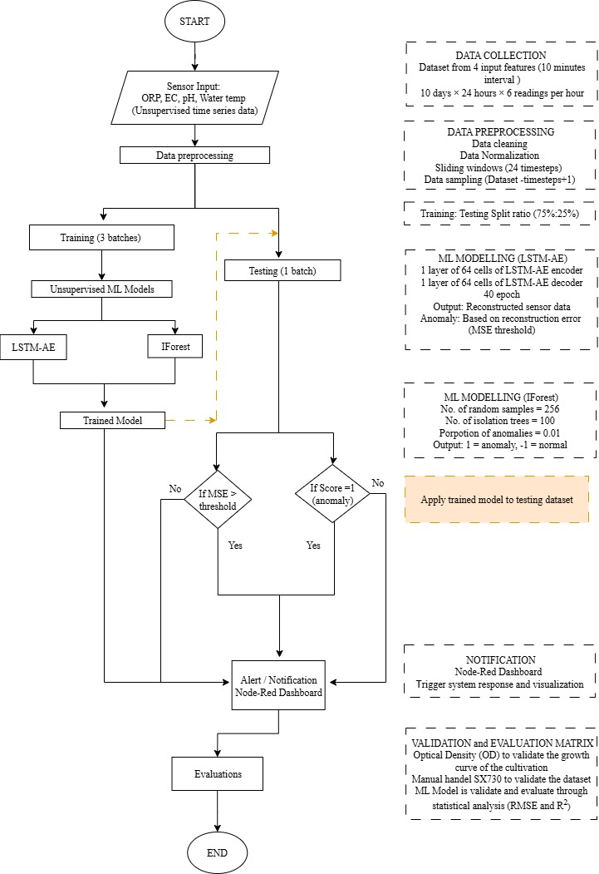
Figure 3.1: Flow chart of LSTM-AE and IForest ML for time-series analysis of microalgae cultivation
Two algorithms are used under the TF environment, namely, LSTM-AE to identify temporal patterns in time series data and IForest for anomaly detection based on outlier patterns. Next, the trained ML model is modified and quantised into a 64-bit TensorFlow Lite (.tflite) format and exported to a Raspberry Pi [135], [172] for inference purposes on edge computing, in line with the low-latency approach [172].The inference results will be stored and displayed directly through the Node-RED interface, which functions as an MQTT client and visual dashboard. This system allows for real time monitoring of culture conditions and early detection of abnormalities based on real time ORP values.
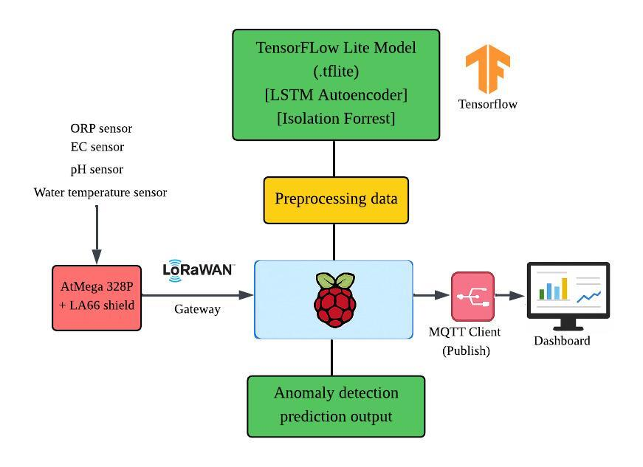
Figure 3.2: ML model framework using TensorFlow Keras

Development of microalgae water quality parameter acquisition using IoT sensor system
The creation of a water multiparameter data acquisition and monitoring system utilizing Internet of Things (IoT) technology for the cultivation of microalgae comprises three primary layers that collectively establish the overall IoT sensor system architecture. Referring to Figure 3.3, the architecture presented in this study is composed of the physical layer, the network server layer, and the application layer. Each of these layers serves a distinct purpose to ensure that the monitoring system operates in a cohesive, real time fashion, ultimately aiding in the advancement of a control model.
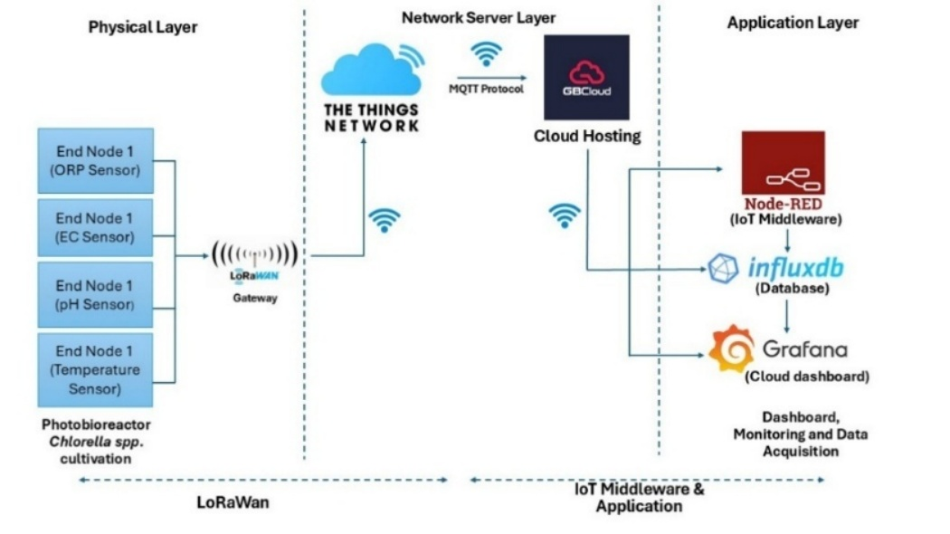
Figure 3.3: Architectural diagram of the IoT-LoraWAN multiparameter sensor data acquisition and monitoring system

Development of the physical layer
The Physical Layer serves as the foundational level, consisting of sensors and end-device connections installed within a closed photobioreactor (PBR) system designed for cultivating Chlorella sp. microalgae. Key monitored parameters include oxidation-reduction potential (ORP), electrical conductivity (EC), pH, and water temperature, as illustrated in Figure 3.3. These four sensors are connected to a 10-bit ATMega 328P microcontroller board, which is directly linked to the LA66 LoRaWAN shield module. The LA66 module is a Class A end node device, following the Aloha protocol, which has the advantages of optimising with low power consumption [117]. The module is compatible with the LoRaWAN protocol version 1.0.3, operates at a frequency of 915 MHz, and can transmit data over distances of up to 6 km, making it ideal for long-range transmission with minimal power usage.
Figure 3.4 shows the wiring connection of the LA66 LoraWAN Shield stacked on top of a 10-bit AtMega 328P Arduino Uno powered by a 5V d.c voltage. Figure Figure 3.4(a) shows the Node 1 configuration, where two sensors are connected to the Arduino Uno microcontroller board via the LA66 LoRaWAN shield and an additional ADC module. The first sensor is a SEN0464 ORP sensor connected to the analogue pin A1. The second sensor is a pH sensor connected to the digital pin D3. Data from these two sensors is sent to TTN via the LA66 module at a frequency of 915 MHz and is then published to the MQTT topics decoded_payload. orp and decoded_payload. pH as in Table 3-1 in the Node-RED platform.
Figure 3.4(b) showes Node 2, which consists of a SEN0451 K=1 EC Sensor and a DS18B20 temperature sensor. The EC sensor is also connected to pin A1. The DS18B20 temperature sensor uses pin D3, based on the 1-Wire protocol for digital data transmission. Each parameter is isolated in Node-RED via the MQTT topic: decoded_payload.ec for EC and decoded_payload.temperature for temperature
Figure 3.4 Wiring connection of the microalgae physical layer
Each sensor operates as an end node configured in series. The automatic detection of EC, ORP, pH, and water temperature data occurs in real time, and the data is relayed to the gateway through the LoRaWAN communication protocol every 10 minutes. The data collected from each sensor is transmitted wirelessly via the LoRaWAN protocol to an external gateway, specifically the DLOS8N (Dragino). This gateway serves as a bridge between the end device and the network server. Subsequently, the gateway forwards the data to The Things Network (TTN), which acts as the network server layer. From the TTN, the information is routed to the IoT application layer, particularly Node-RED, using the MQTT version 3.1.1 protocol.
Figure 3.5 shows the data communication network between the sensing system installed in the microalgae culture and the LoRaWAN network infrastructure. Four types of sensors are used: SEN0464 for ORP measurement, SEN0451 (with K=1 probe) for EC measurement, an analogue pH sensor, and DS18B20 for water temperature. These four sensors are directly connected to the 10-bit ATMega328P microcontroller board, which is the main control component in the monitoring system
.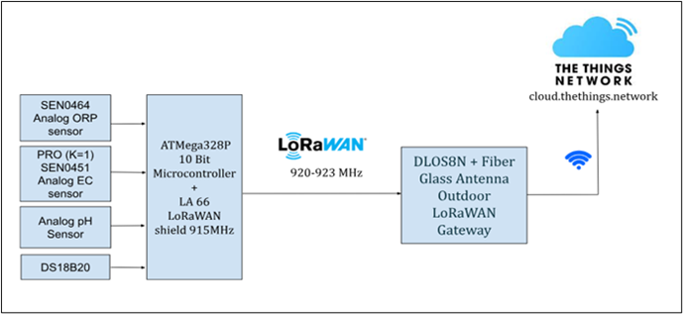
Figure 3.5: End node (sensors) connected to LoRaWan gateway via 915MHz shield
The LA66 LoRaWAN shield module is installed with the ATMega328P, operating at a frequency of 915 MHz, to enable wireless data transmission using the LoRaWAN protocol. Digital data from the sensors that have been processed by the microcontroller is transmitted at a frequency of 920–923 MHz [173]. Through a DLOS8N gateway (Dragino, China) equipped with a fibre optic antenna (915 MHz) to strengthen the signal strength and stability of the connection, the data is sent to the The Things Network (TTN) network server via an internet connection. TTN is an open cloud platform that manages the decoding, temporary storage, and routing of data to the network server layer.
Table 3-1: GPIO configuration and MQTT Topics (PubSub)
No. | Sensor | GPIO | Variable name | Node-Red Topic (PubSub)
1. | SEN0464 ORP Sensor | A1 | orp | msg.payload.uplink_message. decoded_payload. orp
2. | pH sensor | D3 | pH | msg.payload.uplink_message. decoded_payload. pH
3. | SEN0451 K=1 EC Sensor | A1 | ecvalue | msg.payload.uplink_message. decoded_payload. ec
4. | DS18B20 Temp. sensor | D3 | temperature | msg.payload.uplink_message. decoded_payload. temperature

Development of the Network Server Layer
The server layer of the network is the main intermediary that connects raw data from physical devices to the processing system in the cloud. In the case of the Chlorella sp. monitoring system, this layer receives data from the LoRaWAN gateway after transmission by the end node via low-frequency communication.
TTN supports various LoRaWAN frequency regions, including 868 MHz and 900 MHz, depending on the configuration and the location of the device during setup. Based on Figure 3.6, the DLOS8N gateway was set up in UTHM main campus, operating in the spectral frequency of 920-923MHz [4,5]. The gateway was registered under the Australia 1 – au1 cluster due to the nearest location compared to the other 2 clusters, thus it is recommended by TTN. Based on the Figure 3.7, the DLOS8N was registered under the name of MINT-SRC-UTHM with ID of microalgae-UTHM with a frequency of 920-233 MHz.
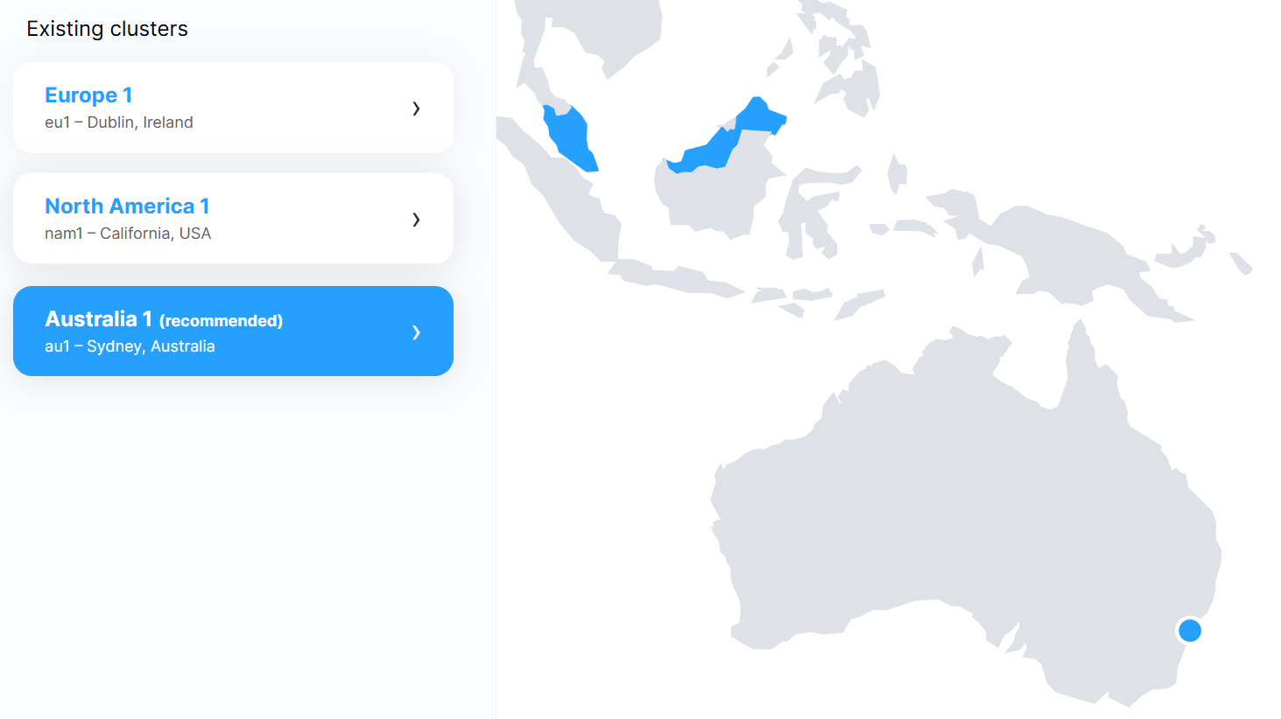
Figure 3.6: Frequency cluster for TTN [126]
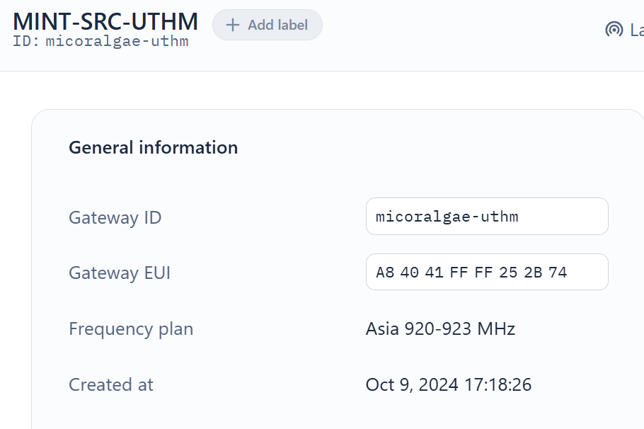
Figure 3.7: Microalgae-uthm LoRaWan setup
After the registration succeeded, the location of the DLOS8N gateway can be monitored and located on the TTN heatmap as Figure 3.8.
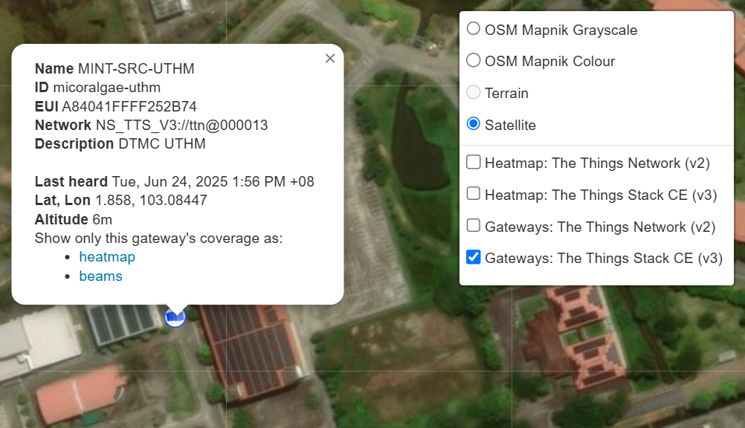
Figure 3.8: TTN LoRaWan gateway heatmap
Under the AES-128 encryption standard, the activation method used to activate the gateway and the end node is activation by personalisation (ABP). ABP is a straightforward method where device parameters, such as DevEUI, AppEUI, and AppKey, are pre-configured in the end node. The DLOS8N is activated by the Gateway EUI as shown in Figure 3.7, while and LA66 LoRaWAN shield was activated by using a unique combination of DevEUI, AppEUI and AppKey to authenticate devices allowed to use the network as shown in Figure 3.9.
The node-sensor la66orp and la66ecph were activated on TTN and were configured to transmit data via LoRaWAN to the TTN application named microalgaeimap. Custom payload formatters written in JSON format were implemented in the TTN Console, whereby the raw byte data was converted into meaningful parameters: ORP (mV), EC (mS/cm), temperature (⁰C) and pH. For instance, the ORP value was obtained by computing two bytes and dividing the result by 10 to produce the actual reading.
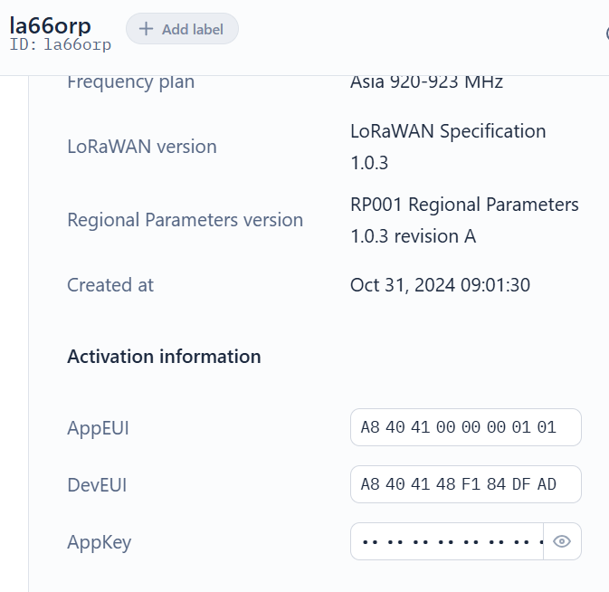
Figure 3.9: End node AppEUI, DevEUI and AppKey
After the activation, the device was activated as Figure 3.10 under microalgeimap application with the specific ID. Under this application, there are 2 end devices of LA66 shield has been registered which is la66orp and la66ecph.
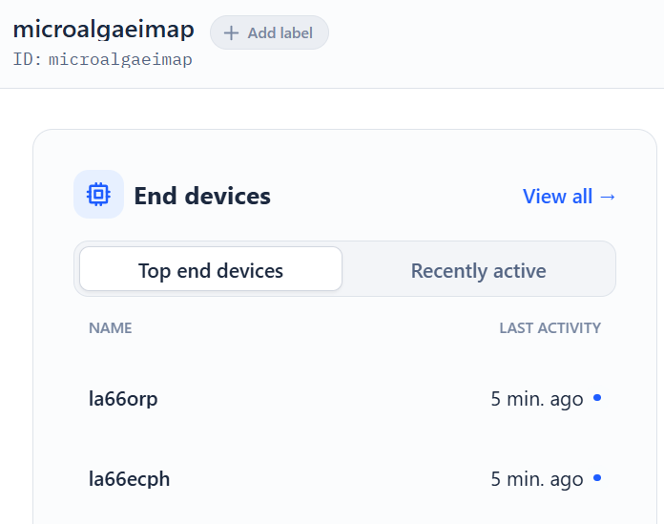
Figure 3.10: End devices under microalgaeimap application
Figure 3.11 shows the display of uplink data from the end node to the TTN server. The Forward uplink data message indicates that the data from the device was successfully sent through the LoRaWAN gateway and received by TTN with the device address DevAddr: 26 0D FE 72. This address is used to distinguish the end node (node 1 or node 2) in the LoRaWAN network during data transmission. The data (ec and temperature) received from the sensor is sent and encoded in the form of a JSON payload, which will then be decoded at the application level. Repeated transmissions at different times (16:59 and 17:09) prove that the system works with a 10-minute interval as specified, the time-series monitoring system is applied in this research.
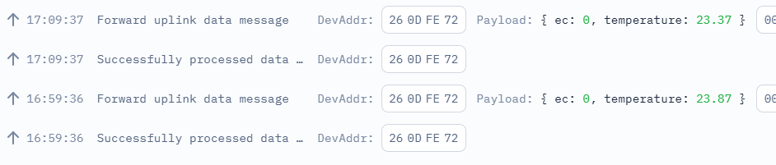
Figure 3.11: TTN dashboard Uplink data from gateway to Node-Red
After the data is successfully processed by TTN, this message will be sent to the MQTT broker and received in Node-RED according to the previously mapped topic. The detection of values ​​in the payload allows automatic data separation in the Node-RED flow, before being stored in InfluxDB and visualized in the Grafana dashboard. This process is the core of the connection between the physical layer and the application layer, which is the backbone of the LoRaWAN-based microalgae IoT system in this study.

Development of the Application Layer and Dashboard
The application layer in this microalgae monitoring system is designed to function as a data control centre, in which processing, visualisation, and storage management are carried out. Based on Figure 3.12, after the data are transmitted from sensors through the LoRaWAN communication protocol, they are processed by The Things Network (TTN) server and subsequently forwarded to the Node-RED application environment via the MQTT protocol. The data flow in Node-RED which was developed to process, store, and visualize IoT sensor data in real time. In Node-RED, all the data obtained from TTN is decoded into JSON format using the payload formatter and then visualised on the real time monitoring dashboard.
The formatted data are then automatically stored in InfluxDB, a time-series database designed to receive and manage data measured at fixed intervals. The use of InfluxDB ensures that all parameter changes are stored in chronological order, which is essential for this study since time-series data serve as vital inputs for ML model simulations. Subsequently, the stored data are visualised using Grafana, a dynamic time-series data visualisation software. Through Grafana, it is possible to interactively visualise daily and weekly trend patterns and identify any deviation in microalgae cultivation conditions.
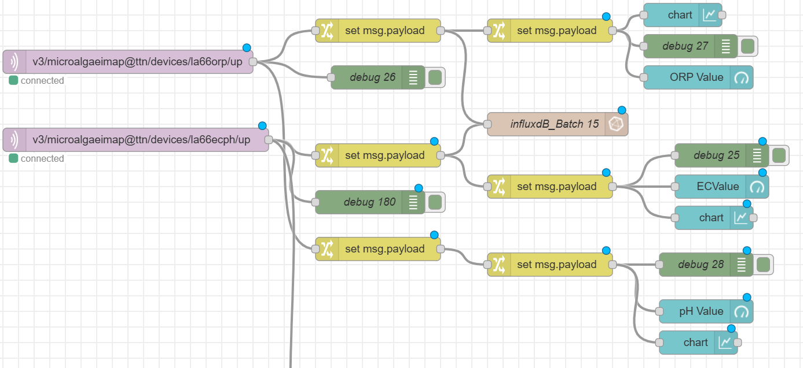
Figure 3.12: Microalgae Cultivation Node-Red flow
In the system implementation, the entire data flow from the pH and ORP sensors to the TTN server was illustrated in Figure 3.13. The sensor data, transmitted through, was decoded using the decodeUplink (input) function. The function extracts four input bytes and converts them into real units via division and bitwise operations. Once decoded, the data was published to Node-RED via the MQTT topic v3/microalgaeimap@ttn/devices/la66orp/up. The values of pH from the topic of payload.uplink_message.decoded.payload.pH and the values of ORP from the topic of payload.uplink_message.decoded.payload.orp were processed individually through separate set msg.payload function nodes to allow downstream visualisation and storage.
The data received from TTN via the topic v3/microalgaeimap@ttn/devices/la66orp/up is sent in JSON format and contains two main parameters, namely orp and pH values, which have been decoded in advance via the payload.uplink_message.decoded.payload function (Figure 3.13). These values are then processed in Node-RED via the set msg.payload function node, which restructures the data into a format compatible with the database requirements.
Figure 3.13: Uplink messages from TTN to Node-Red
The two main input nodes (ttn/devices/la66orp/up and la66ecph/up) receive data sent from TTN via the MQTT protocol. This data is processed through the msg.payload and debug sets for review and delivery to the InfluxDB_Microalgae Cultivation database, as shown in Figure 3.14.
Once re-formatted in the appropriate format, the data is sent to the InfluxDB database via the InfluxDB_Microalgae Cultivation node connection. This connection has been configured with the organisation name my-organisation, bucket UTHM-ALGAE, and measurement microalgae_uthm. Time is recorded in milliseconds to maintain the accuracy of the time series log. This configuration allows for real time storage of electrochemical parameter data from microalgae cultures using InfluxDB version 2.0 hosted on port http://influxdb:8086.
Figure 3.14: Time series data logging to InfluxDB
Additionally, sensor values were visualised using chart and gauge widgets on the Node-RED dashboard (Figure 3.15). Debug nodes were also configured to support development and testing activities.
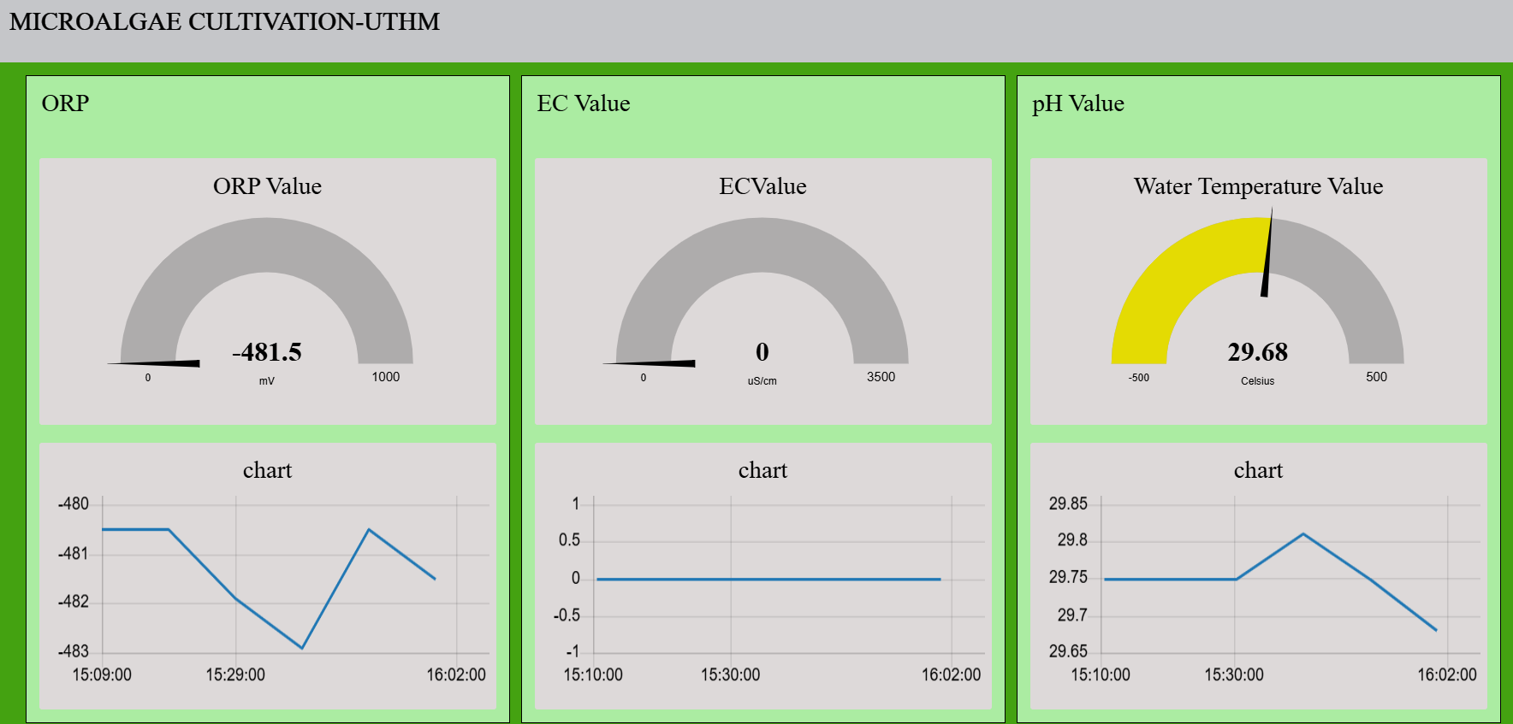
Figure 3.15: Microalgae Cultivation Node-Red dashboard
Based on Figure 3.16, this query was written in Flux and was used to extract data from the UTHM-ALGAE10 bucket in the InfluxDB database. The time range of the data was determined by the v.timeRangeStart to v.timeRangeStop parameters, which were usually controlled dynamically by the user interface in Grafana. The data was then filtered based on the measurement (measurement) that was identified as batch15_uthm, which was referred to a specific experimental batch in the microalgae culture study.
The next filtering was performed on the field (_field) by selecting only the ORP values for analysis. The obtained ORP values were then processed using the aggregateWindow function to produce an average (mean) within each specified time interval (v.windowPeriod). The createEmpty: false parameter was applied to ensure that only windows with data were counted. The result was analysed in Grafana as a display of the average ORP values over time, which was found to be very useful for identifying redox trends in a continuous microalgae culture system.
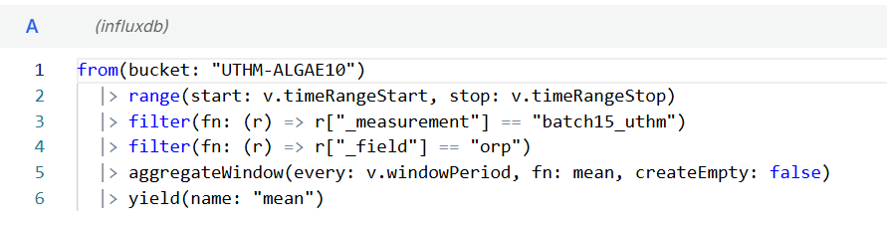
Figure 3.16: InfluxDB query extracting data from bucket
Each parameter, namely ORP, EC, and pH, is sent to display dashboard nodes of real time series charts that allow users to see reading trends directly on the dashboard as shown in Figure 3.17. This flow allows for centralized monitoring, time series data storage, and easy integration with ML at the application layer.
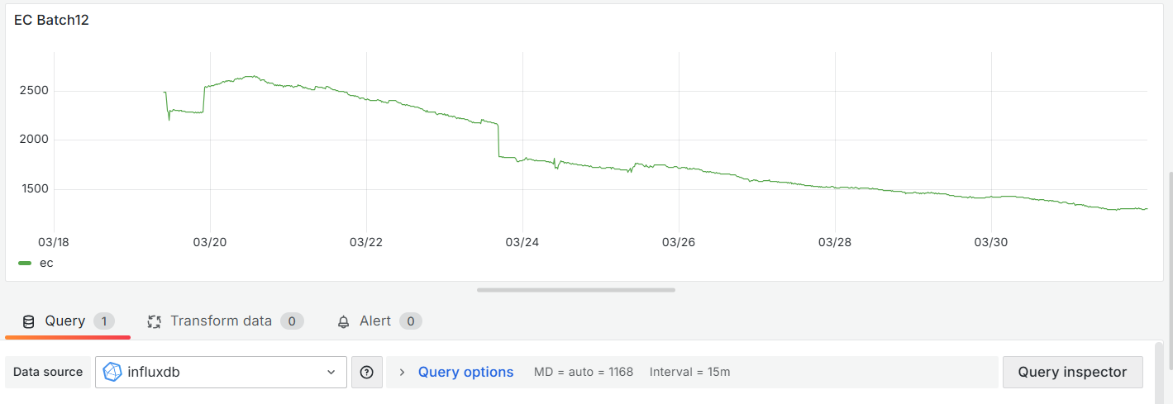
Figure 3.17: Grafana microalgae cultivation dashboard
The time series data of all sensor nodes is then stored in the server to be sent to Grafana for data storage to the database server as shown on Figure 3.18.
Figure 3.18: Grafana database storage

Adaptive Threshold
Thresholding Family | Key References | Threshold Engine | Strengths | Critical Limitations
Rolling Statistical Thresholds | Ndubuaku (2019); Jollois & Wei, 2020, Li (2024) | Rolling μ ± kσ of RE | Simple, interpretable, low latency | Risk of drift incorporation
Quantile-Based Thresholds | Hundman (2018); Lee (2021) | Sliding percentile of RE | Distribution-free | Sensitive to score drift
EWMA Thresholds | Reunanen (2020); Yu (2024) | EWMA control limits | Noise smoothing | Slow response to abrupt drift
Seasonality-Aware Thresholds | Mo (2021); Cho (2024) | STL / periodic baseline | Captures cyclic patterns | Assumes stable seasonality
EVT-Based Thresholds | Lv (DATECT, 2023) | Tail modelling (GPD) | Robust to rare events | Complex, data-hungry
RL-Based Thresholds | Yang (2023) | Policy optimisation | Adaptive & optimal | Hard to interpret
Attention-Based Thresholds | Dong (2022); Maitra (2024) | Weighted RE / Mahalanobis | Multivariate sensitivity | Heavy computation
Edge-Oriented Thresholds | Abououf (2022) | Simplified RE rules | Deployable on edge | Limited adaptivity

- 🔹 Rolling Window Statistical Thresholding
✔️ SAHIH & kuat
- Ndubuaku et al., 2019
Anomaly detection in streaming sensor data using autoencoders and statistical thresholding
IEEE Big Data Conference
→ AE + rolling mean/std RE
✔️ Ini rujukan teras ARST kita
- Jollois & Wei, 2020
Statistical process control for anomaly detection in time series
→ rolling statistics & z-score logic
✔️ sokong statistik sliding window
- Li, 2024
Adaptive thresholding for reconstruction-based anomaly detection under non-stationary environments
IEEE Sensors Journal
✔️ very relevant untuk drift

- 🔹 Quantile / Percentile-Based Thresholding
✔️ Established & widely cited
- Hundman et al., 2018
Detecting spacecraft anomalies using LSTMs and nonparametric dynamic thresholding
KDD 2018
✔️ dynamic percentile threshold (NASA benchmark)
- Lee et al., 2021
Time-series anomaly detection with adaptive quantile regression
→ quantile-adaptive RE bounds
- Tambuwal et al., 2024
Adaptive quantile-based thresholding for unsupervised anomaly detection
✔️ recent extension (acceptable if journal indexed)

- 🔹 EWMA-Based Adaptive Thresholding
✔️ Classical, defendable
- Reunanen, 2020
Adaptive EWMA control limits for anomaly detection
- Zhang et al., 2020
EWMA-based drift-aware anomaly detection
- Yu et al., 2024
Entropy-EWMA for streaming anomaly detection
✔️ EWMA is control-chart lineage, reviewer terima.

- 🔹 Seasonality-Aware Thresholding
✔️ Valid but conditional
- Mo et al., 2021
STL-based anomaly detection for seasonal TS
- Cho et al., 2024
Seasonal adaptive thresholds for IoT streams
- Isaac & Sharma, 2023
KPI adaptive thresholding with periodic baseline

- 🔹 Reinforcement Learning–Driven Thresholding
✔️ State-of-the-art, but complex
- Yang et al., 2023
Learning adaptive anomaly thresholds via deep reinforcement learning
arXiv (widely cited)
✔️ reviewer tahu → acceptable

- 🔹 Distribution-Adaptive / EVT-Based Thresholding
✔️ High impact, high complexity
- Lv et al., 2023 – DATECT
Distribution-adaptive EVT thresholding
IEEE TKDE
✔️ very strong reference
- Fan & Davis
EVT for anomaly detection
✔️ classical EVT lineage

- 🔹 Weighted / Attention-Based Thresholding
✔️ Valid multivariate line
- Dong et al., 2022
Attention-based multivariate anomaly detection
- Maitra et al., 2024
Attention-weighted RE thresholds
- Rahmani et al., 2024
Feature-aware thresholding

- 🔹 Lightweight / Edge-Oriented Thresholding
✔️ Relevant deployment angle
- Abououf et al., 2022
Lightweight AE for edge anomaly detection
- Lee et al., 2021
Simplified RE-based thresholds

Existing adaptive thresholding strategies range from rolling statistical limits and quantile-based rules to more complex EVT and reinforcement learning approaches. While advanced methods offer improved robustness to rare events or multivariate dependencies, they often introduce substantial modelling and deployment complexity. In contrast, rolling statistical thresholds remain attractive for real-time biological monitoring due to their interpretability and low computational cost, despite known risks of drift incorporation.

Microalgae photobioreactor indoor cultivation experimental setup
An indoor photobioreactor system was developed for the cultivation of Chlorella sp. in a controlled experimental environment as shown in Figure 3.19. Based on Table 3-2, the photobioreactor has a capacity of 4000 ml and is inoculated with an initial culture density of 11.11% w/v (500 ml Chlorella sp.). Organic fertiliser was used as a nutrient medium at a concentration of 1.25% w/v (equivalent to 50 ml). To ensure uniformity and stability of the culture environment, aeration was supplied regularly and consistently, while lighting was provided for 16 hours a day at an intensity of 9.48 W/m² from a distance of 0.5 meters. Several important parameters, such as aeration, lighting and nutrient composition, were maintained uniform throughout the experiment.

Figure 3.19: Indoor photobioreactor medium setup; (a) Medium under light exposure (b) Medium with inoculum concentration and fertilizer.
Table 3-2: Experimental setup for indoor microalgae cultivation
No. | Parameters | Value
1. | Medium volume (Filtered water) | 4000ml
2. | Inoculum concentration | 11.11% (500ml)
3. | Microalgae type | Chlorella sp.
4. | Inoculum consentration for fertilizer | 1.25% (50ml)
5. | Fertilyzer type | Organic
6. | Light intensity | 9.48 W/m²
7. | Light exposure | 16 hours ( 8 hours resting period)

The culture temperature was not actively controlled, but instead monitored using a digital temperature sensor (DS18B20) to record natural temperature changes. The sensing system also involved a Gravity Analogue ORP Sensor (SEN0464), EC Sensor PRO (SEN0451 K=1), and Gravity Analogue pH Sensor. All sensors were calibrated using standard solutions: ORP (256 mV), EC (12880 µS/cm), and pH (buffer 4.01, 6.86, and 9.18 at 25°C). Data from the sensors was sent to the IoT system and recorded every 10 minutes.
As a confirmation and validation, manual readings using the SX731 multiparameter probe were also performed three times a day (triplicate). In addition, optical density (OD) readings of microalgae were taken daily from Day 0 to Day 8 using a photospectrometer. These readings are important for quantitatively assessing microalgae biomass growth.
This experiment was repeated 10 times using the same measurements and procedures to ensure reliability and re-validation of the microalgae growth patterns obtained. Data from daily OD were analysed according to the logistic growth model approach, which consists of four main phases: lag phase (initial adaptation), exponential phase (rapid growth), stationary phase (population stability), and decline phase (growth decline). This model is widely used in microbiology to understand the carrying capacity of a system and the growth behaviour of cell populations under controlled conditions. In the context of this study, the logistic model is very useful to identify the optimal control points of parameters such as ORP, EC and pH that contribute to maximum growth of Chlorella sp. It also helps to support the development of predictive models that will be integrated into the proposed ML algorithms.

Machine Learning algorithm for time series analysis
For the purpose of quantitative microalgal growth modelling, Long Short-Term Memory Autoencoder (LSTM-AE) and Isolation Forest (IForest) were used saperately to analyse data obtained from the sensors. Each model was analysed and interpreted independently, and their outcomes were compared to determine which model better captures the anomalies related to microalgae growth fluctuations.
LSTM-AE is suited for predicting the output of microalgae cultures growing based on previous time steps or history, with all the parameters of data that may affect the observed growth hours or days later [143]. LSTM-AE was implemented to detect anomalies based on reconstruction error from the encoded temporal patterns in the measured parameters. To identify any outliers during the monitoring, the IForrest model is implemented [150]. This unsupervised learning approach isolates abnormal patterns that deviate significantly from the majority distribution, without relying on time-dependent encoding.
Based on Figure 3.20, data of EC, ORP, pH and water temperature in real time were collected at, producing a time-series dataset of readings observed from the sensor system. Data from the sensor was retrieved in InfluxDB and kept in the Grafana database.
The input dataset are transmitted automatically to the monitoring system via the application layer. The interval for data transmission to the database, along with the subsequent data retrieval, is established at every 10 minutes, resulting in a system sampling frequency of 6 readings per hour. The total dataset for each batch comprised 10 days × 24 hours × 6 readings per hour, resulting in 1,440 sequential data points per parameter. As four physical parameters were monitored simultaneously, each batch contributed a total of 5,760 data points.
For the dataset partitioning in this study, three batches of Chlorella sp. culture were used as the model training set while one batch was used as the testing set. Three batches of this training set led to a percentage of 75% while 1 testing batch led to a percentage of 25%. Cumulatively, the training set involved 3 batches × 5,760 data = 17,280 data points, while the testing set contained 5,760 data points from the fourth batch. This partitioning also took into account the complete growth cycle of microalgae which includes lag phase, exponential phase, stationary phase and decline phase, thus allowing the model to learn complex growth patterns comprehensively. Model performance validation was carried out using batches that were not used during the training phase, to ensure the effectiveness of generalization to new data.
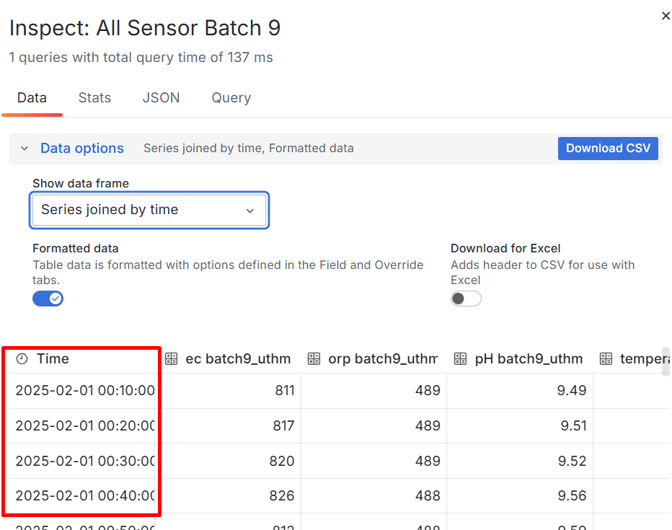
Figure 3.20: Data collection on Grafana at 10-minute intervals

Workflow of LSTM-AE for time series analysis
The framework of the LSTM-AE model for anomaly detection purposes in this study is shown in Figure 3.21 The configuration of the ML which includes the input structure parameters and model training settings is shown in Table 3-3. Each input to the model is formed as an array with size (24, 4), representing 24 consecutive time steps for the 4 monitored parameters, namely ORP, EC, pH and water temperature. The selection of 24 time steps as the sliding window is made based on the sampling frequency of every 10 minutes, which makes 24 steps equivalent to 4 hours of consecutive data. This time period is considered appropriate because it is long enough to capture short-term dynamic patterns related to the physiological changes of microalgae, as well as compact enough to avoid missing a significant number of samples in the training set. Furthermore, it provides a good balance between temporal depth and the effectiveness of the model learning in identifying sequential patterns in multivariate data.
Out of 17,280 data points in the training set, a total of 17,257 samples were successfully generated after the implementation of the sliding window technique, while the testing set produced 5,737 samples from 5,760 data points. This method uses the principle of a sliding window with 24 time steps, where each input sample is formed from 24 consecutive readings. Therefore, the number of samples obtained is determined by the formula (number of data points – number of timesteps + 1), which is (17,280 – 24 + 1 = 17,257) for the training set and (5,760 – 24 + 1 = 5,737) for the testing set.
The model structure consists of one encoder layer and one decoder layer, each containing 64 LSTM neurons or cells. Between these cells, a dropout of 0.2 representing 20% of the cells was randomly turned off during the training iteration. Complete dependence on a specific neuron during training has the potential to increase the risk of overfitting. In this case, a moderate dropout value (between 0.1 and 0.5) is used because it can prevent dependence on a specific neuron and reduce the risk of overfitting. This dropout then maintains a balance between stability during training and maintaining the model's ability to generalize to new data.
Model training was conducted using the Mean Squared Error (MSE) loss function and the Adaptive Moment Estimation (Adam) optimizer, which uses an adaptive learning rate to accelerate the model's steady convergence. A total of 40 epochs were used in the training process, based on initial observations that the model had achieved stable performance within that range. The training batch size was set to 32, while 20% of the training data was used as a validation subset to allow for monitoring model performance during training and to prevent early overfitting during training.
Figure 3.21: LSTM-AE ML modelling framework for microalgae cultivation
Table 3-3: Parameters of LSTM-AE ML models for microalgae cultivation
Hyperparameters | Value | Description
Input Features | 4 | ORP, EC, pH, water temperature
Timesteps (Sliding Window) | 24 | Equivalent to 4 hours
Input Shape | (24, 4) | 24 steps for each features
Total Training Data Points | 17,280 | 75% of total dataset
Total Testing Data Points | 5,760 | 25% of total dataset
Training Samples | 17,257 | Total of training samples after sliding windows
Testing Samples | 5,737 | Total of testing samples after sliding windows
Encoder Layer | 64 | number of neurons (units) in the LSTM encoder layer
Decoder Layer | 64 | number of neurons (units) in the LSTM decoder layer
Dropout | 0.2 | 20% of neuron randomly turn off during training
Optimizer | Adam | Adaptive Moment Estimation for training acceleration
Epochs | 40 | The number of one forward/backward pass of all samples
Batch Size | 32 | The number of samples in one forward and backward pass
Validation Split | 0.2 | 20% out of 75% training dataset
Output |  | Reconstructed sensor data
Anomaly Detection Method |  | Based on reconstruction error (MSE threshold)

Workflow of IForest for time series analysis
In this study, the IForest model was specifically developed to identify anomalies that cannot be detected through direct observation of physicochemical parameters in microalgae culture systems. This unsupervised machine learning model approach is to identify abnormalities in 4 sensor data parameters. IForest is able to isolate outlier data points that are often present in very small amounts and cannot be explicitly identified through the process of randomly constructing decision trees, without the need for class labels or prior information about the characteristics of the anomalies. This model does not require a complex temporal structure, but instead processes each data point independently based on the depth of separation in the tree structure.
The framework of the Iforest ML model for the purposes in this study is shown in Figure 3.22. Base on Table 3-4, the model is trained using 75% (17, 280 dataset) out of the total dataset covering the first three experimental batches, while the remaining 25% (5,760 datasets) from the fourth batch, is used for testing set.The configuration of this IForest model involves several important settings. The number of decision trees or isolation trees used to improve the stability and reliability of anomaly detection is labelled as n_estimators, and is set to 100. In each tree, only 256 random samples (the max_samples parameter) are used to represent the entire data structure without using the entire training set repeatedly. This helps reduce processing time and avoids the risk of overfitting the training data.
The contamination parameter was set to 0.01, to determine the threshold for sensitivity to abnormalities. This value reflects the initial expectation that about one percent of the acquired data is likely to contain unusual values or odd patterns, such as the fluctuation of sensor readings from the normal range due malfunction or system disturbances.
To ensure that the model results can be replicated consistently in each run, the value 42 (random_state ) was used. This setting is important for revalidation purposes and comparison between different experiments. The classification label and an anomaly score is the output from the analysis. For each datasets, an anomaly identification is labeled as 1, where else it is considered as normal if it is labelled as -1. The anomaly score is calculated based on the average isolation depth in the tree structure. Data points that are more rapidly separated from other data during tree construction are considered more unusual and are subsequently classified as anomalies.
Figure 3.22: IForest ML modelling framework for microalgae cultivation
Table 3-4: Parameters of IForest ML models for microalgae cultivation
Hyperparameters | Value | Description
Input Features | 4 | ORP, EC, pH, and water temperature
Total Training Data | 17,280 | 75% of total dataset
Total Testing Data | 5,760 | 25% of total dataset
max_samples | 256 | Maximum number of random samples used for building each isolation tree
n_estimators | 100 | Total number of isolation trees in the IForest model
contamination | 0.01 | Estimated proportion of anomalies in the dataset
random_state | 42 | Ensures consistent and reproducible results
Output | Label & anomaly score | 1 = anomaly, -1 = normal; based on isolation score
Anomaly Detection basis | Isolation Depth | Data points that are isolated more quickly (with shorter path lengths) across the isolation trees

The growth pattern of Chlorella sp. by measuring the Optical Density
Daily monitoring is carried out to assess growth patterns based on optical density (OD) readings. This OD data is then matched with a logistic growth model to identify critical phases such as the lag phase (initial adaptation), exponential phase (rapid growth), and stationary phase (population stability).
The growth of microalgae Chlorella sp. was conducted by measuring the OD during the phase of growth [74]. OD values were taken starting from the first day of cultivation until the stationary phase. The obtained OD data were used to validate and study the growth pattern of Chlorella sp. for each batch of cultivation. The selection of OD as an output variable was based on its direct relationship with biomass concentration, chlorophyll-a content, and cell number [76].
OD readings were obtained using the spectrophotometric method. OD is one of the methods used to observe the growth and condition of microalgae cells using a spectrophotometer by measuring cell density Multiskan Go Photospectrometer (Figure 3.23 (a)) operates in the wavelength range of 200 –1000 nm with a resolution of 1 nm. This instrument uses a xenon lamp and supports measurements of up to 4 absorbance units, making it suitable for dynamic assessment of microalgae growth in real time. 96-well microplates Figure 3.23 (b) were used to collect samples of culture to identify the OD of the culture during a cycle of cultivation.
Figure 3.23: (a) Multiskan Go Photospectrometer, (b) 96 Well-microplates
Figure 3.24 shows the method for assessing OD of the Chlorella sp., which was conducted utilising a microplate spectrophotometer. A cumulative volume of 20 ml of culture samples was systematically collected daily throughout the incubation duration, which ranged from 8 to 10 days as per step 1 . Subsequently, in step 2, 0.1 ml of each sample was carefully pipetted into individual wells of the microplate to facilitate the acquisition of 24 daily measurements. Next, in step 3, light absorption data were recorded at a wavelength of 680 nm following a linear stirring process lasting 10 seconds at a controlled temperature of 37°C. Lastly, the results data were analysed in a digital format (csv) and employed as inputs in the formulation of ML models.
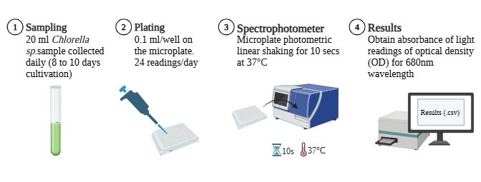
Figure 3.24: Process of obtaining OD value for each cycle of cultivation

Validation of IoT sensor data
For the cross-validation of data obtained from the IoT-based sensor system, a hand-held measuring instrument type SX731 Multiparameter Meter Kit from the Apera Instruments company was utilised. The instrument is capable of measuring seven water quality parameters simultaneously: pH, ORP, EC, TDS, salinity, resistivity, and temperature. Its portability and robust design are advantages that make it suitable for use in field applications, such as in aquaculture systems, water treatment, and environmental monitoring under this research.
Its accuracy in the laboratory for all the parameters it measures is high. Base on Table 3-5, pH measurements conducted are from -2.00 to 19.99 pH with an accuracy of up to ±0.01 pH, while ORP can be measured from -1999 mV to +1999 mV with a resolution of 1 mV. The wide measurement range of 0.00 μS/cm to 199.9 mS/cm for conductivity parameters is adequate for the accurate determination of low to high-concentration solutions.
The use of this instrument is also facilitated by features such as automatic calibration, auto electrode detection, digital filter technology for reading stability, and memory storage for up to 400 data sets. The instrument's moisture and splash water resistance enable it to withstand the high humidity and temperature fluctuations present in microalgae field conditions.
The use of SX731 is for checking the correctness of the readings of the IoT sensor system that is mounted on the microalgae culture medium. Comparison between readings from the IoT system and this handheld device is done from time to time, where pH, ORP, and EC levels are measured at the same time, which is done daily with triplicate readings (three repetitions), morning, afternoon, and evening readings. This procedure allows for data consistency analysis to be performed and identifies any deviation that might occur due to sensor failure, electrode wear-out or external interference with the IoT system. This procedure meets the demand for high precision for formulating ML models for automated monitoring of microalgae growth.
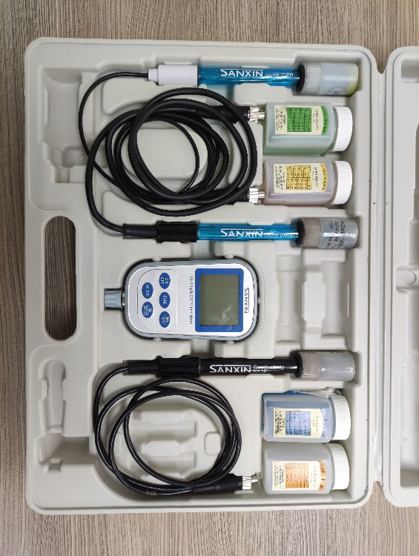
Figure 3.25: SX731 portable handheld multiparameter device

Table 3-5: SX731 portable handheld multiparameter specifications [174]
Parameters | Specifications
ORP | Measurement range (mV/ORP/EH): -1999 mV to 0 to 1999mV  Resolution: 1mV  Accuracy: Meter: ±0.1% FS, Overall: ±15mV
EC | Measurement range: (200 to 1999) μS/cm (2.00 to 19.99) mS/cm  Resistivity: (0 to 100) MΩ·cm  Resolution: 0.01/0.1/1μS/cm 0.01/0.1 mS/cm  Accuracy: Meter: ±1.0% F.S, Overall: ±1.5% F.S  Electrode constant: 0.1 / 1 / 10 cm-1  Reference temperature: 25°C, 20°C, and 18°C
pH | Measurement range: (-2.00 to 19.99) pH  Resolution: 0.1/0.01 pH  Accuracy: Meter: ±0.01pH; Overall: ±0.02pH  Input current: ≤2×10-12 A  Stability: ±0.01 pH/3h
Temperature | Working temperature: 5 to 35°C

RESULTS AND DISCUSSION

Microalgae photobioreactor indoor cultivation experimental results
As the Chlorella sp. sample was cutivated under the same capacity of 4000 ml adding 50ml of organic fertiliser as a nutrient medium, with regular and consistent aeration, the cultivation showed a healthy growth rate as per showed in Figure 12.1.
Under a consistent of lighting period and intensity, the cultivation start to change colour to darker green from day 4 of the cultivation. This is suits with the kinetic growth of the (sigmoid shape), where the growth or exponential phase of the microalgae start rapidly on the 4th day of the cultivation. On the 7th day, the microalgae is starting to show a stationary phase and the microalgae is ready to be harvested.
Figure 12.1: Photographic view of Chlorella sp. in a single cycle cultivation

The real time physical parameters of microalgae in a single cycle
Figure 12.2 to Figure 12.6 present the real time data of EC, ORP, pH, and water temperature recorded over a nine-day incubation period of Chlorella sp. cultivation. The data were collected from the end node and transmitted to the application node throughout the single cultivation cycle. For each parameter, the daily mean value along with the standard deviation (mean ± SD) was calculated and analysed.
EC measurements demonstrated a progressive decline from day 1 (1169.76±33.47µS/cm) to day 7 (768.43±6.56µS/cm) as shown in Figure 12.2. The peak EC measurement was documented on day 1, whereas the minimum was noted on day 7. Subsequently, on day 8 and day 9, EC values exhibited a marginal elevation to 771.02±6.34µS/cm and 788.15±6.55µS/cm, respectively.
The maximum standard deviation was observed on day 4, which was ±56.38µS/cm, signifying a greater variability in measurements on that particular day in comparison to other days. In total, the standard deviation for all EC readings ranged from ±6.34 to ±56.38µS/cm. This observation reflects a uniform distribution of daily EC measurements throughout the incubation duration.
Figure 12.2: Daily average EC (mean ± SD) of Chlorella sp. culture over a 9-day cultivation period
Figure 12.3 shows the daily changes in ORP values throughout the incubation period of Chlorella sp. Daily ORP readings were recorded as mean ± SD. The highest ORP value was recorded on day 3 (–32.81±1.64mV), while the lowest value was recorded on day 4 (–101.27±5.06mV).
The daily standard deviation range was between ±1.64mV to ±5.06mV, with the highest value on day 4 and the lowest value on day 3. This data shows an acceptable level of stability of the ORP sensor readings throughout the observation period.
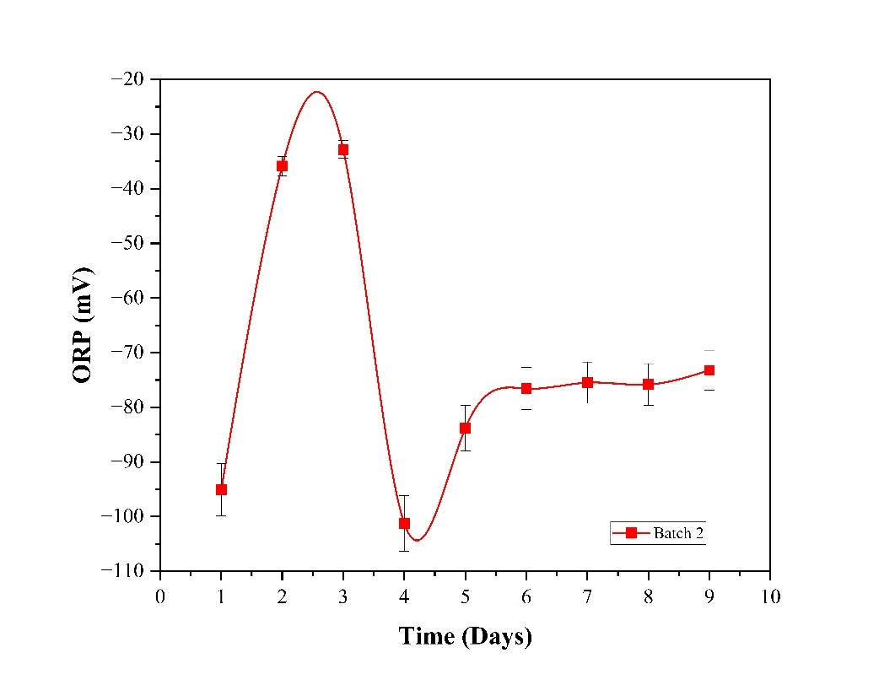
Figure 12.3: Daily average ORP (mean ± SD) of Chlorella sp. culture over a 9-day cultivation period
A significant increase in ORP values occurred from day 1 (–95.10±4.76mV) to day 3, followed by a sharp decrease on day 4. The decomposition process of the material in the fertiliser occurred extensively during the growth stage of Chlorella sp. in the exponential or growth phase (days 3 and 4), with the release of a lot of bubbles and waste on the surface of the cultivation tank Figure 12.4. The ORP value showed a gradual increase from day 5 (–83.82±4.19mV) to day 8 (–75.82±3.79mV), with the redox process occurring stably starting from day 5 until the stationary phase (day 8), with a slower rate of change compared to the initial phase.
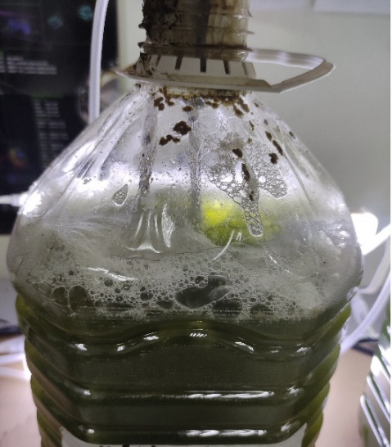
Figure 12.4: Decomposition process of Chlorella sp. (Day 3 and 4)
Figure 12.5: Daily average pH value (mean ± SD) of Chlorella sp. culture over a 9-day cultivation period
Daily water temperature throughout the 9-day incubation interval exhibited a steady increase from day 0 to day 6, as shown in Figure 12.6, with the temperature increasing from 26.49±0.34°C to 28.47±0.42°C. Temperature stability was attained from day 6 to day 9 with minimal fluctuation. The peak daily average temperature was documented on day 6 (28.47±0.42°C), whereas the lowest temperature was observed on day 1 (26.49±0.34°C).
The gradual elevation in temperature during the initial days is required for optimal growth of Chlorella sp. within the range of 27°C to 29°C [35] which was maintained at this level throughout the experiment, can be attributed to the enhancement of photosynthetic activity [50] and the influence of continuous illumination within the enclosed system. The recorded standard deviation (SD) range of ±0.32 to ±0.49 reflects the degree of stability and uniformity of sensor measurements throughout the observational period.
Figure 12.6: Daily average temperature (mean ± SD) of Chlorella sp. culture over a 9-day cultivation period

Change pattern of OD and EC of Chlorella sp. in a single cycle of cultivation
Figure 12.7 depicts experimental data of the simultaneous change pattern between OD and EC values during the 9-day cultivation period of Chlorella sp. The graph shows an inverse relationship between the increase in microalgal biomass and the decrease in dissolved ions in the culture medium, represented by the EC parameter. Through observation, it can be identified that the exponential growth phase of microalgae occurs simultaneously with the rapid nutrient depletion phase in the system.
The OD measurements reveal a persistent augmentation from day 1 (0.39) to day 7 (1.16), subsequently reaching a plateau until day 9 (0.911). This elevation in OD values signifies a corresponding increase in the concentration of microalgal cells within the culture medium, as indicated by the absorption of light. Conversely, the EC values exhibit a steady decline from day 1 (2471.33 µS/cm) to day 9 (1416.30 µS/cm). This decrement is observable on a daily basis, with notable changes occurring particularly from day 2 to day 6.
The intersection point between the OD and EC curves around day 5 to 6 marks the critical transition from the nutrient-rich state to the nutrient-limited phase, which usually occurs in closed systems. The measurement model shows a significant change in the growth of Chlorella sp. and a decrease in EC values during the nine-day incubation period. Table 12-1 shows the biomass concentration reading based on OD increased consistently from day 1 to day 8, indicating an increase in photosynthetic activity and the proliferation of microalgae cells in the culture medium. The OD value increased from 0.39267 on the first day to 0.911 on the ninth day, with the most significant increase recorded between days 3 to 6 (0.45913 to 0.91433).
The OD value began to show stability by day 9, marking the end of the exponential growth phase. In contrast, the EC value showed a progressive decrease from 2471.33 µS/cm to 1416.30 µS/cm over the same period. During the growth phase of the Chlorella sp., a decreasing pattern reflects the utilisation of nutrient ions by the microalgae to support cell proliferation and chlorophyll a synthesis. An inverse relationship between OD and EC can be clearly observed from days 5 to 8, where the EC value decreased significantly in parallel with the sharp increase in OD from 0.85133 to 0.904.
The significant rate of EC decrease in the middle of the cultivation period indicates that Chlorella sp. absorb dissolved nutrients such as nitrogen and other minerals at an optimal rate, coinciding with increased biomass. The kinetic model was accurate in predicting the growth of microalgae, as the nutrient concentrations and the operating conditions for microalgae cultivation are predominant factors in determining their growth and death patterns [175]. This pattern is consistent with the physiological behaviour of microalgae during the rapid growth phase, and proves that EC parameters can be used as indirect indicators to evaluate metabolic activity and nutrient utilisation rates in closed culture systems.
Figure 12.7: Temporal fluctuations between the OD and EC of a single cultivation period (9 days) of Chlorella sp.
Table 12-1: Value of OD and EC in a single cycle cultivation (mean)
Time (Days) | OD | EC (µS/cm)
1 | 0.392 | 2471.33
2 | 0.410 | 2496.46
3 | 0.459 | 2495.50
4 | 0.788 | 2239.38
5 | 0.851 | 1761.86
6 | 0.912 | 1704.24
7 | 0.914 | 1553.56
8 | 0.904 | 1466.10
9 | 0.911 | 1416.30

The real time physical parameters of microalgae in the 3-cycle
The experiment of three distinct sets of microalgae Chlorella sp. culture batches was conducted using a consistent methodology and environment, including parameters such as seed and fertiliser concentration and volume, light intensity, duration of exposure, and nutrient levels. Each batch was done independently under standardised operating conditions to guarantee the comparability of data across each batch. The readings from the SX730/731 probe served as a reference for validation.
Table 12-2 shows the data of ORP, EC, pH, and water temperature parameters for the growth of Chlorella sp. obtained from the SX7310 Multiparameter Meter Kit. The sample frequency of data taken is 3 readings per day, which are data in the morning, afternoon and evening. Taking into account the growth period of 10 days, data recorded for each parameter amounts to 30 readings, and then the total data for the entire parameter is 120 readings. The data is then taken as mean and SD values and analysed, and then used as validation data and compared with time series data, which are transmitted automatically to the monitoring system via the application layer, incorporating InfluxDB and Grafana. The data is then expressed in the form of a graph, as in Figure 12.8 to Figure 12.11 for comparison and validation of three batches of Chlorella sp. cultivation.
According to Figure 12.8, all three EC batches exhibited a steady decline throughout the incubation period. Batch 1 and batch 2 commenced at approximately 1850µS/cm, decreasing to 1350µS/cm and 1300µS/cm, respectively, yielding a decrease range of 500µS/cm and 550µS/cm. In contrast, batch 3 began with the highest value of 2280µS/cm and dropped to 1200µS/cm by day 9, indicating a change range of 1080µS/cm. The SX731 probe readings displayed slight variations, initiating at around 2280µS/cm before decreasing to 1350µS/cm, remaining within a range that was consistent with the primary batch readings.
Figure 12.8: Daily average EC for 3 batches of Chlorella sp. culture over a 9-day cultivation period
Referring to Figure 12.9, all three ORP batches demonstrated a comparable pattern, with values rising from day one to day three, followed by a sharp decline on day four, and a subsequent increase thereafter from day 5 to day 9. Batch 1 noted a minimum value of –145mV and a maximum of –20mV. Batch 2 presented a range from –100mV to –30mV, compared with batch 3, which recorded values between –105mV and –30mV. The SX731 readings maintained stability within the range of –20mV to –60mV and exhibited a slight sharp decrease on days three and four, similar to the trends observed in the main batches.
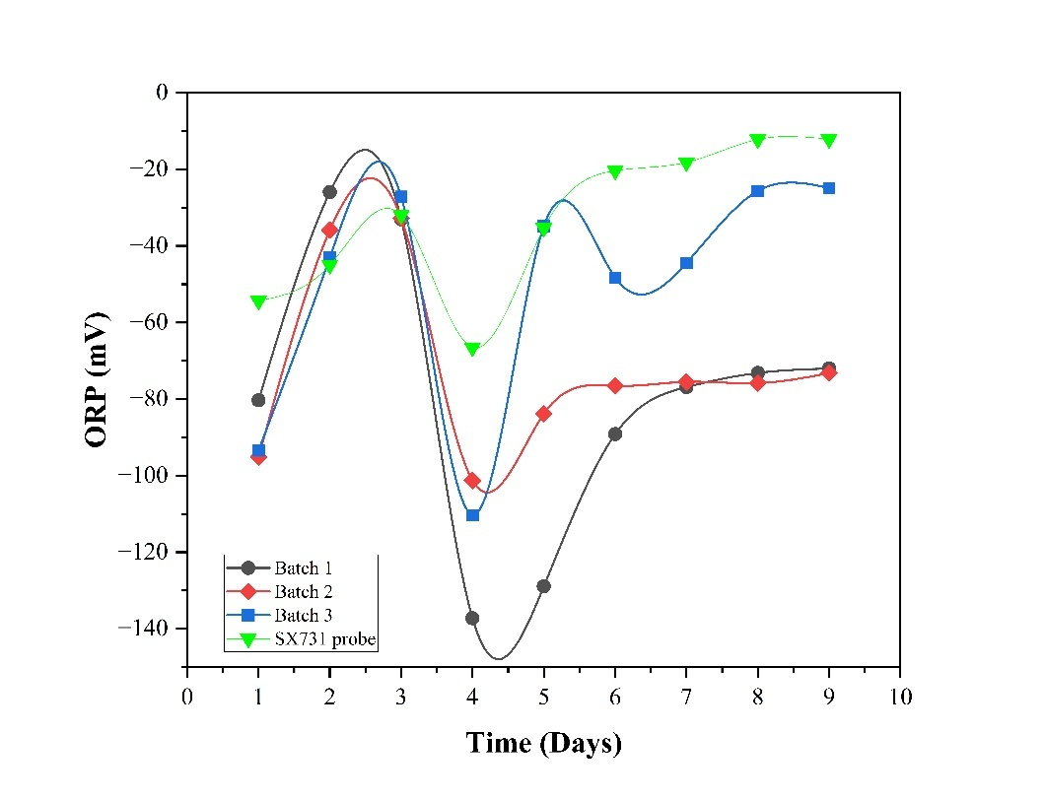
Figure 12.9: Daily average ORP for 3 batches of Chlorella sp. culture over a 9-day cultivation period
In reference to Figure 12.10, batch 1 displayed an increase in stability in pH from 8.3 to a peak of 9.5, while batch 2 began at 8.4 and attained a maximum of 9.6 and batch 3 showed the broadest pH range, fluctuating between 7.2 and 8.9. However, the reading is still within the range of accepted pH values for Chlorella sp. to grow. The SX730 probe documented stable readings within the range of 8.5 to 8.7 throughout the experiment, serving as a validation reference for the stability of pH readings acquired from the automated system.
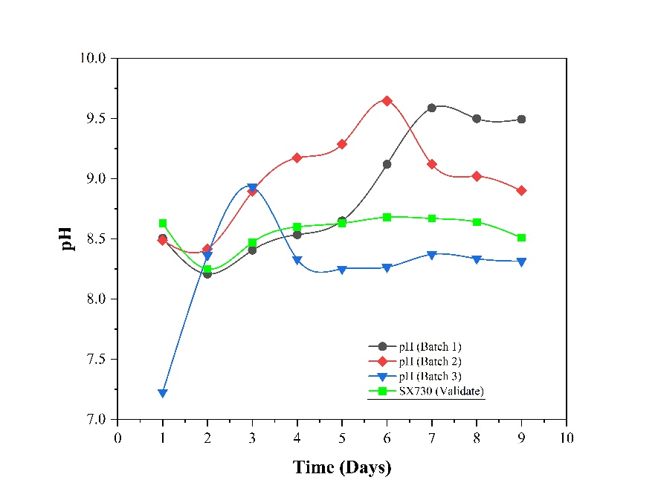
Figure 12.10: Daily average pH value for 3 batches of Chlorella sp. culture over a 9-day cultivation period
Based on Figure 12.11, batch 1 indicated a gradual rise in temperature from 26.5°C to 28.6°C. Batch 2 initiated at 27.6°C and reached a peak of 29.0°C, whereas batch 3 recorded temperatures ranging from 28.0°C to 29.3°C. The readings from the SX731 probe were consistent, aligning with the temperature trends observed in the primary sensing system, falling within the range of 28.0°C to 29.2°C.
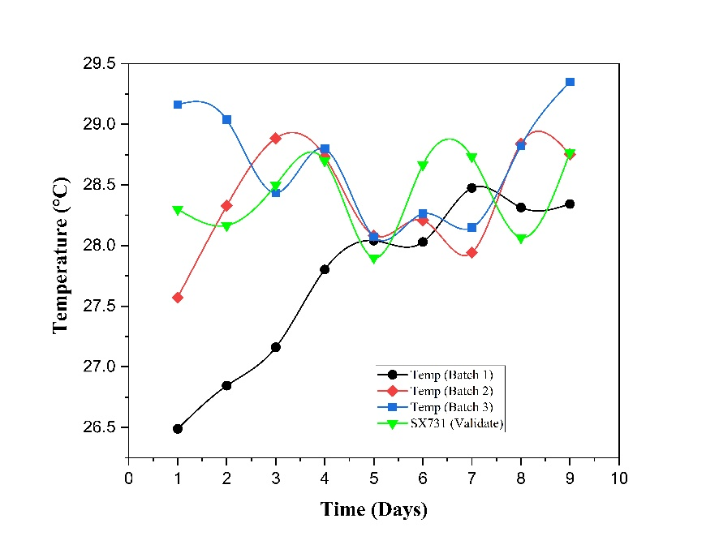
Figure 12.11: Daily average temperature for 3 batches of Chlorella sp. culture over a 9-day cultivation period
Table 12-2: Triplicate readings of Chlorella sp. cultivation in a single cycle using SX731 Multiparameter Meter Kit

EC (uS/cm) / Time (Days) | 0 | 1 | 2 | 3 | 4 | 5 | 6 | 7 | 8 | 9
SX731 (Reading 1) | 2390.00 | 1700.00 | 1765.00 | 1500.00 | 1716.00 | 1590.00 | 1291.00 | 1330.00 | 1290.00 | 2390.00
SX731 (Reading 2) | 2250.00 | 1876.00 | 1751.00 | 1488.00 | 1690.00 | 1480.00 | 1285.00 | 1326.00 | 1317.00 | 2250.00
SX731 (Reading 3) | 2190.00 | 1920.00 | 1760.00 | 1390.00 | 1678.00 | 1490.00 | 1276.00 | 1330.00 | 1280.00 | 2190.00
Mean / Average | 2276.67 | 1832.00 | 1758.67 | 1459.33 | 1694.67 | 1520.00 | 1284.00 | 1328.67 | 1295.67 | 2276.67
Std Deviation | 102.6320 | 116.4131 | 7.0946 | 60.3435 | 19.4251 | 60.8276 | 7.5498 | 2.3094 | 19.1398 | 102.6320
Note: Table (b) Reading of EC 9uS/cm) versus time (days) using SX731 handheld Multiparameter Meter Kit
ORP (mv) / Time (Days) | 0 | 1 | 2 | 3 | 4 | 5 | 6 | 7 | 8 | 9
SX731 (Reading 1) | -60.00 | -55.00 | -43.00 | -35.00 | -66.00 | -35.00 | -21.00 | -18.50 | -12.00 | -60.00
SX731 (Reading 2) | -59.00 | -55.00 | -45.00 | -30.00 | -67.00 | -36.00 | -20.00 | -18.00 | -12.50 | -59.00
SX731 (Reading 3) | -60.00 | -53.00 | -47.00 | -31.00 | -66.50 | -35.00 | -20.00 | -18.00 | -12.00 | -60.00
Mean / Average | -59.67 | -54.33 | -45.00 | -32.00 | -66.50 | -35.33 | -20.33 | -18.17 | -12.17 | -59.67
Std Deviation | 0.57 | 1.15 | 2.00 | 2.64 | 0.50 | 0.57 | 0.57 | 0.28 | 0.28 | 0.57
Note: Table (a) Reading of ORP (mV) versus time (days) using SX731 handheld Multiparameter Meter Kit

Water temperature (⁰C) / Time (days) | 0 | 1 | 2 | 3 | 4 | 5 | 6 | 7 | 8 | 9
SX731 (Reading 1) | 28.00 | 28.00 | 28.50 | 28.90 | 27.80 | 28.80 | 28.80 | 28.00 | 28.60 | 28.00
SX731 (Reading 2) | 28.70 | 27.50 | 28.00 | 28.70 | 27.90 | 28.70 | 28.70 | 28.20 | 28.70 | 28.70
SX731 (Reading 3) | 28.20 | 29.00 | 29.00 | 28.50 | 28.00 | 28.50 | 28.70 | 28.00 | 29.00 | 28.20
Mean / Average | 28.30 | 28.17 | 28.50 | 28.70 | 27.90 | 28.67 | 28.73 | 28.07 | 28.77 | 28.30
Std Deviation | 0.3606 | 0.7638 | 0.5000 | 0.2000 | 0.1000 | 0.1528 | 0.0577 | 0.1155 | 0.2082 | 0.3606
Note: Table (d) Reading of Water temperature (⁰C) versus time (days) using SX731 handheld Multiparameter Meter Kit

pH/ Time (days) | 0 | 1 | 2 | 3 | 4 | 5 | 6 | 7 | 8 | 9
SX731 (Reading 1) | 8.61 | 8.23 | 8.45 | 8.60 | 8.66 | 8.69 | 8.66 | 8.63 | 8.47 | 8.61
SX731 (Reading 2) | 8.65 | 8.23 | 8.48 | 8.60 | 8.60 | 8.67 | 8.67 | 8.64 | 8.52 | 8.65
SX731 (Reading 3) | 8.62 | 8.30 | 8.47 | 8.61 | 8.63 | 8.68 | 8.68 | 8.66 | 8.53 | 8.62
Mean / Average | 8.63 | 8.25 | 8.47 | 8.60 | 8.63 | 8.68 | 8.67 | 8.64 | 8.51 | 8.63
Std Deviation | 0.0208 | 0.0404 | 0.0153 | 0.0058 | 0.0300 | 0.0100 | 0.0100 | 0.0153 | 0.0321 | 0.0208
Note: Table (c) Reading of pH versus time (days) using SX731 handheld Multiparameter Meter Kit

(b

Optical density of Chlorella sp. in indoor cultivation
Table 12-4 shows the data of OD obtained from the Multiskan Go Photospectrometer for 3 batches of cultivation. 96 Well-microplates were used to collect samples of culture every day. The sample frequency of data taken is 8 readings (Reading A to Reading H). By taking into account the growth period of 10 days, data recorded for each parameter amounts to 80 readings, and then the total data for three batches of cultivations is 240 readings. The data is then taken as mean and SD values and analysed, and then used to obtain the shape of the microalgae growth curve. The shape of the microalgae growth curve is necessary to confirm that the cultivation method used is suitable for the growth medium of Chlorella sp. The data is then expressed in the form of a graph, as in Figure 12.12 for 1 1-cycle batch culture and Figure 12.13 for 3 3-cycle batch culture of Chlorella sp.
Figure 12.12 shows the daily trend of OD readings at 680nm wavelength for Chlorella sp. cultures conducted in a single cycle during the culture period. Overall, the graph showed a progressive increase in OD values from day one to day eight, indicating a continuous active growth phase throughout the study period. The OD readings obtained also met the characteristics of a growth kinetic curve, which consists of 4 main phases: lag phase, exponential phase, stationary phase, and decline phase.
In a single batch observation cycle, the absorbance values for both wavelengths showed a clear increasing trend. Based on Figure 12.12, starting with a low reading on day 0 at 0.393 for 680 nm wavelength, the growth of the microalgae is in an initial adaptation phase, known as the lag phase. This phase is characterised by slow metabolic activity, when the cells are adapting to the new environment.
Significant changes were first observed on days 2 to 5, indicating a transition to an exponential phase characterised by a sharp increase in OD values, consistent with increased cell division and active nutrient uptake. When entering days 6 to 8, the pattern of OD increase began to flatten, indicating the entry into the stationary phase, which is a balance between the rate of cell proliferation and the rate of cell death.
Figure 12.12: OD (680nm) of Chlorella sp. in a single cycle of cultivation
The OD (680nm) of Chlorella sp. in 3-cycle cultivation were shown in Figure 12.13. The OD reading for batch 1 started at ~0.35 and increased consistently until reaching ~0.94 on day 8. Batch 2 recorded a more stable growth, starting at ~0.36 and reaching ~0.96 by the last day of incubation. Meanwhile, batch 3 showed the highest growth rate among the three batches, with the OD reading increasing from ~0.36 to almost ~0.98 on day 8. All three batches began to show a plateau after day 6, suggesting a transition from the exponential to the stationary phase in the microalgal growth cycle. In terms of growth rate in the intermediate phase (days 3 to 5), batch 1 showed a slower increase compared to batch 2 and batch 3.
Figure 12.13: OD (680nm) of Chlorella sp. in 3 cycles of cultivation
Based on Figure 12.14, Pearson correlation shows a strong negative relationship between EC and ORP with a coefficient r = -0.78. This shows that when the ORP value increases, the EC value tends to decrease. This situation reflects the ion exchange in the microalgae culture media, where an increase in ion concentration measured by the EC parameter can decrease the redox activity, thus decreasing the ORP value. The metabolic processes of microalgae may affect the ionic balance in the culture medium.
EC and temperature (Temp) also show a moderate relationship with negative correlation (r = -0.54), indicating that temperature changes, to some extent, affect the concentration of dissolved salts in the system. In a closed and small-scale context such as a photobioreactor, increased temperature can cause an increase in the rate of water evaporation, thus concentrating the salt or nutrient solution, but in this case, the trend shows the opposite, due to consistent temperature control throughout the observation period.
A moderate relationship is observed between ORP and temperature, with positive correlation giving a value of r = 0.31. This indicates that increasing temperature has little effect on increasing the redox potential in the culture system. Increasing temperature can increase oxygen solubility and accelerate oxidation reactions in aquaculture media. This positive correlation also indicates the stability of the redox system when the temperature is maintained within the appropriate range.
The use of ORP as a parameter in microalgae cultivation is seen as a potential implementation result of the correlation of r values obtained. The strong indicator of the negative correlation between ORP and EC (r=-0.78) and the positive correlation between ORP and temperature (r=0.31) has the potential to make the ORP parameter an ML data parameter to monitor growth and detect anomalies throughout the growth of microalgae.
Figure 12.14: Pearson Correlation of ORP with other parameters
Using EC, ORP, pH, and temperature parameters, Table 12-3 displays the Pearson correlation coefficient between absorbance values at wavelengths of 470 and 680 nm. The analysis's findings indicate that, of the two absorbance wavelengths, ORP has the strongest and most significant correlation, whereas EC has a somewhat positive relationship. However, there is only a slight and negligible relationship between pH and temperature.

Table 12-3: Pearson Correlation Results on OD and culture parameters
Relationship | R Value | Significant
Abs470 vs ORP | 0.986 | Strong and significant
Abs680 vs ORP | 0.978 | Strong and significant
Abs470 vs EC | 0.592 | Positive significant
Abs680 vs EC | 0.660 | Positive significant

The strength and direction of the linear relationship between the EC, ORP, pH, and temperature parameters and the OD value were evaluated using Pearson's correlation coefficient. The absorbance value (Abs470) (Abs680), which indicates the biomass density during cultivation and the concentration of microalgae during photosynthesis, is represented by the OD value. An indication of a parameter's potential for use as an early indicator in a real time microalgae growth monitoring or prediction system is given by the correlation value for each parameter.
The ORP parameter has the strongest and most reliable correlation with both absorbance wavelengths, according to the Pearson correlation value. Abs680 recorded a value of r = 0.978, whereas Abs470 and ORP have a correlation of r = 0.986. Since both values fall within the range of very strong correlation, the rise in microalgae concentration is directly impacted by even slight changes in ORP. This validates that the Pearson correlation results are consistent, thus strengthening the role of ORP as a critical parameter in the microalgae culture monitoring system.
For Abs470 and Abs680, the correlation values for EC are r = 0.59 and r = 0.66, respectively. Although this value is in the moderate to strong range and indicates a positive trend, it cannot be compared to the relationship indicated by ORP. The uncertainty of the EC correlation to absorbance is also influenced by the non-uniform ion composition in the culture.
There was little to no correlation between the temperature and pH parameters and the absorbance values. At a wavelength of 680 nm, the temperature is at r = -0.26, and the pH correlation value is approximately r = -0.02 as well. This weak negative correlation shows that there is no significant relationship between these parameters and the growth of microalgae during this stage of culture. Therefore, rather than being the primary predictive parameter, their use as a key feature in modelling needs to be reevaluated based on the need for support monitoring alone.
Days of cultivation | 0 | 1 | 2 | 3 | 4 | 5 | 6 | 7 | 8 | 9
96 Well microplates (Reading A) | 0.1082 | 0.1763 | 0.1977 | 0.2324 | 0.3197 | 0.3702 | 0.4074 | 0.4026 | 0.3911 | 0.3714
96 Well microplates (Reading B) | 0.1055 | 0.1870 | 0.2018 | 0.2458 | 0.3334 | 0.3980 | 0.4140 | 0.3968 | 0.4063 | 0.3833
96 Well microplates (Reading C) | 0.1048 | 0.1729 | 0.1944 | 0.2714 | 0.3474 | 0.3990 | 0.4022 | 0.3933 | 0.3877 | 0.3988
96 Well microplates (Reading D) | 0.1065 | 0.1743 | 0.2000 | 0.2646 | 0.3579 | 0.3817 | 0.4043 | 0.4185 | 0.4079 | 0.3932
96 Well microplates (Reading E) | 0.1071 | 0.1764 | 0.1837 | 0.2667 | 0.3477 | 0.3724 | 0.4031 | 0.4027 | 0.3988 | 0.3874
96 Well microplates (Reading F) | 0.1077 | 0.1844 | 0.1978 | 0.2590 | 0.3813 | 0.3800 | 0.4016 | 0.4166 | 0.4089 | 0.3942
96 Well microplates (Reading G) | 0.1088 | 0.1739 | 0.2011 | 0.2532 | 0.3717 | 0.3609 | 0.4091 | 0.4135 | 0.4011 | 0.3866
96 Well microplates (Reading H) | 0.1098 | 0.1793 | 0.2011 | 0.2744 | 0.3566 | 0.3645 | 0.4080 | 0.4053 | 0.4002 | 0.3901
Mean / Average | 0.1073 | 0.1781 | 0.1972 | 0.2584 | 0.3520 | 0.3783 | 0.4062 | 0.4062 | 0.4003 | 0.3881
Std Deviation | 0.0017 | 0.0051 | 0.0060 | 0.0141 | 0.0198 | 0.0143 | 0.0042 | 0.0092 | 0.0077 | 0.0083
Note: Table (a) Reading of Optical Density (OD) in a single cultivation for 680nm wavelength (Batch 1)
(b
Days of cultivation | 0 | 1 | 2 | 3 | 4 | 5 | 6 | 7 | 8 | 9
96 Well microplates (Reading A) | 0.1578 | 0.2086 | 0.2793 | 0.2514 | 0.2522 | 0.3160 | 0.3638 | 0.3081 | 0.3186 | 0.2905
96 Well microplates (Reading B) | 0.1341 | 0.2053 | 0.1807 | 0.2361 | 0.2386 | 0.2891 | 0.3346 | 0.3334 | 0.3092 | 0.2906
96 Well microplates (Reading C) | 0.1393 | 0.2029 | 0.2241 | 0.2289 | 0.2532 | 0.2976 | 0.3236 | 0.3249 | 0.3170 | 0.2943
96 Well microplates (Reading D) | 0.1224 | 0.1832 | 0.1685 | 0.2226 | 0.2446 | 0.2834 | 0.3182 | 0.2812 | 0.3010 | 0.3043
96 Well microplates (Reading E) | 0.1310 | 0.1826 | 0.1682 | 0.2190 | 0.2342 | 0.3095 | 0.2812 | 0.3136 | 0.3199 | 0.2918
96 Well microplates (Reading F) | 0.1258 | 0.1956 | 0.1699 | 0.2181 | 0.2551 | 0.2934 | 0.3014 | 0.3043 | 0.3252 | 0.2954
96 Well microplates (Reading G) | 0.1280 | 0.1881 | 0.1638 | 0.2315 | 0.2510 | 0.2799 | 0.3463 | 0.3225 | 0.3111 | 0.3016
96 Well microplates (Reading H) | 0.1363 | 0.1963 | 0.1734 | 0.2238 | 0.2352 | 0.2845 | 0.2767 | 0.3509 | 0.3113 | 0.3200
Mean / Average | 0.1343 | 0.1953 | 0.1910 | 0.2289 | 0.2455 | 0.2942 | 0.3182 | 0.3174 | 0.3142 | 0.2986
Std Deviation | 0.0110 | 0.0100 | 0.0406 | 0.0110 | 0.0085 | 0.0129 | 0.0306 | 0.0209 | 0.0075 | 0.0100
Note: Table (b) Reading of Optical Density (OD) in a single cultivation for 680nm wavelength (Batch 2)
Table 12-4: Optical Density (OD) from Multiskan Go photospectrometer for a single Chlorella sp. cultivation in 3 batches of cultivation

Days of cultivation | 0 | 1 | 2 | 3 | 4 | 5 | 6 | 7 | 8 | 9
96 Well microplates (Reading A) | 0.1032 | 0.1387 | 0.1676 | 0.2128 | 0.3284 | 0.3723 | 0.3724 | 0.4492 | 0.4055 | 0.4325
96 Well microplates (Reading B) | 0.0881 | 0.1421 | 0.1782 | 0.2023 | 0.3261 | 0.4193 | 0.3099 | 0.3909 | 0.3823 | 0.3955
96 Well microplates (Reading C) | 0.0897 | 0.1453 | 0.1773 | 0.2114 | 0.3302 | 0.3768 | 0.4153 | 0.4011 | 0.4005 | 0.4229
96 Well microplates (Reading D) | 0.0921 | 0.1385 | 0.1747 | 0.2093 | 0.3320 | 0.4294 | 0.3996 | 0.3937 | 0.3700 | 0.4112
96 Well microplates (Reading E) | 0.0898 | 0.1415 | 0.1717 | 0.2110 | 0.3373 | 0.3786 | 0.3751 | 0.4053 | 0.3963 | 0.4001
96 Well microplates (Reading F) | 0.0914 | 0.1440 | 0.1721 | 0.2128 | 0.3323 | 0.3435 | 0.3905 | 0.3912 | 0.3884 | 0.4022
96 Well microplates (Reading G) | 0.0996 | 0.1388 | 0.1733 | 0.1833 | 0.3263 | 0.3443 | 0.3734 | 0.3875 | 0.3929 | 0.4016
96 Well microplates (Reading H) | 0.1013 | 0.1418 | 0.1684 | 0.2119 | 0.3342 | 0.3681 | 0.3596 | 0.3985 | 0.4296 | 0.4184
Mean / Average | 0.0944 | 0.1413 | 0.1729 | 0.2069 | 0.3309 | 0.3790 | 0.3745 | 0.4022 | 0.3957 | 0.4106
Std Deviation | 0.0060 | 0.0025 | 0.0038 | 0.0101 | 0.0039 | 0.0312 | 0.0315 | 0.0199 | 0.0176 | 0.0130
Note: Table (c) Reading of Optical Density (OD) in a single cultivation for 680nm wavelength (Batch 3)

CONCLUSION AND FUTURE WORK

Conclusion
This study has presented the development framework of an IoT-based intelligent monitoring system, combined with multi-parameter sensing, data transmission via LoRaWAN, and the execution of LSTM-AE and IForest ML models on edge devices to facilitate real time cultivation of Chlorella sp. microalgae. A preliminary investigation has been undertaken to assess the correlations among the primary parameters, specifically ORP, EC, pH, and water temperature, with OD values serving as indicators of biomass proliferation.
Descriptive statistical analysis of the three preliminary study batches revealed that the EC values for Batch 1 ranged from 1.35 to 1.85 mS/cm (mean 1.58 ± 0.15), for Batch 2 from 1.30 to 1.85 mS/cm (mean 1.55 ± 0.14), and for Batch 3 from 1.20 to 2.28 mS/cm (mean 1.62 ± 0.26). ORP values fluctuated between -145.0 and -20.0 mV for Batch 1 (mean -82.3 ± 31.4), -100.0 and -30.0 mV for Batch 2 (mean -68.5 ± 20.9), and -105.0 and -30.0 mV for Batch 3 (mean -69.8 ± 22.7). The pH measurements remained stable within the range of 8.05 to 8.89 (mean 8.42 ± 0.20), whereas water temperature varied from 24.50 to 26.02°C (mean 25.18 ± 0.41) during the observation interval. The OD values exhibited a steady increment from the first day to the eighth day, with Batch 3 registering the highest OD on the eighth day (0.982 ± 0.004) in comparison to Batch 1 (0.940 ± 0.006) and Batch 2 (0.961 ± 0.005). The OD data acquired formed a growth trajectory that aligns with the growth paradigm of microalgae Chlorella sp. by previous researchers, encompassing lag, exponential, and stationary phases. The suitability of the experimental parameters used allows microalgae growth to proceed optimally and produce a clear growth pattern. Building upon this foundation, the experiment shall be replicated to procure a more consistent and precise time series dataset, thereby strengthening the foundation for the establishment of a more robust and highly accurate ML model in the comprehensive study phase.
In summary, the outcomes of this preliminary investigation prove the significance of integrating diverse parameters as the foundation for the development of a real time monitoring system predicated on IoT and LoRaWAN. The statistical values obtained provide empirical justification for the utilisation of these parameters as inputs for the proposed LSTM-AE and IForest models. Future comprehensive studies will concentrate on the formulation of an ML model with the ORP parameter as a singular, more integrated variable, in addition to executing a thorough validation process on the developed model.

Future Work
Based on the pre-study achievements and findings, several future work recommendations have been identified to strengthen and expand the scope of this study.
a) Development of Raspberry Pi and TensorFlow-Based Edge Device
Design and develop a dedicated edge device using Raspberry Pi integrated with the TensorFlow framework to enable local implementation of machine learning models. This device will process real time data from ORP, EC, pH, and temperature sensors, with additional OD parameter values as the output of ML analysis. This OD will be used as validation for supervised ML through offline post-analysis or ground truth to show the S-shape growth of microalgae throughout the proliferation period.
b) Development of Hybrid LSTM-AE and IForest Model
Combine the excellent advantages of LSTM-AE in temporal pattern identification with the strength of IForest in anomaly identification based on normal patterns. The model will be developed using a data partitioning pipeline (75% training, 25% testing), converted to .tflite format, and implemented on Raspberry Pi to ensure scalable, real-time analysis capabilities.
c) Use of ORP as a Single Parameter for Model Integration
Conduct further studies by making ORP the main parameter (single parameter) in the construction of a more integrated ML model. This approach will test the effectiveness of ORP as a single indicator that can represent the overall condition of microalgae cultures.
d) Model Validation and Performance Evaluation Process
Conduct a systematic validation process on the developed ML model, including the use of evaluation metrics such as RMSE and R², to ensure the reliability of the model before use in real operations.
e) Experiment Repetition for More Accurate Time Series Data
Conduct experiment repetition to obtain more consistent and accurate time series data (ORP, EC, pH, and water temperature). This data will be used to strengthen the ML model training process, thus improving the prediction accuracy and robustness of the algorithm developed for microalgae monitoring applications at real scale.
f) Full-scale testing in different environments
Extending testing from indoor photobioreactors to open ponds or outdoor systems to evaluate system performance under dynamic environmental conditions. This approach will also test the system’s resilience to weather disturbances, temperature variations, and exposure to natural light.

REFERENCE
[1] T. Wang et al., “Transition of bioeconomy as a key concept for the agriculture and agribusiness development: An extensive review on ASEAN countries,” Front. Sustain. Food Syst., vol. 6, Nov. 2022, doi: 10.3389/fsufs.2022.998594.
[2] S. Wang, A. R. Stiles, C. Guo, and C. Liu, “Microalgae cultivation in photobioreactors: An overview of light characteristics,” Eng. Life Sci., vol. 14, no. 6, pp. 550–559, Nov. 2014, doi: 10.1002/elsc.201300170.
[3] W. G. Morais Junior, M. Gorgich, P. S. Corrêa, A. A. Martins, T. M. Mata, and N. S. Caetano, “Microalgae for biotechnological applications: Cultivation, harvesting and biomass processing,” Aquaculture, vol. 528, p. 735562, Nov. 2020, doi: 10.1016/j.aquaculture.2020.735562.
[4] K. Gaurav, K. Neeti, and R. Singh, “Microalgae-based biodiesel production and its challenges and future opportunities: A review,” Green Technologies and Sustainability, vol. 2, no. 1, p. 100060, 2024, doi: https://doi.org/10.1016/j.grets.2023.100060.
[5] H. Ning, R. Li, and T. Zhou, “Machine learning for microalgae detection and utilization,” Front. Mar. Sci., vol. 9, Jul. 2022, doi: 10.3389/fmars.2022.947394.
[6] S. Dikel and I. Demirkale, “Global Aquaculture Feed Market: Trends And Challenges,” Sep. 2024.
[7] Y. Ladjal-Ettoumi et al., “Physicochemical and Functional Properties of Spirulina and Chlorella Proteins Obtained by Iso-Electric Precipitation,” Food Biophys., vol. 19, no. 2, pp. 439–452, 2024, doi: 10.1007/s11483-024-09836-8.
[8] S. M. Aly, N. I. ElBanna, and M. Fathi, “Chlorella in aquaculture: challenges, opportunities, and disease prevention for sustainable development,” Aquaculture International, vol. 32, no. 2, pp. 1559–1586, 2024, doi: 10.1007/s10499-023-01229-x.
[9] C. M. Kuo, Y. L. Sun, C. H. Lin, C. H. Lin, H. T. Wu, and C. S. Lin, “Cultivation and biorefinery of microalgae (Chlorella sp.) for producing biofuels and other byproducts: A review,” Dec. 01, 2021, MDPI. doi: 10.3390/su132313480.
[10] S. Gao, W. Chen, S. Cao, P. Sun, and X. Gao, “Microalgae as fishmeal alternatives in aquaculture: current status, existing problems, and possible solutions,” Environmental Science and Pollution Research, vol. 31, no. 11, pp. 16113–16130, Feb. 2024, doi: 10.1007/s11356-024-32143-1.
[11] M. Ma and Q. Hu, “Microalgae as feed sources and feed additives for sustainable aquaculture: Prospects and challenges,” Rev. Aquac., vol. 16, no. 2, pp. 818–835, Mar. 2024, doi: 10.1111/raq.12869.
[12] A. Richmond, Handbook of microalgal culture biotechnology and applied phycology. John Wiley & Sons, 2008. Accessed: Dec. 04, 2024. [Online]. Available: https://www.google.com.my/books/edition/Handbook_of_Microalgal_Culture/KdHgq2CbTPwC?hl=en&gbpv=0
[13] Sk. Y. A. Siddiki et al., “Microalgae biomass as a sustainable source for biofuel, biochemical and biobased value-added products: An integrated biorefinery concept,” Fuel, vol. 307, p. 121782, Jan. 2022, doi: 10.1016/j.fuel.2021.121782.
[14] A. P. Peter et al., “Microalgae for biofuels, wastewater treatment and environmental monitoring,” Environ. Chem. Lett., vol. 19, no. 4, pp. 2891–2904, Aug. 2021, doi: 10.1007/s10311-021-01219-6.
[15] C. Chiellini, V. Serra, L. Gammuto, A. Ciurli, V. Longo, and M. Gabriele, “Evaluation of Nutraceutical Properties of Eleven Microalgal Strains Isolated from Different Freshwater Aquatic Environments: Perspectives for Their Application as Nutraceuticals,” Foods, vol. 11, no. 5, p. 654, Feb. 2022, doi: 10.3390/foods11050654.
[16] K. R. Szulczyk, M. A. Cheema, and S. M. Ziaei, “The economic feasibility of microalga to produce commercial biodiesel and reduce carbon dioxide emissions in Malaysia,” Algal Res., vol. 68, p. 102871, 2022, doi: https://doi.org/10.1016/j.algal.2022.102871.
[17] E. Lee, M. Jalalizadeh, and Q. Zhang, “Growth kinetic models for microalgae cultivation: A review,” Algal Res., vol. 12, pp. 497–512, Nov. 2015, doi: 10.1016/j.algal.2015.10.004.
[18] A. S. Azmi, N. A. CHE AZIZ, N. I. Mohamad Puad, A. A. Halim, F. Yusof, and S. Yusup, “Chlorella vulgaris logistic growth kinetics model in high concentrations of aqueous ammonia,” IIUM Engineering Journal, vol. 19, no. 2, pp. 1–9, Dec. 2018, doi: 10.31436/iiumej.v19i2.893.
[19] I. Farag, “Resources Conservation in Microalgae Biodiesel Production,” International Journal of Engineering and Technical Research, vol. 1, no. 1, pp. 2321–0869, Aug. 2013, [Online]. Available: https://www.researchgate.net/publication/259868136
[20] S. Pääkkönen, I. Pölönen, and P. Salmi, “Semi-supervised anomaly detection from Chlorella vulgaris cultivations using hyperspectral imaging,” Smart Agricultural Technology, vol. 12, no. June, p. 101121, Dec. 2025, doi: 10.1016/j.atech.2025.101121.
[21] C. F. Soon et al., “Smart sensing and anomaly detection for microalgae culture based on LoRaWAN sensors and LSTM autoencoder,” Aquaculture International, vol. 33, no. 6, pp. 1–25, Nov. 2025, doi: 10.1007/S10499-025-02104-7/TABLES/3.
[22] P. Oliveira, M. Salomé Duarte, and P. Novais, “Conception and evaluation of anomaly detection models for monitoring analytical parameters in wastewater treatment plants,” AI Communications, vol. 37, no. 3, pp. 443–465, Jun. 2024, doi: 10.3233/AIC-230064.
[23] H. R. Lim et al., “Evaluation of Real-Time Monitoring on the Growth of Spirulina Microalgae: Internet of Things and Microalgae Technologies,” IEEE Internet Things J., vol. 11, no. 2, pp. 3274–3281, Jan. 2024, doi: 10.1109/JIOT.2023.3296525.
[24] D. Miguel and S. Silva, “Growth of microalgae in microcapillary strips,” 2024. Accessed: Jul. 31, 2025. [Online]. Available: https://baes.uc.pt/handle/10316/117880
[25] A. S. Qambar and M. M. Al Khalidy, “Anomaly Detection in Wastewater Treatment Plants Using Unsupervised Machine Learning Algorithms,” SSRN Electronic Journal, vol. 6, 2022, doi: 10.2139/ssrn.4191844.
[26] T. Igou, S. Zhong, E. Reid, and Y. Chen, “Real-Time Sensor Data Profile-Based Deep Learning Method Applied to Open Raceway Pond Microalgal Productivity Prediction,” Environ. Sci. Technol., vol. 57, no. 46, pp. 17981–17989, Nov. 2023, doi: 10.1021/acs.est.2c07578.
[27] Y. Chen, J. Zhang, J. Liu, J. Wang, W. Li, and C. Wang, “Predicting brown tide microalgae concentrations using reconstructed fluorescence spectroscopy combined with CNN,” Microchemical Journal, vol. 199, p. 110071, Apr. 2024, doi: 10.1016/J.MICROC.2024.110071.
[28] K. Naveed et al., “Machine learning assisted predictive urban digital twin for intelligent monitoring of air quality index for smart city environment,” Environmental Modelling & Software, vol. 192, p. 106559, Aug. 2025, doi: 10.1016/J.ENVSOFT.2025.106559.
[29] K. Meenatchi Sundaram, D. Kumar, J. Lee, S. Barathi, and K. Rajendran, “Time series forecasting of microalgae cultivation for a sustainable wastewater treatment,” Process Safety and Environmental Protection, vol. 196, no. December 2024, p. 106845, Apr. 2025, doi: 10.1016/j.psep.2025.106845.
[30] A. A. Ramandani, J. W. R. Chong, S. Srinuanpan, J. W. Lim, J.-J. Jiang, and K. S. Khoo, “Artificial intelligence-driven prediction models for the cultivation of Chlorella vulgaris FSP-E in food waste culture medium: A comparative analysis and validation of models,” Algal Res., vol. 86, p. 103935, 2025, doi: https://doi.org/10.1016/j.algal.2025.103935.
[31] J. Gonçalves Neto, L. Vidal Ozorio, T. C. Campos de Abreu, B. Ferreira dos Santos, and F. Pradelle, “Modeling of biogas production from food, fruits and vegetables wastes using artificial neural network (ANN),” Fuel, vol. 285, 2021, doi: 10.1016/j.fuel.2020.119081.
[32] R. Rai, M. K. Tiwari, D. Ivanov, and A. Dolgui, “Machine learning in manufacturing and industry 4.0 applications,” Int. J. Prod. Res., vol. 59, no. 16, pp. 4773–4778, Aug. 2021, doi: 10.1080/00207543.2021.1956675.
[33] C. Verdouw, B. Tekinerdogan, A. Beulens, and S. Wolfert, “Digital twins in smart farming,” Agric. Syst., vol. 189, p. 103046, Apr. 2021, doi: 10.1016/j.agsy.2020.103046.
[34] S. Mihai et al., “Digital Twins: A Survey on Enabling Technologies, Challenges, Trends and Future Prospects,” IEEE Communications Surveys and Tutorials, vol. 24, no. 4, pp. 2255–2291, 2022, doi: 10.1109/COMST.2022.3208773.
[35] A. Kalinina et al., “Study of the Influence of the Temperature and Time of Microalgae Cultivation on the Reproduction Rate of Chlorella and Scenedesmus Microalgae When Cultured in a Tubular Photobioreactor,” Microbiol. Res. (Pavia)., vol. 14, no. 4, pp. 2105–2112, Dec. 2023, doi: 10.3390/microbiolres14040142.
[36] V. Patrinou et al., “Optimization of Cultivation Conditions for Tetraselmis striata and Biomass Quality Evaluation for Fish Feed Production,” Water (Basel)., vol. 14, no. 19, p. 3162, Oct. 2022, doi: 10.3390/w14193162.
[37] H. Yu, J. Kim, C. Rhee, J. Shin, S. G. Shin, and C. Lee, “Effects of Different pH Control Strategies on Microalgae Cultivation and Nutrient Removal from Anaerobic Digestion Effluent,” Microorganisms, vol. 10, no. 2, p. 357, Feb. 2022, doi: 10.3390/microorganisms10020357.
[38] M. Musa, G. A. Ayoko, A. Ward, C. Rösch, R. J. Brown, and T. J. Rainey, “Factors affecting microalgae production for biofuels and the potentials of chemometric methods in assessing and optimizing productivity,” 2019, MDPI.
[39] K. Gao, “Approaches and involved principles to control pH/pCO2 stability in algal cultures,” J. Appl. Phycol., vol. 33, no. 6, pp. 3497–3505, Dec. 2021, doi: 10.1007/s10811-021-02585-y.
[40] L. Porras Reyes, I. Havlik, and S. Beutel, “Software sensors in the monitoring of microalgae cultivations,” Rev. Environ. Sci. Biotechnol., vol. 23, no. 1, pp. 67–92, Mar. 2024, doi: 10.1007/s11157-023-09679-8.
[41] E. A. O’Neill and N. J. Rowan, “Microalgae as a natural ecological bioindicator for the simple real-time monitoring of aquaculture wastewater quality including provision for assessing impact of extremes in climate variance – A comparative case study from the Republic of Ireland,” Science of The Total Environment, vol. 802, p. 149800, 2022.
[42] A. Rahmat, I. Jaya, T. Hestirianoto, D. Jusadi, and M. Kawaroe, “Evaluation of System Performance for Microalga Cultivation in Photobioreactor with IOTs (Internet of Things),” International Journal of Sciences: Basic and Applied Research (IJSBAR) International Journal of Sciences: Basic and Applied Research, vol. 49, no. 2, pp. 95–107, 2020.
[43] S. Promput, S. Maithomklang, and C. Panya-isara, “Design and Analysis Performance of IoT-Based Water Quality Monitoring System using LoRa Technology,” TEM Journal, pp. 29–35, Feb. 2023, doi: 10.18421/TEM121-04.
[44] R. M. A. Haseeb-Ur-Rehman et al., “Sensor Cloud Frameworks: State-of-the-Art, Taxonomy, and Research Issues,” IEEE Sens. J., vol. 21, no. 20, pp. 22347–22370, Oct. 2021, doi: 10.1109/JSEN.2021.3090967.
[45] F. Bensaali, X. Zhai, A. Amira, and L. Liu, “Guest Editorial Special Issue on Real-Time Data Processing for Internet of Things,” IEEE Internet Things J., vol. 5, no. 5, pp. 3487–3490, 2018.
[46] M. Z. Ahmad Sobri et al., “A Review Unveiling Various Machine Learning Algorithms Adopted for Biohydrogen Productions from Microalgae,” Fermentation, vol. 9, no. 3, p. 243, Mar. 2023, doi: 10.3390/fermentation9030243.
[47] N. Politaeva, I. Ilin, K. Velmozhina, and P. Shinkevich, “Carbon dioxide utilization using Chlorella microalgae,” Environments, vol. 10, no. 7, p. 109, 2023.
[48] C. Song, X. Han, Q. Yin, D. Chen, H. Li, and S. Li, “Performance intensification of CO2 absorption and microalgae conversion (CAMC) hybrid system via low temperature plasma (LTP) treatment,” Science of The Total Environment, vol. 801, p. 149791, 2021.
[49] E. Marwani and I. Kurniawan, “Biomass and Algal Oil Productivity with Fatty Acid Profiles of Botryococcus Sp. Cultures Under Different Concentrations of Nitrogen,” Indian J. Sci. Technol., vol. 12, no. 47, pp. 1–9, Dec. 2019, doi: 10.17485/ijst/2019/v12i47/148651.
[50] H. Kiani, R. Aznar, M. M. Poojary, B. K. Tiwari, and R. Halim, “Chromatographic Techniques to Separate and Identify Bioactive Compounds in Microalgae,” Front. Energy Res., vol. 10, Jun. 2022, doi: 10.3389/fenrg.2022.904014.
[51] V. R. Moreira, Y. A. R. Lebron, and L. V. de S. Santos, “Predicting the biosorption capacity of copper by dried Chlorella pyrenoidosa through response surface methodology and artificial neural network models,” Chemical Engineering Journal Advances, vol. 4, 2020, doi: 10.1016/j.ceja.2020.100041.
[52] P. H. Baudelet, G. Ricochon, M. Linder, and L. Muniglia, “A new insight into cell walls of Chlorophyta,” Algal Res., vol. 25, pp. 333–371, Jul. 2017, doi: 10.1016/J.ALGAL.2017.04.008.
[53] S. Abdur Razzak et al., “Microalgae cultivation in photobioreactors: sustainable solutions for a greener future,” Green Chemical Engineering, vol. 5, no. 4, pp. 418–439, Dec. 2024, doi: 10.1016/j.gce.2023.10.004.
[54] C. Kumar, M. Sharma, M. Kaur, S. K. Arya, and M. Khatri, “Cultivation of Algae: Techniques and Challenges,” in Value Added Products From Bioalgae Based Biorefineries: Opportunities and Challenges, S. K. Arya, M. Khatri, and G. Singh, Eds., Singapore: Springer Nature Singapore, 2024, pp. 43–65. doi: 10.1007/978-981-97-1662-3_3.
[55] P. Loke Show, “Global market and economic analysis of microalgae technology: Status and perspectives,” Bioresour. Technol., vol. 357, Aug. 2022, doi: 10.1016/j.biortech.2022.127329.
[56] A. Ahmad and S. S. Ashraf, “Sustainable food and feed sources from microalgae: Food security and the circular bioeconomy,” Algal Res., vol. 74, Jul. 2023, doi: 10.1016/J.ALGAL.2023.103185.
[57] F. Chen, Y. Leng, Q. Lu, and W. Zhou, “The application of microalgae biomass and bio-products as aquafeed for aquaculture,” Algal Res., vol. 60, p. 102541, Dec. 2021, doi: 10.1016/J.ALGAL.2021.102541.
[58] P. E. Tham et al., “Insights of microalgae-based aquaculture feed: A review on circular bioeconomy and perspectives,” Algal Res., vol. 74, p. 103186, Jul. 2023, doi: 10.1016/J.ALGAL.2023.103186.
[59] Z. Gao et al., “Feasibility of growing microalgae on wastewaters collected from a vinegar plant for, concurrently, nutrient removal and biomass production,” Algal Res., vol. 74, Jul. 2023, doi: 10.1016/J.ALGAL.2023.103188.
[60] D. Y. Y. Tang, K. S. Khoo, K. W. Chew, Y. Tao, S.-H. Ho, and P. L. Show, “Potential utilization of bioproducts from microalgae for the quality enhancement of natural products,” Bioresour. Technol., vol. 304, p. 122997, May 2020, doi: 10.1016/j.biortech.2020.122997.
[61] F. Chen, Y. Leng, Q. Lu, and W. Zhou, “The application of microalgae biomass and bio-products as aquafeed for aquaculture,” Algal Res., vol. 60, p. 102541, 2021, doi: https://doi.org/10.1016/j.algal.2021.102541.
[62] P. E. Tham et al., “Insights of microalgae-based aquaculture feed: A review on circular bioeconomy and perspectives,” Algal Res., vol. 74, p. 103186, 2023, doi: https://doi.org/10.1016/j.algal.2023.103186.
[63] N. Rafa, S. F. Ahmed, I. A. Badruddin, M. Mofijur, and S. Kamangar, “Strategies to Produce Cost-Effective Third-Generation Biofuel From Microalgae,” Sep. 07, 2021, Frontiers Media S.A. doi: 10.3389/fenrg.2021.749968.
[64] D. T. Zewdie and A. Y. Ali, “Cultivation of microalgae for biofuel production: Coupling with sugarcane-processing factories,” Energy Sustain. Soc., vol. 10, no. 1, Aug. 2020, doi: 10.1186/s13705-020-00262-5.
[65] M. I. Khan, J. H. Shin, and J. D. Kim, “The promising future of microalgae: Current status, challenges, and optimization of a sustainable and renewable industry for biofuels, feed, and other products,” Mar. 05, 2018, BioMed Central Ltd. doi: 10.1186/s12934-018-0879-x.
[66] I. L. Muñoz and O. Bernard, “Modeling the influence of temperature, light intensity and oxygen concentration on microalgal growth rate,” Processes, vol. 9, no. 3, p. 496, Mar. 2021, doi: 10.3390/pr9030496.
[67] R. Concepcion II, M. J. A. Saavedra, J. Alejandrino, and M. G. Palconit, “Chlorella Vulgaris Surface-Mount Photobioreactor with Vision-Based Growth Signature Prediction Optimized by Electromagnetism-Like Mechanism,” International Journal of Recent Technology and Engineering (IJRTE), vol. 9, no. 4, pp. 378–387, Nov. 2020, doi: 10.35940/IJRTE.D5007.119420.
[68] S. L. Meng et al., “Interaction Effects of Temperature, Light, Nutrients, and pH on Growth and Competition of Chlorella vulgaris and Anabaena sp. Strain PCC,” Front. Environ. Sci., vol. 9, Jul. 2021, doi: 10.3389/fenvs.2021.690191.
[69] I. T. K. Ru, Y. Y. Sung, M. Jusoh, M. E. A. Wahid, and T. Nagappan, “Chlorella vulgaris: a perspective on its potential for combining high biomass with high value bioproducts,” 2020, Informa UK Ltd. doi: 10.1080/26388081.2020.1715256.
[70] G. Canelli et al., “Biochemical and Nutritional Evaluation of Chlorella and Auxenochlorella Biomasses Relevant for Food Application,” Front. Nutr., vol. 7, Sep. 2020, doi: 10.3389/fnut.2020.565996.
[71] J. Masojídek, G. Torzillo, and M. Koblížek, “Photosynthesis in Microalgae,” in Handbook of Microalgal Culture, Wiley, 2013, pp. 21–36. doi: 10.1002/9781118567166.ch2.
[72] A. Lehmuskero, M. Skogen Chauton, and T. Boström, “Light and photosynthetic microalgae: A review of cellular- and molecular-scale optical processes,” Prog. Oceanogr., vol. 168, pp. 43–56, Nov. 2018, doi: 10.1016/j.pocean.2018.09.002.
[73] L. Ramanna, I. Rawat, and F. Bux, “Brightening microalgal potential: A study on organic fluorescent dyes to increase photosynthetic active radiation,” Algal Res., vol. 81, p. 103585, Jul. 2024, doi: 10.1016/j.algal.2024.103585.
[74] E. B. Young, L. Reed, and J. A. Berges, “Growth parameters and responses of green algae across a gradient of phototrophic, mixotrophic and heterotrophic conditions,” PeerJ, vol. 10, p. e13776, 2022.
[75] K. D. Pamungkas, K. Anam, and T. Budiati, “Effect of High Cell Density to Lipid Content Microalgae Chlorella vulgaris on Photoautotrophic Cultivation,” Food Science and Technology Journal (Foodscitech), vol. 6, pp. 78–85, Dec. 2023, doi: 10.25139/fst.v6i2.5426.
[76] L. Fatemeh and D. Mohsen, “Effects of Environmental Factors on the Growth, Optical Density and Biomass of the Green Algae Chlorella Vulgaris in Outdoor Conditions,” Journal of Applied Sciences and Environmental Management, vol. 20, no. 1, p. 133, May 2016, doi: 10.4314/jasem.v20i1.16.
[77] V. C. Liyanaarachchi, G. K. S. H. Nishshanka, M. Sakarika, P. H. V Nimarshana, T. U. Ariyadasa, and M. Kornaros, “Artificial neural network (ANN) approach to optimize cultivation conditions of microalga Chlorella vulgaris in view of biodiesel production,” Biochem. Eng. J., vol. 173, p. 108072, 2021, doi: https://doi.org/10.1016/j.bej.2021.108072.
[78] J. B. Magdaong, A. B. Culaba, A. T. Ubando, J. S. Chang, and W. H. Chen, “Developing an artificial neural network model for predicting the growth of Chlorella sorokiniana in a photobioreactor”,” in IOP Conference Series: Earth and Environmental Science, 2020. doi: 10.1088/1755-1315/463/1/012014.
[79] A. Azmi, N. A. C. Aziz, N. I. Mohamad Puad, A. Abdul Halim, F. Yusof, and Y. Suzana, “Chlorella vulgaris logistic growth kinetics model in high concentrations of aqueous ammonia,” IIUM Engineering Journal, vol. 19, pp. 1–9, Feb. 2018.
[80] Ihab Farag, “Resources Conservation in Microalgae Biodiesel Production,” Oct. 2013, Accessed: Jul. 03, 2025. [Online]. Available: https://www.researchgate.net/publication/259868136_Resources_Conservation_in_Microalgae_Biodiesel_Production
[81] P. Darvehei, P. A. Bahri, and N. R. Moheimani, “Model development for the growth of microalgae: A review,” Renewable and Sustainable Energy Reviews, vol. 97, pp. 233–258, Dec. 2018, doi: 10.1016/j.rser.2018.08.027.
[82] K. H. Chowdury, N. Nahar, and U. K. Deb, “The Growth Factors Involved in Microalgae Cultivation for Biofuel Production: A Review,” Computational Water, Energy, and Environmental Engineering, vol. 09, no. 04, pp. 185–215, 2020, doi: 10.4236/cweee.2020.94012.
[83] S. H. Ammar, “Cultivation of Microalgae Chlorella vulgaris in Airlift photobioreactor for Biomass Production using commercial NPK Nutrients Cultivation of Microalgae for Biomass Production,” P.P. [Online]. Available: https://www.researchgate.net/publication/299597219
[84] A. Saccardo, F. Bezzo, and E. Sforza, “Microalgae growth in ultra-thin steady-state continuous photobioreactors: assessing self-shading effects,” Front. Bioeng. Biotechnol., vol. 10, Aug. 2022, doi: 10.3389/fbioe.2022.977429.
[85] S. Ma’mun, A. Wahyudi, and A. S. Raghdanesa, “Growth rate measurements of Chlorella vulgaris in a photobioreactor by Neubauer-improved counting chamber and densitometer,” IOP Conf. Ser. Earth Environ. Sci., vol. 963, no. 1, p. 012015, Jan. 2022, doi: 10.1088/1755-1315/963/1/012015.
[86] A. Hallmann, “Algae Biotechnology - Green Cell-Factories on the Rise,” Curr. Biotechnol., vol. 05, p. 1, Nov. 2015, doi: 10.2174/2211550105666151107001338.
[87] M. A. Borowitzka, “Commercial production of microalgae: ponds, tanks, tubes and fermenters,” 1999.
[88] A. Bora, A. S. Thondi Rajan, K. Ponnuchamy, G. Muthusamy, and A. Alagarsamy, “Microalgae to bioenergy production: Recent advances, influencing parameters, utilization of wastewater – A critical review,” Science of The Total Environment, vol. 946, p. 174230, Oct. 2024, doi: 10.1016/j.scitotenv.2024.174230.
[89] A. K. Rai and S. A. Gurung, “Microalgal Promise to the Next Generation: A Dual Potential Perspective as Cosmeceuticals and Biofuels,” in Micro-algae: Next-generation Feedstock for Biorefineries: Cultivation and Refining Processes, P. Verma, Ed., Singapore: Springer Nature Singapore, 2022, pp. 55–82. doi: 10.1007/978-981-19-0793-7_3.
[90] D. S. Andrade et al., “Microalgae: Cultivation, Biotechnological, Environmental, and Agricultural Applications,” in Advances in the Domain of Environmental Biotechnology: Microbiological Developments in Industries, Wastewater Treatment and Agriculture, N. R. Maddela, L. C. García Cruzatty, and S. Chakraborty, Eds., Singapore: Springer Singapore, 2021, pp. 635–701. doi: 10.1007/978-981-15-8999-7_23.
[91] V. Singh and V. Mishra, “Analysing the effects of culture parameters on wastewater treatment capability of microalgae through association rule mining,” J. Environ. Chem. Eng., vol. 10, no. 5, p. 108444, 2022, doihttps://doi.org/10.1016/j.jece.2022.108444.
[92] T. Taha and M. Youssef, “Improvement of Growth Parameters of Zea mays and Properties of Soil Inoculated with Two Chlorella Species,” Reports and Opinions, vol. 7, Aug. 2015.
[93] Y. Lalle, L. C. Fourati, M. Fourati, and J. P. Barraca, “A Comparative Study of LoRaWAN, SigFox, and NB-IoT for Smart Water Grid,” in 2019 Global Information Infrastructure and Networking Symposium (GIIS), IEEE, Dec. 2019, pp. 1–6. doi: 10.1109/GIIS48668.2019.9044961.
[94] V. Bonilla, B. Campoverde, and S. G. Yoo, “A Systematic Literature Review of LoRaWAN: Sensors and Applications,” Sensors, vol. 23, no. 20, p. 8440, Oct. 2023, doi: 10.3390/s23208440.
[95] Y. Shen, W. Yuan, Z. J. Pei, Q. Wu, and E. Mao, “Microalgae Mass Production Methods,” Trans. ASABE, vol. 52, pp. 1275–1287, Jul. 2009, doi: 10.13031/2013.27771.
[96] I. Barkia, N. Saari, and S. R. Manning, “Microalgae for High-Value Products Towards Human Health and Nutrition,” Mar. Drugs, vol. 17, no. 5, p. 304, May 2019, doi: 10.3390/md17050304.
[97] A. Santin et al., “Microalgae-Based PUFAs for Food and Feed: Current Applications, Future Possibilities, and Constraints,” J. Mar. Sci. Eng., vol. 10, no. 7, p. 844, Jun. 2022, doi: 10.3390/jmse10070844.
[98] J. J. Milledge and S. Heaven, “A review of the harvesting of micro-algae for biofuel production,” Rev. Environ. Sci. Biotechnol., vol. 12, no. 2, pp. 165–178, 2013, doi: 10.1007/s11157-012-9301-z.
[99] M. Segovia and J. Garcia-Alfaro, “Design, Modeling and Implementation of Digital Twins,” Sensors, vol. 22, no. 14, p. 5396, Jul. 2022, doi: 10.3390/s22145396.
[100] Y. Zarmi et al., “Enhanced Algal Photosynthetic Photon Efficiency by Pulsed Light,” iScience, vol. 23, no. 5, p. 101115, 2020, doi: https://doi.org/10.1016/j.isci.2020.101115.
[101] G. Satpati and R. Pal, “Microalgae- Biomass to Biodiesel: A Review,” vol. 9, pp. 11–37, Dec. 2018.
[102] R. K. Oruganti et al., “Artificial intelligence and machine learning tools for high-performance microalgal wastewater treatment and algal biorefinery: A critical review,” Science of The Total Environment, vol. 876, p. 162797, 2023, doi: https://doi.org/10.1016/j.scitotenv.2023.162797.
[103] S. Rocca, A. Agostini, J. Giuntoli, L. Marelli, and E. commission, “Biofuels from algae: technology options, energy balance and GHG emissions. Insights from a literature review,” Joint Research Centre (JRC), Institute for Energy and Transport, 2015. doi: 10.2790/125847.
[104] T. Anuadha, “The monitoring of water quality in IoT environment,” Int. J. Sci. Res. Sci. Technol., vol. 4, no. 5, pp. 903–907, 2018.
[105] L. Qin, Md. A. Alam, and Z. Wang, “Open Pond Culture Systems and Photobioreactors for Microalgal Biofuel Production,” in Microalgae Biotechnology for Development of Biofuel and Wastewater Treatment, Md. A. Alam and Z. Wang, Eds., Singapore: Springer Singapore, 2019, pp. 45–74. doi: 10.1007/978-981-13-2264-8_3.
[106] A. Copeland and D. A. Lytle, “Measuring the oxidation–reduction potential of important oxidants in drinking water,” Journal AWWA, vol. 106, no. 1, Jan. 2014, doi: 10.5942/jawwa.2014.106.0002.
[107] K. Petera, Š. Papáček, C. I. González, J. M. Fernández-Sevilla, and F. G. Acién Fernández, “Advanced Computational Fluid Dynamics Study of the Dissolved Oxygen Concentration within a Thin-Layer Cascade Reactor for Microalgae Cultivation,” Energies (Basel)., vol. 14, no. 21, p. 7284, Nov. 2021, doi: 10.3390/en14217284.
[108] R. Agüero-Quiñones, M. De, L. Cruz-Noriega, and W. Rojas-Villacorta, “Electric Potential of Chlorella sp. Microalgae Biomass in Microbial Fuel Cells (MFCs),” Bioengineering 2025, Vol. 12, Page 635, vol. 12, no. 6, p. 635, Jun. 2025, doi: 10.3390/BIOENGINEERING12060635.
[109] N. A. Cloete, R. Malekian, and L. Nair, “Design of Smart Sensors for Real-Time Water Quality Monitoring,” IEEE Access, vol. 4, pp. 3975–3990, 2016, doi: 10.1109/ACCESS.2016.2592958.
[110] K. H. Chowdury, N. Nahar, and U. K. Deb, “The Growth Factors Involved in Microalgae Cultivation for Biofuel Production: A Review,” Computational Water, Energy, and Environmental Engineering, vol. 09, pp. 185–215, 2020.
[111] R. Qiu, S. Gao, P. A. Lopez, and K. L. Ogden, “Effects of pH on cell growth, lipid production and CO2 addition of microalgae Chlorella sorokiniana,” Algal Res., vol. 28, pp. 192–199, Dec. 2017, doi: 10.1016/j.algal.2017.11.004.
[112] H. R. Lim, K. S. Khoo, W. Y. Chia, K. W. Chew, S.-H. Ho, and P. L. Show, “Smart microalgae farming with internet-of-things for sustainable agriculture,” Biotechnol. Adv., vol. 57, p. 107931, Jul. 2022, doi: 10.1016/j.biotechadv.2022.107931.
[113] T. Garbowski, “The Effect of Chlorella vulgaris (Chlorellales: Chlorellaceae) on the Fertility of Sandy Soils and on the Composition of Soil Leachates,” J. Soil Sci. Plant Nutr., vol. 24, no. 4, pp. 6496–6506, Dec. 2024, doi: 10.1007/s42729-024-01984-7.
[114] R. Barten et al., “Growth parameter estimation and model simulation for three industrially relevant microalgae: Picochlorum, Nannochloropsis, and Neochloris,” Biotechnol. Bioeng., vol. 119, no. 6, pp. 1416–1425, Jun. 2022, doi: 10.1002/bit.28052.
[115] M. Kumar and M. P. Sharma, “Optimisation of biodiesel production from Chlorella protothecoides microalgal oil using combined ANN-GA software,” International Journal of Oil, Gas and Coal Technology, vol. 33, no. 4, 2023, doi: 10.1504/IJOGCT.2023.132500.
[116] M. Flores-Iwasaki, G. A. Guadalupe, M. Pachas-Caycho, S. Chapa-Gonza, R. C. Mori-Zabarburú, and J. C. Guerrero-Abad, “Internet of Things (IoT) Sensors for Water Quality Monitoring in Aquaculture Systems: A Systematic Review and Bibliometric Analysis,” AgriEngineering, vol. 7, no. 3, p. 78, Mar. 2025, doi: 10.3390/agriengineering7030078.
[117] M. Baddula, B. Ray, and M. Chowdhury, “Performance Evaluation of Aloha and CSMA for LoRaWAN Network,” 2020 IEEE Asia-Pacific Conference on Computer Science and Data Engineering, CSDE 2020, Dec. 2020, doi: 10.1109/CSDE50874.2020.9411539.
[118] V. Bonilla, B. Campoverde, and S. G. Yoo, “A Systematic Literature Review of LoRaWAN: Sensors and Applications,” Sensors (Basel)., vol. 23, no. 20, p. 8440, Oct. 2023, doi: 10.3390/S23208440.
[119] X. Chen, M. Lech, and L. Wang, “A Complete Key Management Scheme for LoRaWAN v1.1,” Sensors, vol. 21, no. 9, p. 2962, Apr. 2021, doi: 10.3390/s21092962.
[120] B. Miles, E.-B. Bourennane, S. Boucherkha, and S. Chikhi, “A study of LoRaWAN protocol performance for IoT applications in smart agriculture,” Comput. Commun., vol. 164, pp. 148–157, Dec. 2020, doi: 10.1016/j.comcom.2020.10.009.
[121] N. Sornin, A.Bertolaud, J.Delclef, V.Delport, and P.Duffy, “Lorawan technical specification, LORA alliance version 1.1, 2017,” Jul. 2016.
[122] O. Dieng, C. Pham, and O. Thiare, “Comparing and adapting propagation models for LoRa networks,” International Conference on Wireless and Mobile Computing, Networking and Communications, vol. 2020-October, Oct. 2020, doi: 10.1109/WIMOB50308.2020.9253410.
[123] N. S. Bezerra, C. Åhlund, S. Saguna, and V. A. de Sousa, “Propagation Model Evaluation for LoRaWAN: Planning Tool Versus Real Case Scenario,” in 2019 IEEE 5th World Forum on Internet of Things (WF-IoT), 2019, pp. 1–6. doi: 10.1109/WF-IoT.2019.8767299.
[124] S. Naoui, M. E. Elhdhili, and L. A. Saidane, “Trusted third party based key management for enhancing LoRaWAN security,” Proceedings of IEEE/ACS International Conference on Computer Systems and Applications, AICCSA, vol. 2017-October, pp. 1306–1313, Jul. 2017, doi: 10.1109/AICCSA.2017.73.
[125] K. Ntshabele, B. Isong, N. Gasela, and A. M. Abu-Mahfouz, “A Comprehensive Analysis of LoRaWAN Key Security Models and Possible Attack Solutions,” Mathematics 2022, Vol. 10, Page 3421, vol. 10, no. 19, p. 3421, Sep. 2022, doi: 10.3390/MATH10193421.
[126] “Frequency Plans by Country | The Things Network.” Accessed: Jul. 01, 2025. [Online]. Available: https://www.thethingsnetwork.org/docs/lorawan/frequencies-by-country/
[127] F. C. Andriulo, M. Fiore, M. Mongiello, E. Traversa, and V. Zizzo, “Edge Computing and Cloud Computing for Internet of Things: A Review,” Informatics, vol. 11, no. 4, p. 71, Sep. 2024, doi: 10.3390/informatics11040071.
[128] Y. Nimmagadda, “Training on Edge,” in Model Optimization Methods for Efficient and Edge AI, Wiley, 2025, pp. 197–221. doi: 10.1002/9781394219230.ch11.
[129] Y. Nimmagadda, “Model Optimization Techniques for Edge Devices,” in Model Optimization Methods for Efficient and Edge AI, Wiley, 2025, pp. 57–85. doi: 10.1002/9781394219230.ch4.
[130] I. K. Kasmeridis and V. V. Dimakopoulos, “OpenMP Offloading in the Jetson Nano Platform,” in Workshop Proceedings of the 51st International Conference on Parallel Processing, New York, NY, USA: ACM, Aug. 2022, pp. 1–8. doi: 10.1145/3547276.3548517.
[131] X. Wang and W. Jia, “Optimizing Edge AI: A Comprehensive Survey on Data, Model, and System Strategies,” pp. 1–31, Jan. 2025, [Online]. Available: http://arxiv.org/abs/2501.03265
[132] S. Faiazuddin, M. V. Lakshmaiah, K. T. Alam, and M. Ravikiran, “IoT based Indoor Air Quality Monitoring system using Raspberry Pi4,” in 2020 4th International Conference on Electronics, Communication and Aerospace Technology (ICECA), IEEE, Nov. 2020, pp. 714–719. doi: 10.1109/ICECA49313.2020.9297442.
[133] N. Gabdullin and A. Raskovalov, “Google Coral-based edge computing person reidentification using human parsing combined with analytical method,” Internet of Things, vol. 22, p. 100701, Jul. 2023, doi: 10.1016/J.IOT.2023.100701.
[134] S. Lu, J. Lu, K. An, X. Wang, and Q. He, “Edge Computing on IoT for Machine Signal Processing and Fault Diagnosis: A Review,” Jul. 01, 2023, Institute of Electrical and Electronics Engineers Inc. doi: 10.1109/JIOT.2023.3239944.
[135] I. Idrissi, M. Azizi, and O. Moussaoui, “A Lightweight Optimized Deep Learning-based Host-Intrusion Detection System Deployed on the Edge for IoT,” International Journal of Computing and Digital Systems, vol. 11, no. 1, pp. 209–216, Jan. 2022, doi: 10.12785/ijcds/110117.
[136] O. Jouini, K. Sethom, A. Namoun, N. Aljohani, M. H. Alanazi, and M. N. Alanazi, “A Survey of Machine Learning in Edge Computing: Techniques, Frameworks, Applications, Issues, and Research Directions,” Technologies (Basel)., vol. 12, no. 6, Jun. 2024, doi: 10.3390/TECHNOLOGIES12060081.
[137] M. Sivakumar, S. Parthasarathy, and T. Padmapriya, “Trade-off between training and testing ratio in machine learning for medical image processing,” PeerJ Comput. Sci., vol. 10, 2024, doi: 10.7717/PEERJ-CS.2245.
[138] Y. C. Yeh et al., “Improving microalgae growth modeling of outdoor cultivation with light history data using machine learning models: A comparative study,” Bioresour. Technol., vol. 390, Dec. 2023, doi: 10.1016/j.biortech.2023.129882.
[139] Y. Xie et al., “Deep Learning CNN-GRU Method for GNSS Deformation Monitoring Prediction,” Applied Sciences, vol. 14, no. 10, p. 4004, May 2024, doi: 10.3390/app14104004.
[140] J. W. R. Chong et al., “Artificial intelligence-driven microalgae autotrophic batch cultivation: A comparative study of machine and deep learning-based image classification models,” Algal Res., vol. 79, p. 103400, Apr. 2024, doi: 10.1016/j.algal.2024.103400.
[141] X. Wei, L. Zhang, H. Q. Yang, L. Zhang, and Y. P. Yao, “Machine learning for pore-water pressure time-series prediction: Application of recurrent neural networks,” Geoscience Frontiers, vol. 12, no. 1, pp. 453–467, Jan. 2021, doi: 10.1016/j.gsf.2020.04.011.
[142] H. Rodríguez-Rángel, D. M. Arias, L. A. Morales-Rosales, V. Gonzalez-Huitron, M. Valenzuela Partida, and J. García, “Machine Learning Methods Modeling Carbohydrate-Enriched Cyanobacteria Biomass Production in Wastewater Treatment Systems,” Energies (Basel)., vol. 15, no. 7, p. 2500, Mar. 2022, doi: 10.3390/en15072500.
[143] T. Syed, S. Kalliadan, J. Mädler, K. Laukens, L. Roef, and L. Urbas, “LSTM-based soft sensor for the prediction of microalgae growth,” in Computer Aided Chemical Engineering, vol. 53, Elsevier B.V., 2024, pp. 3145–3150. doi: 10.1016/B978-0-443-28824-1.50525-1.
[144] A. Aieb, A. Liotta, A. Jacob, and M. A. Yaqub, “Short-Term Forecasting of Non-Stationary Time Series †,” Engineering Proceedings, vol. 68, no. 1, 2024, doi: 10.3390/engproc2024068034.
[145] J. Luo et al., “Confocal hyperspectral microscopic imager for the detection and classification of individual microalgae,” Optics Express, Vol. 29, Issue 23, pp. 37281-37301, vol. 29, no. 23, pp. 37281–37301, Nov. 2021, doi: 10.1364/OE.438253.
[146] Z. Zhuo, H. Wang, R. Liao, and H. Ma, “Machine Learning Powered Microalgae Classification by Use of Polarized Light Scattering Data,” Applied Sciences, vol. 12, no. 7, p. 3422, Mar. 2022, doi: 10.3390/app12073422.
[147] P. Otálora, J. L. Guzmán, F. G. Acién, M. Berenguel, and A. Reul, “Microalgae classification based on machine learning techniques,” Algal Res., vol. 55, p. 102256, May 2021, doi: 10.1016/J.ALGAL.2021.102256.
[148] V. Singh, M. Verma, M. S. Chivate, and V. Mishra, “Machine learning-based optimisation of microalgae biomass production by using wastewater,” J. Environ. Chem. Eng., vol. 11, no. 6, p. 111387, 2023, doi: https://doi.org/10.1016/j.jece.2023.111387.
[149] K. Shan et al., “Temporal prediction of algal parameters in Three Gorges Reservoir based on highly time-resolved monitoring and long short-term memory network,” J. Hydrol. (Amst)., vol. 605, p. 127304, Feb. 2022, doi: 10.1016/J.JHYDROL.2021.127304.
[150] D. ElMenshawy, W. Helmy, and N. El-Tazi, “A Novel Approach for Collective Anomaly Detection in Internet of Things,” in Proceedings of 2020 6th International Conference on Computing and Data Engineering, New York, NY, USA: ACM, Jan. 2020, pp. 86–90. doi: 10.1145/3379247.3379285.
[151] U. A. Usmani, I. Abdul Aziz, J. Jaafar, and J. Watada, “Deep Learning for Anomaly Detection in Time-Series Data: An Analysis of Techniques, Review of Applications, and Guidelines for Future Research,” IEEE Access, vol. 12, pp. 174564–174590, 2024, doi: 10.1109/ACCESS.2024.3495819.
[152] R. Garg, S. Barpanda, and G. N. Rao Salanke S, “Machine Learning Algorithms for Time Series Analysis and Forecasting”, doi: https://doi.org/10.48550/arXiv.2211.14387.
[153] A. Alsharef, S. Sonia, K. Kumar, and C. Iwendi, “Time Series Data Modeling Using Advanced Machine Learning and AutoML,” Sustainability, vol. 14, no. 22, p. 15292, Nov. 2022, doi: 10.3390/su142215292.
[154] S. Siami-Namini, N. Tavakoli, and A. Siami Namin, “A Comparison of ARIMA and LSTM in Forecasting Time Series,” in 2018 17th IEEE International Conference on Machine Learning and Applications (ICMLA), IEEE, Dec. 2018, pp. 1394–1401. doi: 10.1109/ICMLA.2018.00227.
[155] J. Lv, Y. Wang, and S. Chen, “Adaptive Multivariate Time-Series Anomaly Detection,” Inf. Process. Manag., vol. 60, no. 4, Jul. 2023, doi: 10.1016/j.ipm.2023.103383.
[156] J. D. Hamilton, Time Series Analysis. Princeton, New Jersey: Princeton University Press, 1994.
[157] Z. Zamanzadeh Darban, G. I. Webb, S. Pan, C. Aggarwal, and M. Salehi, “Deep Learning for Time Series Anomaly Detection: A Survey,” ACM Comput. Surv., vol. 57, no. 1, pp. 1–42, Jan. 2025, doi: 10.1145/3691338.
[158] F. Shen, J. Zheng, L. Ye, and X. Ma, “LSTM Soft Sensor Development of Batch Processes with Multivariate Trajectory-Based Ensemble Just-in-Time Learning,” IEEE Access, vol. 8, pp. 73855–73864, 2020, doi: 10.1109/ACCESS.2020.2988668.
[159] J. R. C. Ramos, J. Pinto, G. Poiares-Oliveira, L. Peeters, P. Dumas, and R. Oliveira, “Deep hybrid modeling of a HEK293 process: Combining long short-term memory networks with first principles equations,” Biotechnol. Bioeng., vol. 121, no. 5, pp. 1554–1568, May 2024, doi: 10.1002/BIT.28668.
[160] S. Y. Ji, B. K. Jeong, and D. H. Jeong, “An Analysis of Temporal Features in Multivariate Time Series to Forecast Network Events,” Applied Sciences (Switzerland), vol. 13, no. 18, Sep. 2023, doi: 10.3390/app131810411.
[161] O. I. Provotar, Y. M. Linder, and M. M. Veres, “Unsupervised Anomaly Detection in Time Series Using LSTM-Based Autoencoders,” in 2019 IEEE International Conference on Advanced Trends in Information Theory (ATIT), IEEE, Dec. 2019, pp. 513–517. doi: 10.1109/ATIT49449.2019.9030505.
[162] H. Nizam, S. Zafar, Z. Lv, F. Wang, and X. Hu, “Real-Time Deep Anomaly Detection Framework for Multivariate Time-Series Data in Industrial IoT,” IEEE Sens. J., vol. 22, no. 23, pp. 22836–22849, Dec. 2022, doi: 10.1109/JSEN.2022.3211874.
[163] H. Wang and H. Zhang, “An Anomaly Detection Method for Multivariate Time Series Data Based on Variational Autoencoders and Association Discrepancy,” Mathematics, vol. 13, no. 7, Apr. 2025, doi: 10.3390/math13071209.
[164] L. Kong, J. Yu, D. Tang, Y. Song, and D. Han, “Multivariate Time Series Anomaly Detection With Generative Adversarial Networks Based on Active Distortion Transformer,” IEEE Sens. J., vol. 23, no. 9, pp. 9658–9668, May 2023, doi: 10.1109/JSEN.2023.3260563.
[165] J. Audibert, P. Michiardi, F. Guyard, S. Marti, and M. A. Zuluaga, “USAD: UnSupervised Anomaly Detection on Multivariate Time Series,” in Proceedings of the ACM SIGKDD International Conference on Knowledge Discovery and Data Mining, Association for Computing Machinery, Aug. 2020, pp. 3395–3404. doi: 10.1145/3394486.3403392.
[166] S. Laridi, G. Palmer, and K.-M. M. Tam, “Enhanced federated anomaly detection through autoencoders using summary statistics-based thresholding,” Sci. Rep., vol. 14, no. 1, p. 26704, Nov. 2024, doi: 10.1038/s41598-024-76961-2.
[167] D. Li, D. Chen, J. Goh, and S. Ng, “Anomaly Detection with Generative Adversarial Networks for Multivariate Time Series,” Jan. 2019, [Online]. Available: http://arxiv.org/abs/1809.04758
[168] H. Wang and H. Zhang, “An Anomaly Detection Method for Multivariate Time Series Data Based on Variational Autoencoders and Association Discrepancy,” Mathematics, vol. 13, no. 7, p. 1209, Apr. 2025, doi: 10.3390/math13071209.
[169] H. Tian, H. Kong, S. Lu, and K. Li, “Unsupervised anomaly detection of multivariate time series based on multi-standard fusion,” Neurocomputing, vol. 611, p. 128634, Jan. 2025, doi: 10.1016/j.neucom.2024.128634.
[170] A. Mazzelli et al., “Multivariate modeling for microalgae growth in outdoor photobioreactors,” Algal Res., vol. 45, p. 101663, Jan. 2020, doi: 10.1016/j.algal.2019.101663.
[171] B. D. Topçuoğlu, N. A. Lesniak, M. T. Ruffin, J. Wiens, and P. D. Schloss, “A Framework for Effective Application of Machine Learning to Microbiome-Based Classification Problems,” mBio, vol. 11, no. 3, Jun. 2020, doi: 10.1128/mBio.00434-20.
[172] F. Oliveira, D. G. Costa, F. Assis, and I. Silva, “Internet of Intelligent Things: A convergence of embedded systems, edge computing and machine learning,” Internet of Things, vol. 26, p. 101153, Jul. 2024, doi: 10.1016/j.iot.2024.101153.
[173] W. A. Jabbar, T. Subramaniam, A. E. Ong, M. I. Shu’Ib, W. Wu, and M. A. de Oliveira, “LoRaWAN-Based IoT System Implementation for Long-Range Outdoor Air Quality Monitoring,” Internet of Things, vol. 19, p. 100540, Aug. 2022, doi: 10.1016/J.IOT.2022.100540.
[174] “Apera SX731 Handheld pH/ORP/Conductivity/TDS/Salinity/Resistivity Multiparameter Meter Kit - AI467.” Accessed: Jul. 03, 2025. [Online]. Available: https://www.jjstech.com/ai467.html?srsltid=AfmBOoqaZQacNhcMuvMwI7lOE-hl219iuDkMNLC8lDsCJ2-JsayQlXS3
[175] V. C. Eze, S. B. Velasquez-Orta, A. Hernández-García, I. Monje-Ramírez, and M. T. Orta-Ledesma, “Kinetic modelling of microalgae cultivation for wastewater treatment and carbon dioxide sequestration,” Algal Res., vol. 32, pp. 131–141, Jun. 2018, doi: 10.1016/J.ALGAL.2018.03.015.
[176] T. Bito, E. Okumura, M. Fujishima, and F. Watanabe, “Potential of Chlorella as a Dietary Supplement to Promote Human Health,” Nutrients, vol. 12, no. 9, p. 2524, Aug. 2020, doi: 10.3390/nu12092524.
[177] A. Udayan et al., “Production of microalgae with high lipid content and their potential as sources of nutraceuticals,” Phytochemistry Reviews, vol. 22, no. 4, pp. 833–860, 2023, doi: 10.1007/s11101-021-09784-y.
[178] M. P. Spínola, A. R. Mendes, and J. A. M. Prates, “Chemical Composition, Bioactivities, and Applications of Spirulina (Limnospira platensis) in Food, Feed, and Medicine,” Foods, vol. 13, no. 22, p. 3656, Nov. 2024, doi: 10.3390/foods13223656.
[179] Z. V. Finkel, M. J. Follows, J. D. Liefer, C. M. Brown, I. Benner, and A. J. Irwin, “Phylogenetic Diversity in the Macromolecular Composition of Microalgae,” PLoS One, vol. 11, no. 5, p. e0155977, May 2016, doi: 10.1371/journal.pone.0155977.
[180] E. Imamoglu, “Artificial Intelligence and/or Machine Learning Algorithms in Microalgae Bioprocesses,” Bioengineering, vol. 11, no. 11, p. 1143, Nov. 2024, doi: 10.3390/bioengineering11111143.

APPENDICES
APPENDIX A
Table 1: Optical Density (OD) for a single Chlorella sp. cultivation in a single cycle (a) 470 nm wavelength (b) 680 nm wavelength
Days of cultivation | 0 | 1 | 2 | 3 | 4 | 5 | 6 | 7 | 8 | 9
UVI Vis (Reading 1) | 0.326 | 0.330 | 0.576 | 0.826 | 0.900 | 1.042 | 1.143 | 1.132 | 1.140 | 1.042
UVI Vis (Reading 2) | 0.350 | 0.340 | 0.603 | 0.805 | 0.866 | 1.041 | 1.136 | 1.133 | 1.133 | 1.041
UVI Vis (Reading 3) | 0.354 | 0.340 | 0.620 | 0.856 | 0.908 | 1.068 | 1.156 | 1.145 | 1.140 | 1.068
Mean / Average | 0.343 | 0.337 | 0.600 | 0.829 | 0.891 | 1.050 | 1.145 | 1.137 | 1.138 | 1.050
Std Deviation | 0.0151 | 0.0058 | 0.0222 | 0.0256 | 0.0223 | 0.0153 | 0.0101 | 0.0072 | 0.0040 | 0.0153
Note: Table (a) Reading of Optical Density (OD) in a single cultivation for 470nm wavelength

Days of cultivation | 0 | 1 | 2 | 3 | 4 | 5 | 6 | 7 | 8 | 9
UVI Vis (Reading 1) | 0.333 | 0.388 | 0.400 | 0.439 | 0.768 | 0.848 | 0.923 | 0.924 | 0.892 | 0.891
UVI Vis (Reading 2) | 0.340 | 0.390 | 0.412 | 0.465 | 0.798 | 0.839 | 0.922 | 0.911 | 0.918 | 0.896
UVI Vis (Reading 3) | 0.340 | 0.400 | 0.420 | 0.468 | 0.799 | 0.867 | 0.896 | 0.928 | 0.8962 | 0.901
Mean / Average | 0.327 | 0.393 | 0.411 | 0.459 | 0.788 | 0.851 | 0.912 | 0.914 | 0.904 | 0.890
Std Deviation | 0.0058 | 0.0064 | 0.0101 | 0.0192 | 0.0176 | 0.0143 | 0.0035 | 0.0084 | 0.0064 | 0.0035
Note: Table (b) Reading of Optical Density (OD) in a single cultivation for 680nm wavelength

APPENDIX B
Table 2: Optical Density (OD) for a single Chlorella sp. cultivation in a single cycle (a) 680 nm wavelength (b) 470 nm wavelength
Days of cultivation | 0 | 1 | 2 | 3 | 4 | 5 | 6 | 7 | 8 | 9
96 Well microplates (Reading A) | 0.1262 | 0.1716 | 0.196 | 0.2337 | 0.3596 | 0.4039 | 0.4042 | 0.478 | 0.1262 | 0.1716
96 Well microplates (Reading B) | 0.1066 | 0.1766 | 0.2071 | 0.2345 | 0.3505 | 0.46 | 0.3403 | 0.4261 | 0.1066 | 0.1766
96 Well microplates (Reading C) | 0.1094 | 0.1788 | 0.2046 | 0.2413 | 0.363 | 0.4106 | 0.4562 | 0.4366 | 0.1094 | 0.1788
96 Well microplates (Reading D) | 0.1112 | 0.1719 | 0.2072 | 0.2424 | 0.3658 | 0.4854 | 0.4378 | 0.4306 | 0.1112 | 0.1719
96 Well microplates (Reading E) | 0.1115 | 0.1755 | 0.2021 | 0.2395 | 0.3756 | 0.4147 | 0.4066 | 0.4414 | 0.1115 | 0.1755
96 Well microplates (Reading F) | 0.1119 | 0.1778 | 0.1994 | 0.2397 | 0.3677 | 0.3848 | 0.4247 | 0.4314 | 0.1119 | 0.1778
96 Well microplates (Reading G) | 0.1226 | 0.1727 | 0.1983 | 0.2076 | 0.3586 | 0.38 | 0.4034 | 0.4222 | 0.1226 | 0.1727
96 Well microplates (Reading H) | 0.1228 | 0.175 | 0.1973 | 0.2372 | 0.3705 | 0.3963 | 0.3922 | 0.4362 | 0.1228 | 0.175
Mean / Average | 0.1153 | 0.1750 | 0.2015 | 0.2345 | 0.3639 | 0.4170 | 0.4082 | 0.4378 | 0.1153 | 0.1750
Std Deviation | 0.0069 | 0.0025 | 0.0041 | 0.0106 | 0.0073 | 0.0346 | 0.0323 | 0.0162 | 0.0069 | 0.0025
Note: Table (b) Reading of Optical Density (OD) in a single cultivation for 470nm wavelength (Batch 2)

Days of cultivation | 0 | 1 | 2 | 3 | 4 | 5 | 6 | 7 | 8 | 9
96 Well microplates (Reading A) | 0.1032 | 0.1387 | 0.1676 | 0.2128 | 0.3284 | 0.3723 | 0.3724 | 0.4492 | 0.1032 | 0.1387
96 Well microplates (Reading B) | 0.0881 | 0.1421 | 0.1782 | 0.2023 | 0.3261 | 0.4193 | 0.3099 | 0.3909 | 0.0881 | 0.1421
96 Well microplates (Reading C) | 0.0897 | 0.1453 | 0.1773 | 0.2114 | 0.3302 | 0.3768 | 0.4153 | 0.4011 | 0.0897 | 0.1453
96 Well microplates (Reading D) | 0.0921 | 0.1385 | 0.1747 | 0.2093 | 0.332 | 0.4294 | 0.3996 | 0.3937 | 0.0921 | 0.1385
96 Well microplates (Reading E) | 0.0898 | 0.1415 | 0.1717 | 0.211 | 0.3373 | 0.3786 | 0.3751 | 0.4053 | 0.0898 | 0.1415
96 Well microplates (Reading F) | 0.0914 | 0.144 | 0.1721 | 0.2128 | 0.3323 | 0.3435 | 0.3905 | 0.3912 | 0.0914 | 0.144
96 Well microplates (Reading G) | 0.0996 | 0.1388 | 0.1733 | 0.1833 | 0.3263 | 0.3443 | 0.3734 | 0.3875 | 0.0996 | 0.1388
96 Well microplates (Reading H) | 0.1013 | 0.1418 | 0.1684 | 0.2119 | 0.3342 | 0.3681 | 0.3596 | 0.3985 | 0.1013 | 0.1418
Mean / Average | 0.0944 | 0.1413375 | 0.1729125 | 0.20685 | 0.33085 | 0.3790375 | 0.374475 | 0.402175 | 0.0944 | 0.1413375
Std Deviation | 0.0060 | 0.0025 | 0.0038 | 0.0101 | 0.0039 | 0.0312 | 0.0315 | 0.0199 | 0.0060 | 0.0025
Note: Table (a) Reading of Optical Density (OD) in a single cultivation for 680nm wavelength (Batch 2)

APPENDIX C
Figure 1: Photographic view of Chlorella sp. culture with time (day)

APPENDIX D
Figure 2: Experimental setup for microalgae cultivation; (a) Medium, seed and fertiliser, (b) Adding the medium, (c) Mixing the medium, (d) End Node placement in the medium, (e) Batches of cultivation

APPENDIX E
Name | Time (Days) | ORP Batch 1 | SD | ORP Batch 2 | SD | ORP Batch 3 | SD | ORP SX731 Probe  (validate) | SD
Units |  | mV |  | mV |  | mV |  | mV
 | A | B | C | D | E | F | G | H | I
Comments |  | Batch 1 | 5% of Batch 1 | Batch 2 | 5% of Batch 2 | Batch 3 | 5% of Batch 3 | SX731 probe | 5% of SX731
Function, F(x) = |  |  | B*(5)/100 |  | D*(5)/100 |  | F*(5)/100 |  | H*(5)/100
 | 1 | -80.29 | -4.01 | -95.10 | -4.75 | -93.38 | -4.66 | -54.33 | -2.71
 | 2 | -25.94 | -1.29 | -35.85 | -1.79 | -43.01 | -2.15 | -45.00 | -2.25
 | 3 | -33.06 | -1.65 | -32.81 | -1.64 | -27.18 | -1.35 | -32.00 | -1.60
 | 4 | -137.22 | -6.86 | -101.26 | -5.06 | -110.33 | -5.51 | -66.50 | -3.32
 | 5 | -128.89 | -6.44 | -83.81 | -4.19 | -34.76 | -1.73 | -35.33 | -1.76
 | 6 | -89.11 | -4.45 | -76.58 | -3.82 | -48.29 | -2.41 | -20.33 | -1.01
 | 7 | -76.88 | -3.84 | -75.48 | -3.77 | -44.45 | -2.22 | -18.17 | -0.90
 | 8 | -73.16 | -3.65 | -75.81 | -3.79 | -25.65 | -1.28 | -12.17 | -0.60
 | 9 | -72.00 | -3.60 | -73.23 | -3.66 | -24.88 | -1.24 | -12.10 | -0.60

Table 3: Mean and SD for ORP for 3 batches of Chlorella sp. culture over a 9-day cultivation period
APPENDIX F
Name | Time (Days) | EC (uS/cm) | SD | EC (uS/cm) | SD | EC (uS/cm) | SD | EC SX731 Probe  (validate) | SD
Units |  | uS/cm |  | uS/cm |  | uS/cm |  | uS/cm
 | A | B | C | D | E | F | G | H | I
Comments |  | Batch 1 | 5% of Batch 1 | Batch 2 | 5% of Batch 2 | Batch 3 | 5% of Batch 3 | SX731 probe | 5% of SX731
Function, F(x) = |  |  | B*(5)/100 |  | D*(5)/100 |  | F*(5)/100 |  | H*(5)/100
 | 1 | 2076.667 | 103.833 | 2111.000 | 105.550 | 2471.333 | 123.567 | 2276.667 | 113.833
 | 2 | 2143.308 | 107.165 | 2028.815 | 101.441 | 2496.462 | 124.823 | 1832.000 | 91.600
 | 3 | 1973.514 | 98.676 | 2016.736 | 100.837 | 2495.500 | 124.775 | 1758.667 | 87.933
 | 4 | 1826.45833 | 91.323 | 2005.681 | 100.284 | 2239.375 | 111.969 | 1459.333 | 72.967
 | 5 | 1787.694 | 89.385 | 1786.208 | 89.310 | 1761.861 | 88.093 | 1694.667 | 84.733
 | 6 | 1675.069 | 83.753 | 1746.722 | 87.336 | 1704.236 | 85.212 | 1520.000 | 76.000
 | 7 | 1575.458 | 78.773 | 1676.056 | 83.803 | 1553.556 | 77.678 | 1284.000 | 64.200
 | 8 | 1505.861 | 75.293 | 1570.903 | 78.545 | 1466.097 | 73.305 | 1328.667 | 66.433
 | 9 | 1455.069 | 72.753 | 1497.517 | 74.876 | 1416.300 | 70.815 | 1295.667 | 64.783

Table 4: Mean and SD for EC for 3 batches of Chlorella sp. culture over a 9-day cultivation period
APPENDIX G
Name | Time (Days) | pH | SD | pH | SD | pH | SD | pH SX731 Probe | SD
Units
 | A | B | C | D | E | F | G | H | I
Comments |  | Batch 1 | 5% of Batch 1 | Batch 2 | 5% of Batch 2 | Batch 3 | 5% of Batch 3 | SX731 probe | 5% of SX731
Function, F(x) = |  |  | B*(1)/100 |  | D*(1)/100 |  | F*(1)/100 |  | H*(1)/100
 | 1 | 8.51 | 0.09 | 8.49 | 0.08 | 7.23 | 0.07 | 8.63 | 0.09
 | 2 | 8.21 | 0.08 | 8.42 | 0.08 | 8.36 | 0.08 | 8.25 | 0.08
 | 3 | 8.41 | 0.08 | 8.90 | 0.09 | 8.93 | 0.09 | 8.47 | 0.08
 | 4 | 8.54 | 0.08 | 9.17 | 0.09 | 8.33 | 0.08 | 8.6 | 0.08
 | 5 | 8.65 | 0.09 | 9.29 | 0.09 | 8.25 | 0.08 | 8.63 | 0.09
 | 6 | 9.12 | 0.0912 | 9.65 | 0.10 | 8.27 | 0.08 | 8.68 | 0.09
 | 7 | 9.59 | 0.10 | 9.12 | 0.09 | 8.37 | 0.08 | 8.67 | 0.09
 | 8 | 9.50 | 0.09 | 9.02 | 0.09 | 8.34 | 0.08 | 8.64 | 0.09
 | 9 | 9.49 | 0.09 | 8.90 | 0.09 | 8.31 | 0.08 | 8.51 | 0.09

Table 5: Mean and SD for pH for 3 batches of Chlorella sp. culture over a 9-day cultivation period
APPENDIX H
Name | Time (Days) | Temperature | SD | Temperature | SD | Temperature | SD | Temp. SX731 Prob  (validate) | SD
Units |  | ⁰C |  | ⁰C |  | ⁰C |  | ⁰C
 | A | B | C | D | E | F | G | H | I
Comments |  | Batch 1 | 5% of Batch 1 | Batch 2 | 5% of Batch 2 | Batch 3 | 5% of Batch 3 | SX731 probe | 5% of SX731
Function, F(x) = |  |  | B*(1)/100 |  | D*(1)/100 |  | F*(1)/100 |  | H*(1)/100
 | 1 | 26.49 | 0.26 | 27.57 | 0.27 | 29.16 | 0.29 | 28.30 | 0.28
 | 2 | 26.84 | 0.27 | 28.33 | 0.28 | 29.03 | 0.29 | 28.17 | 0.28
 | 3 | 27.16 | 0.27 | 28.88 | 0.29 | 28.43 | 0.28 | 28.50 | 0.28
 | 4 | 27.80 | 0.28 | 28.73 | 0.29 | 28.80 | 0.29 | 28.70 | 0.29
 | 5 | 28.04 | 0.28 | 28.08 | 0.28 | 28.07 | 0.28 | 27.90 | 0.28
 | 6 | 28.03 | 0.28 | 28.21 | 0.28 | 28.26 | 0.28 | 28.67 | 0.289
 | 7 | 28.47 | 0.28 | 27.940 | 0.28 | 28.15 | 0.28 | 28.73 | 0.29
 | 8 | 28.31 | 0.28 | 28.84 | 0.28 | 28.82 | 0.29 | 28.07 | 0.28
 | 9 | 28.34 | 0.28 | 28.75 | 0.29 | 29.35 | 0.29 | 28.77 | 0.29

Table 6: Mean and SD for water temperature for 3 batches of Chlorella sp. culture over a 9-day cultivation period
APPENDIX I
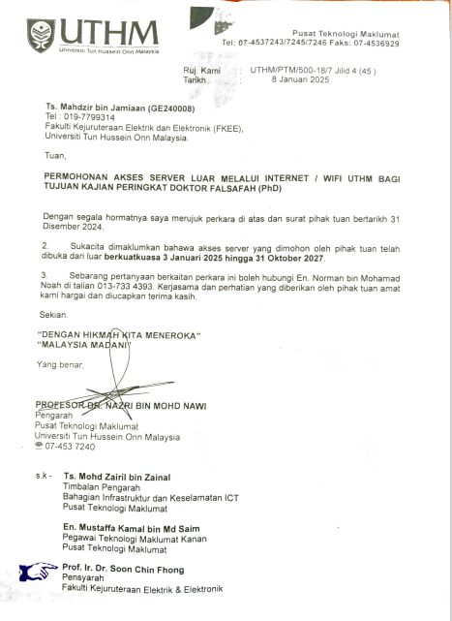
Figure 3: Letter of Permission from PTM UTHM to access external servers via UTHM internet

PUBLICATION AND CONFERENCE
International Conference on Engineering, Science and Nanotechnology 2025 (ICESNANO2025), “Development of an IoT-LoRaWAN sensor-enabled photobioreactor system for characterizing the growth of microalgae” Submitted to Journal Of Advanced Manufacturing (JAMT) UTeM.

C. F. Soon, Mahdzir Jamiaan, et al., “Smart sensing and anomaly detection for microalgae culture based on LoRaWAN sensors and LSTM autoencoder,” Aquaculture International, vol. 33, no. 6, pp. 1–25, Nov. 2025, doi: https://doi.org/10.1007/s10499-025-02104-7

VITAE
Click here to enter text.

